PRIMAVERA PROJECT REPORT

SMART STROE GLOBAL SOURCES
(A Web Based Application)
Muhamamd Tayyab 03298181-055
Abu Zafar Jawaid Abro 03-298181-035
MSPM III-B


MS PROJECT MANAGEMENT

BAHRIA UNIVERSITY LAHORE CAMPUS

SUBMITTED TO: MR. SHAHZAD AHMAD

Certificate
This witness statement is issued to the applicant for the fulfillment of his MS (Project Management) program requirements being carried out at Bahria University Lahore Campus (BULC).
It is hereby stated that Mr. Muhammad Tayyab Enrolment: 03-298181-055 and Mr. Abu Zafar Jawaid Abro Enrolment: 03-298181-035 Class: MSPM-III-B Semester: Spring 2019 Of Bahria University have visited in which they observed how our various projects are helpful for their PRIMAVERA Course implementation.
They were mainly concerned about how projects in our organization are helpful regarding Planning, Scheduling and Resource Utilization.
Moreover, it is important to mention that Mr. Muhammad Tayyab and Mr. Abu Zafar Jawaid Abro demonstrated good moral practices, enthusiastic approach to work, task convergence capabilities and professionalism while they stayed with this organization.

Certified by Company Official:

Name: Waqar Nawab
Designation: Project Manager, Pakistan Office
Company Name: Pure Logics
Company Address: 75-R1 Phase 2 Johar Town, Lahore
Phone Number: +923315959957

Preface

As per the requirements on MSPM degree program in Bahria University, I have learned various Project Management tools and techniques and performed various implementation for various tasks. So, to materialized my efforts.
PRIMAVERA requires the students to practically implement the project knowledge they have learnt so far by taking a company and make a comprehensive report about it.
This report consists of two parts. In the first part we give you a brief overview of the Company taken into consideration for this report. The organization’s mission, vision, organizational hierarchy has been listed so that it could give the reader a very brief insight into the organization and correlate the fact that hoe PRIMAVERA can help achieve the said organization a consistency in their projects. PRIMAVERA for software organizations can mean an asset which may help them sustain, monitor, review, manage and control their business.
In the second part the actual implementation of the we have actually taken into account 50+ activities from Smart Store project (which is a web based application) and performed various functions on it such as resource allocation, dependencies ,relationships etc.

Acknowledgements

All praises for almighty Allah the beneficent and the most merciful, who blessed us with the courage to complete this project successfully. We feel grateful in taking the opportunity to thank our respected supervisor, Mr. Shahzad Ahmad, for his precious time, instructions, optimistic approach, and humbleness. Without him it would have been impossible for us to accomplish the project successfully.

Table of Contents

Preface ii
Acknowledgements iii
Chapter 1 Introduction 7
1.1) Introduction 8
1.2) Vision Statement 8
1.2.1) Mission Statement 8
1.2.2) Organization Self Products 9
1.2.3) Axess 9
1.2.4) NFS Ascent 9
1.3) NFS Digital 9
1.4) Organization Culture and Structure 10
1.5) Organization Culture and Structure 11
1.6) Working Methodologies 11
1.7) Team Management 11
Chapter 2 12
Structure of Organization 12
2.2) Project Charter 13
2.2.1) Project Statement 16
2.2.2) Introduction 17
2.1.1) Advantages 17
Chapter 3 Requirement Specifications 18
3.2) Existing Systems 19
3.2.1) Ali Baba 19
3.2.2) Daraz 19
3.3) Proposed System 20
3.4) Stakeholder 20
3.5) Requirements 21
3.5.1) Requirements of Functional 21
Registration 21
Rate List 21
3.5.2) Primavera Project Reports 22
3.5.3) Hardware Requirements 22
3.5.4) Software Specifications 23
3.6) Primavera 23
3.6.1) Activities 23
3.6.1.1) Gantt Chart 25
3.6.1.2) Resources 28
3.6.1.2) WBS 29
3.6.1.2) EPS Table View 30
3.6.1.2) EPS Chart View 31
3.6.1.2) Calendar 32
3.6.1.2) Relationship 33
3.6.1.2) S- Curve 34
Chapter 5 System Implementation 35
5.1) System Architecture 36
5.2) Processing Logic 37
• Functionality of Modules 37
5.4 Use Cases 39
5.4.1) Operational Scenario 39
5.4.2) Use Case#1 40
5.4.3) Use Case#2 41
5.4.4) Use Case#3 42
5.4.5) Use Case#4 43
5.4.6) Use Case#5 44
5.4.7) Use Case#6 45
Chapter 7 Conclusion 46
Appendix A References 48
Bibliography 49
Appendix B User Manual 50
B.1.1) Home Page 52
B.1.1) Product detail Page 53

List of Figures
Figure 1 Activities 15
Figure 2 Ganttchart 16
Figure 3 Resources 17
Figure 4 WBS 18
Figure 5 Table View 19
Figure 6 EPS Chart 20
Figure 7 Calendar 21
Figure 8 Relations 23
Figure 9 S Curve 24
Figure 10 System Architecture 34
Figure 11 Processing Logic 35
Figure 12 Class Diagram 36
Figure 13 Home Page 54
Figure 14 Login Page 55
Figure 15 Product Page 56

Chapter 1 Introduction

1.1) Introduction

Pure Logics is a technology based company that accumulates people, processes and technology in the efficient way. Our global partners or client are all over the world which is helping us to stabilize our procedures and processes. Around 500 companies around the world are collaborating with us from gross root level to mature level. We provide them technology solutions and result driven processes. From the last 1 year our company has contributed very well to established technology hub with the help of different teams to deliver good results to our precious clients around the world.
Moreover, our visit to this organization was very informative that we realized this organization is working on new technologies and different management tools like JIRA, Trello mobile development and have many customers all around the work their development teams are connected with all around the world. They are focusing on Ecommerce, Mobile development and Web application development.

1.2) Vision Statement

To be a globally respected corporation that provides best-of-breed business solutions, leveraging technology, delivered by best-in-class people.

1.2.1) Mission Statement

Our mission statement is to make sure our existence is the field of information technology is to provide solutions of different businesses. Our stabilize and comprehensive approach towards businesses through technological tools that can make us efficient problem solver.

1.2.2) Organization Self Products

PureLogics is a mature organization which is connected all over the world and making supreme software for their clients and provides them excellent businesses solution that can reduce their problem and make a vital position in a market. Different software packages which contain Artificial Intelligence concepts. Different business models are helping clients around the world to make their processes efficient.
We start with center business technique and work outwards thinking about each component of your business from publicizing to media portrayal and physical stationery to site marking. Major products are listed below:

1.2.3) Axess

Purelogic Axess is a visitor management system which helps to record efficiently all visitors. It basically tells the number of visitors who visit the premises. With the help of this software receptionist can easily track the information of visitors.

1.2.4) NFS Ascent

Ascent is a technology which enables finance, automotive and big household companies to run their operations smoothly especially it provides ease to retailer and wholesalers.

1.3) NFS Digital

NFS Digital is an ecosystem that is helpful for finance operations and enables companies to gain benefits of digital systems.

1.4) Organization Culture and Structure

PureLogics has their first office in Pakistan and second one in America. They are working on different methodologies like Agile, Waterfall and new technologies like AWS, Boot strap. They are more focus on projects organization with services in Software designing, development, UX design development. They have Mr. Ayaz as IT Director and Mr. Waqar Nawab as Chief Technical officer and Project Manager and Network Administrator in their organization apart from project teams. Below is the organ gram of the organization.

1.5) Organization Culture and Structure

The PureLogics believes on providing value to its customers because to gain a leader of software industry globally.
Major core values are listed below:

1.6) Working Methodologies

PureLogics, we specialized in web and social web application offering a combination of consulting, outsourcing and provide services regarding all platforms like web development, mobile development and social media solutions and web services. It does business with a customer first outlook. Our prime focus is to engage our client 24 hours. Client has a vital role in company and PureLogics always try to provide best solution and speed up processes to their client.

1.7) Team Management

Team is the assets of any organization. PureLogics believes binding between senior management and development teams. They share information between each other. And also they are accountable to do what they have done or doing. Moral values have a great importance in team management. All team members collaborate and hard work together.

Chapter 2

Structure of Organization

  - Project Management Structure in Organization

In PureLogics Project manager is the captain of the ship. Project team has to day to day performance reports directly to the project manager. Team use JIRA for daily performance. Tasks distribution and time estimation to complete that tasks basically defined by project manager. The project manager then, further one, assigns responsibilities according to team members’ Skills and capabilities. Team members, in return, log time daily in these applications.

Project Charter

Project Name:  Smart Store |  |  | Project Number:  0.1
Date:  01 JAN 2016 |  |  | Revision Number:  1.1
- Targets

- Smart store is a web application. Which follow the concept of B2B.
- There is a need for a system which can make it easy for a businessman to know about the current products in the market and how to get them from reliable sources on time.
- There must be a system which should help the businessman to know about the current situation of the market and what trends are going on.
- To maintain Buyer and Supplier relation
- Efficient workforce and time management

- DELIVERABLES

- It’s a smart store project which required a web application for interaction between supplier and retailer.
- It will help the buyer and supplier to purchase and transfers of their stock in a very efficient manner.
- Increased level of security of buyer and suppliers

- SCOPE DEFINITION

Web App must be user friendly and should be managed easily by the user. It will be a Multilfuntional web application. It contain in three component
- The App must be user friendly. Must support a user Friendly Interface.
- Business Process Improvement
- Development, Enhancement and Deployment
4. MILESTONES

- Service Delivery
- Responsive Layout
- Authentication & Security
- Registration
- Stuff check in
- Dashboard
- Account /Extension Management
- Information Campaigns
- Rating between suppliers and Retailer
5. ORGANIZATIONAL STRUCTURE

Function |  | Name |  | Role
Report |  | Waqar Nawab |  | PM
Employee |  | Younas Ikram |  | Team Lead
Employee |  | Ahmed |  | Senior Software Engineer
Employee |  | Mohsin |  | AI Algorithm Specalist
Employee |  | Kamran Afzal |  | Designer
- AUTHORIZATION

Approved by: | Project Manager |  |  |  | Date
Approved by: | CTO |  |  |  | Date
Approved by: | IT Director |  |  |  | Date
Approved by: | CEO |  |  |  | Date

Project Statement

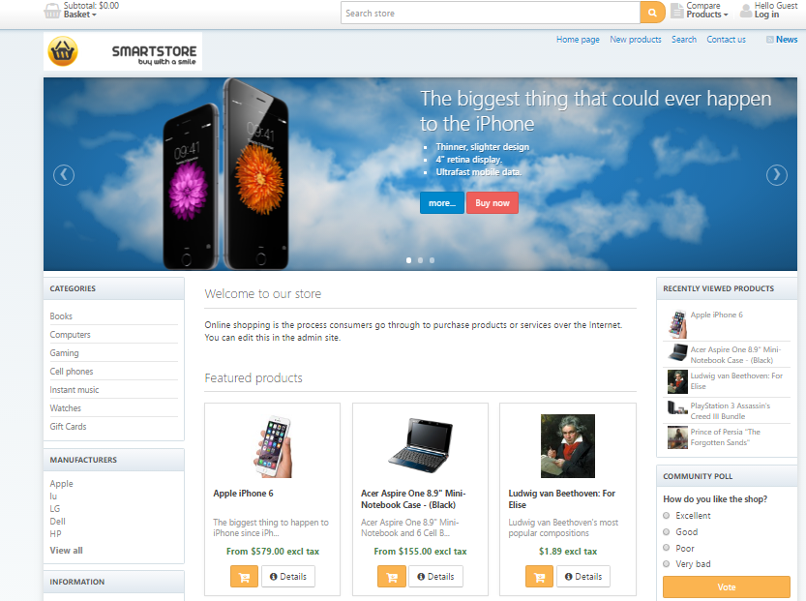

Introduction

The system that has all the solutions of above mentioned problems. Rating of products will be there in our proposed system.
By considering the b2b system the proposed system is very authentic, low cost and minimum storage requirement. This system allows business man and retailer to interact with each other in a whole new way by using our online platform to make their business deals. Moreover; this system also allows business man to get to know about new products coming to the market.

Advantages

- Low cost
Most of the business systems are costly due to its heavy maintenance, problem but the business system we are proposing is of low cost since its functionality is more effective. This system requires only reliable internet connection along with a pc, laptop, mobile, tablet etc for the user to use our system.
- Efficiency
Due to its friendly web interface and easy access this system will not require the assistance and a normal person would be able to use that system. It saves big amount of time and it can be accessed from anywhere any time 24/7.
- Ease of Maintenance
Maintenance setbacks frequently occur in most of the systems. The proposed System does not require heavy maintenance its maintenance is only required when new products are introduced in the market or new members join so the database needs to be updated on timelybasis.

Chapter 3 Requirement Specifications

  - Requirement Specification

Software and hardware requirements are those which can be designed for the development of any system and its function. Requirement specification is basically an idea through which we can find our outputs by giving the inputs technically that can be in a form of (input = process = output). That can be in form of functional and non-functional specifications for both software and hardware.

Existing Systems
The above discussed system in Literature review chapter has their own limitations.

Ali Baba
if buyer wants to check the current location of suppliers he can’t do that.

Daraz
Buyer can not avail the facility to check the find near supplier.

Proposed System

In our system we simply say that it is the mixture of all the above systems. It works in multiples ways to enhance the user experience e.g.

      - By considering the b2b system the proposed system is very authentic.
      - This system allows business man and retailer to interact with each other in a whole new way by using our online platform to make their business deals.
      - This system also allows business man to get to know about new products coming to the market.

Stakeholder

This application will have following modules:

      - Project Management office
      - Wholesaler
      - Retailer
      - Development Team
      - Quality Assurance Team
      - CEO
      - Technical Director
      - Suppliers

Requirements

Requirements of Functional

Registration
The buyer will register with detailed information and create their accounts on platform.

Rate List
The general market rates will be used which will be whole sale rates because of fluctuation of rates in the local market.

Primavera Project Reports
The implementation of the project has been done in PRIMAVERA. This segment contains perspective and reports produced from Primavera.
- Project Overview
- WBS
- OBS
- EPS Table
- Calendar
- S Curve
- EPS Chart view
- Gantt Chart
- Resource Sheet
- Activities
- Relations

Hardware Requirements

This software requires hardware devices which are important for the system. These hardware devices are
      - CPU
      - Display device
      - Printer for reports

Software Specifications
- Microsoft Visual Studio
- This is used for dot net development.
- Language
- The language we are using for software development is C#.
- Operating System
- The operating systems being used are Windows 7 and windows 8.

Primavera

3.6.1) Activities

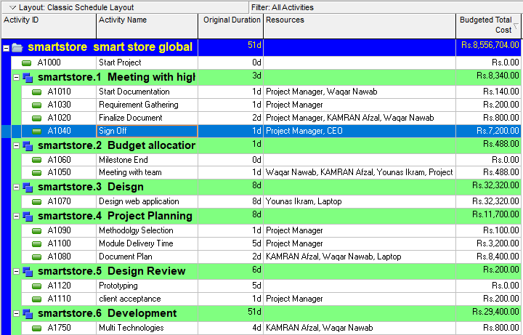

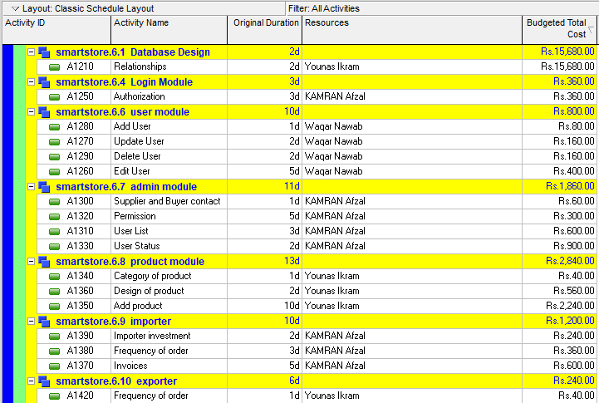

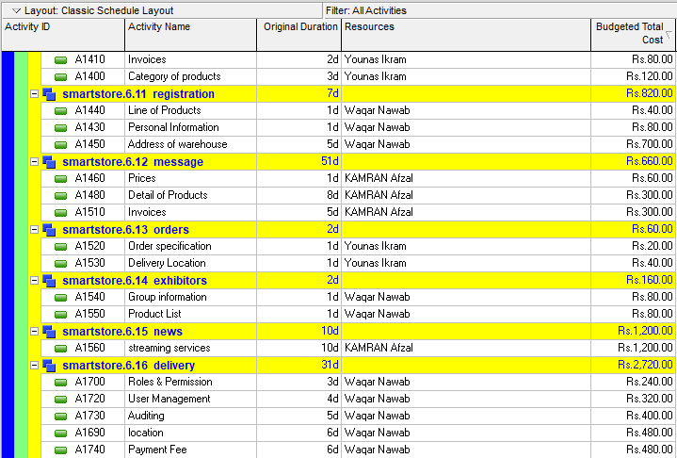
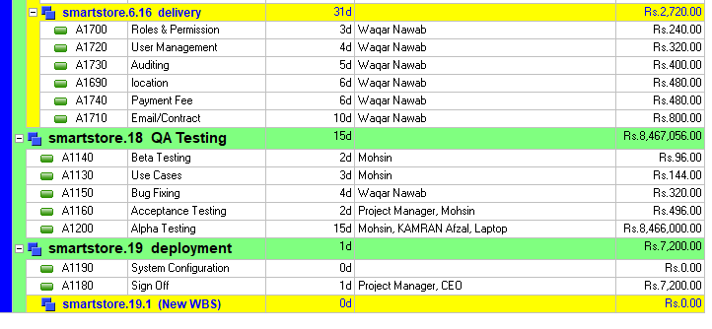
Figure 1 Activities

3.6.1.1) Gantt Chart

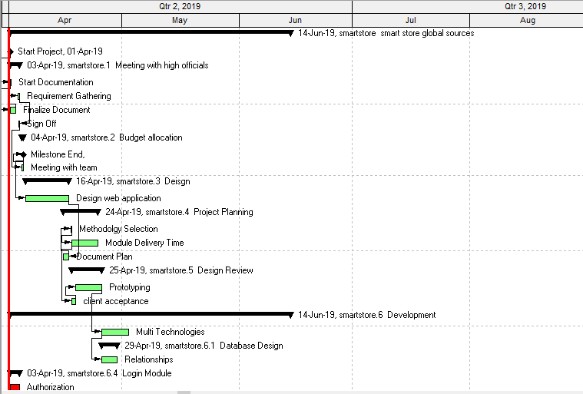

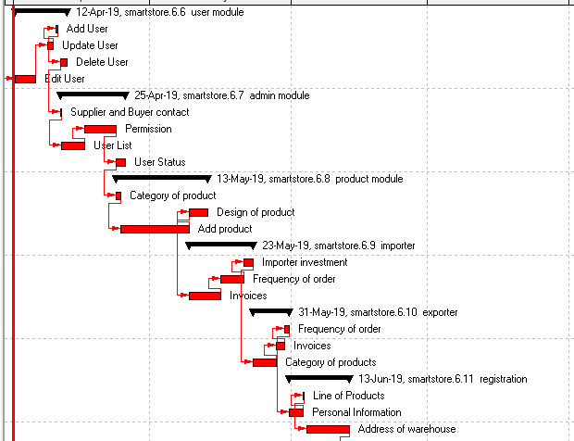
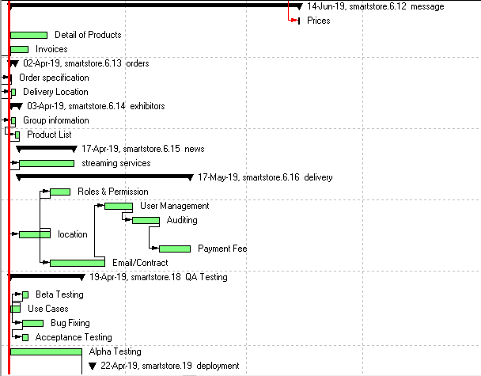
Figure 2 Ganttchart

Resources

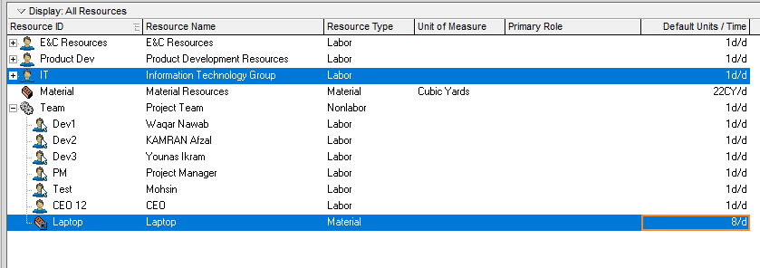

Figure 3 Resources

WBS

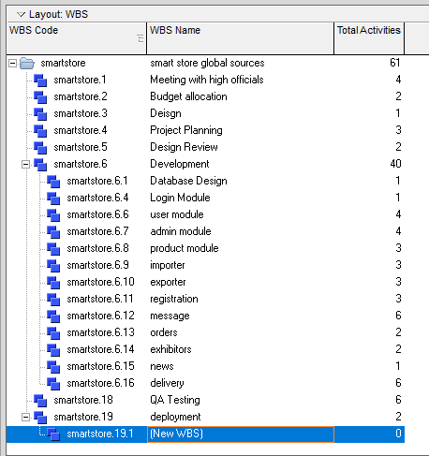

Figure 4 WBS

EPS Table View

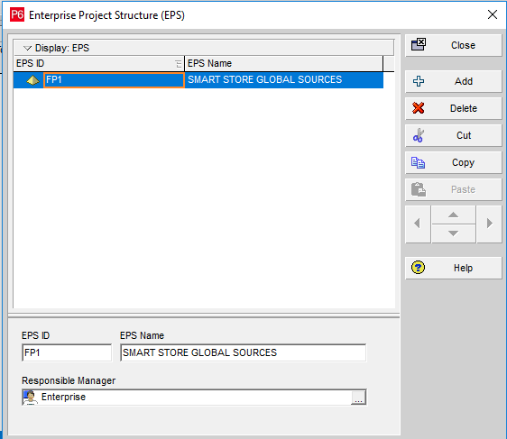

Figure 5 EPS Table View

EPS Chart View

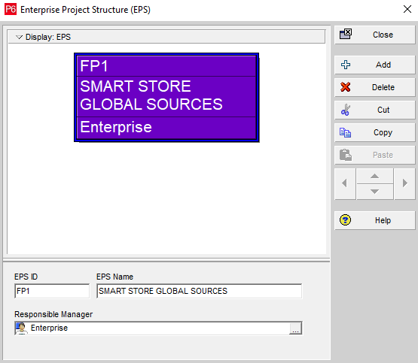

Figure 6 EPS Chart

Calendar

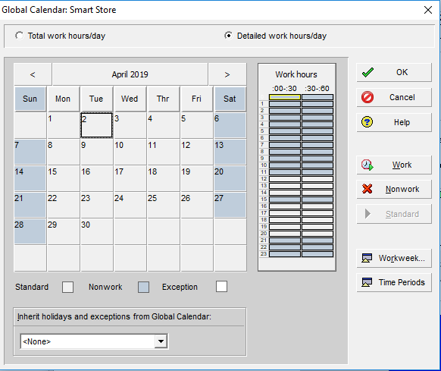

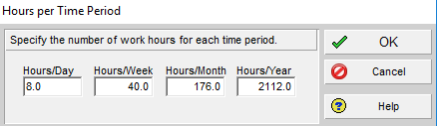

Figure 7 Calendar

Relationship

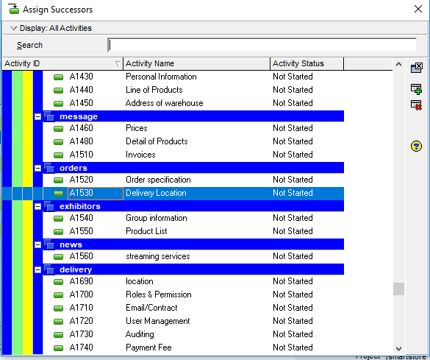

Figure 8 Relations

S- Curve

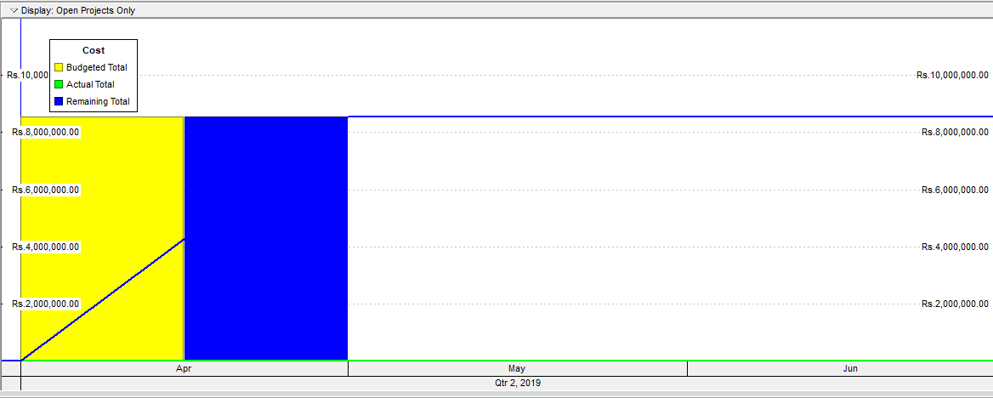

Figure 9 S Curve

Chapter 5 System Implementation

System Architecture

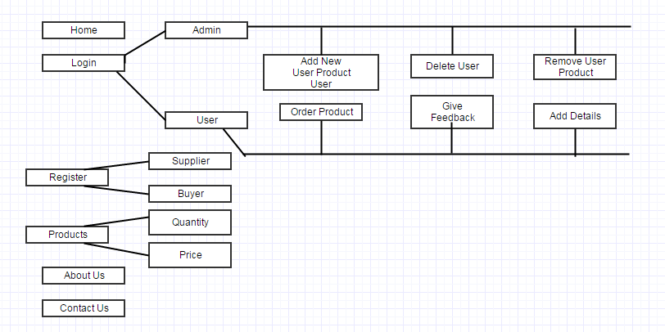
Figure 10 System Architecture

Processing Logic

Functionality of Modules

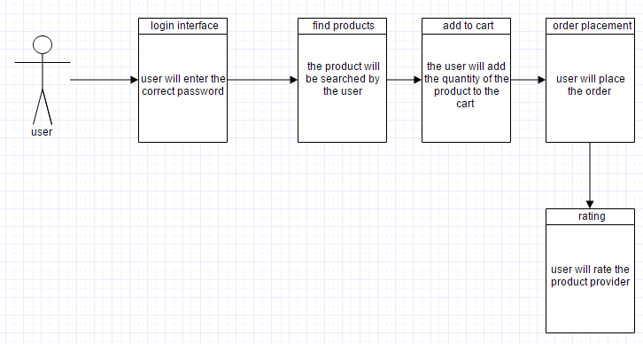
Figure 11 Processing Logic

    - Class Diagram

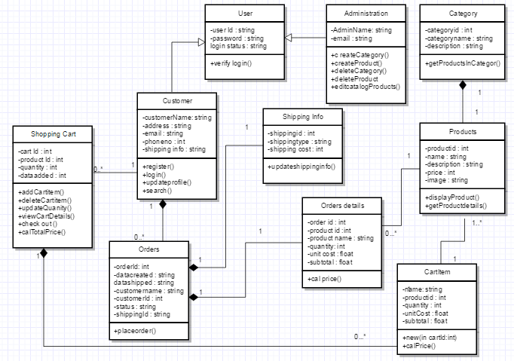
Figure 12 Class Diagram

Use Cases

5.4.1) Operational Scenario

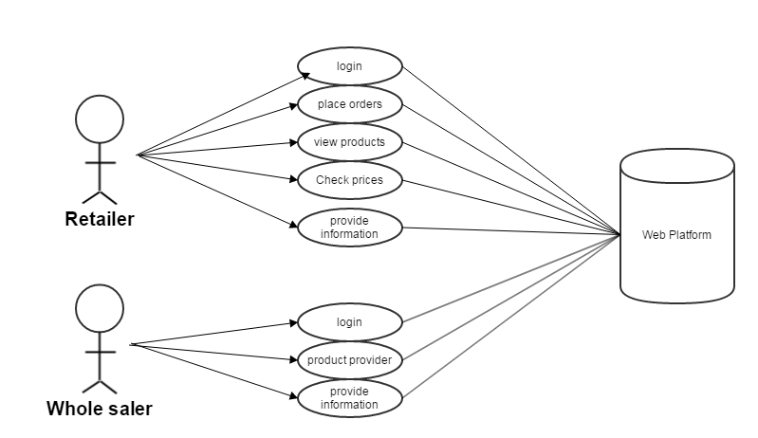

5.4.2) Use Case#1

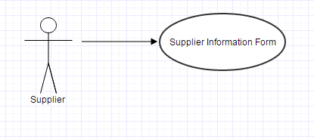

Title | UC1:Supplier Information Form
Version No. | 1.0
Actors | Supplier
Description | Supplier will fill his/her information in this form and sends it as a request.
Trigger | Press the proceed button for further processing
Main Success Scenario | Step | Action
 | 1. | Enter correct information by the supplier
 | 2. | All fields should be filled properly
 | 3. | Enter the proceed button
Alternate Flows | Step | Action
 | 1. | If any field remains empty then he/she will not proceed to the next stage
Special Requirements | - The font in GUI for this use case is visible from 1 meter away  - The language is English which is used in GUI  - The template used for GUI is similar to Windows environment
Assumptions | Same user fill his/her information again and again
Pre-conditions | The information is already given or saved on the PC
Post-conditions | The supplier information request processes successfully
User interface | A form with all the information, also having proceed button
Issues | Should not be any empty fields

Use Case#2

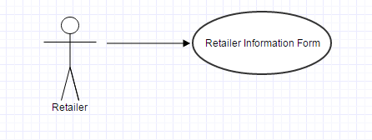

Title | UC2:Retailer Information Form
Version No. | 1.0
Actors | Retailer
Description | Retailer will fill his/her information in this form and sends it as a request.
Trigger | Press the proceed button for further processing
Main Success Scenario | Step | Action
 | 1. | Enter correct information by the retailer
 | 2. | All fields should be filled properly
 | 3. | Enter the proceed button
Alternate Flows | Step | Action
 | 1. | If any field remains empty then he/she will not proceed to the next stage
Special Requirements | - The font in GUI for this use case is visible from 1 meter away  - The language is English which is used in GUI  - The template used for GUI is similar to Windows environment
Assumptions | Same user fill his/her information again and again
Pre-conditions | The information is already given or saved on the PC
Post-conditions | The retailer information request processes successfully
User interface | A form with all the information, also having proceed button
Issues | Should not be any empty fields

Use Case#3

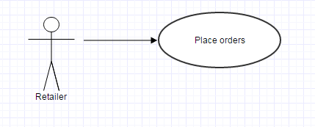

Title | UC3: Place order
Version No. | 1.0
Actors | User
Description | This use case will be used for placing order by the user to buy products
Trigger | The user will enter the number of items
Main Success Scenario | Step | Action
 | 1 | Buyer will choose the items and their quantity.
 | 2 | After selecting the number of products the user will press button buttsave/submit button
Alternate Flows | Step | Action
 | 1 | User will be intimate by the system at every stage.
Special Requirements | Enter the correct pin code
Assumptions | May be user leave the order during process
Pre-conditions | The user should have authorization to edit after order placement.
Post-conditions | The order will be uploaded after clicking on save button.
User interface | The user can see on the screen items names and their rates and a save button.
Issues | Items are unavailable

Use Case#4

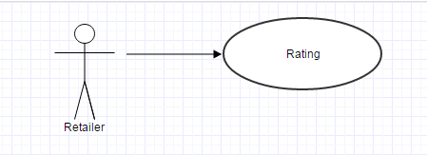

Title | UC4: Rating
Version No. | 1.0
Actors | User
Description | This use case is for rating the product provided by the supplier.
Trigger | Unknown rating
Main Success Scenario | Step | Action
 | 1 | The buyer will rate the products.
 | 2 | Card will be returned to the user
Alternate Flows | Step | Action
 | 1 | None
Special Requirements | N/A
Assumptions | The ratings will be stored in the database.
Pre-conditions | The rating based on businesses point of view and shown to other. buyers.
Post-conditions | The suppliers can improve rating by improving quality.
User interface | N/A
Issues | Fake rating.

Use Case#5

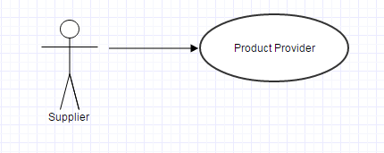

Title | UC5: Products provider
Version No. | 1.0
Actors | Supplier
Description | This use case is for Supplier who will provide the product he can deliver.
Trigger | The product already provided by the same supplier
Main Success Scenario | Step | Action
 | 1 | The supplier can provide the detail product information.
Alternate Flows | Step | Action
 |  | None
Special Requirements
Assumptions | The prices of the give products will be known by the administrator.
Pre-conditions | Must have login ID
Post-conditions | Fill the form and press submit button.
User interface
Issues | Products names are invalid

Use Case#6

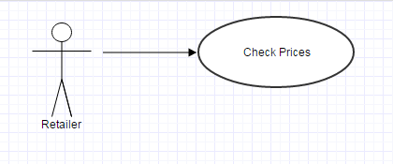

Title | UC6: Check Prices
Version No. | 1.0
Actors | Retailer
Description | This use case is for checking the prices of the product by retailer.
Trigger | N/A
Main Success Scenario | Step | Action
 | 1 | The user will check the product prices product.
 |  | N/A
Alternate Flows | Step | Action
 | 1 | None
Special Requirements | N/A
Assumptions | The prices will be stored in the database.
Pre-conditions | The platform must be updated.
Post-conditions | None
User interface | N/A
Issues | Market deviation in accordance to the prices

Chapter 7 Conclusion

  - Conclusion

Primavera has a vital role in organization success because it enhances the processes and procedures of an organization. Monitoring and evaluation could be easily done by Primavera software package.

Appendix A References

Bibliography

Bendy, M. A. H. a. C. J., 1970. Global Sources. [Online]
Available at: http://www.globalsources.com/
Bly, B., 2013. The Business to Business Marketing Hand Book. River Vale: Technical Communication.
Ma, J., April 4, 1999. Ali Baba. [Online]
Available at: https://www.alibaba.com/
W.Schaefer, M., n.d. B2B Blogging E Book. [Online]
Available at: http://www.businessesgrow.com/wp-content/uploads/2010/11/10.12_MLT_EBook_Compilation1.pdf

Appendix B User Manual

B.1) Appendix B

B.1.1) Home Page

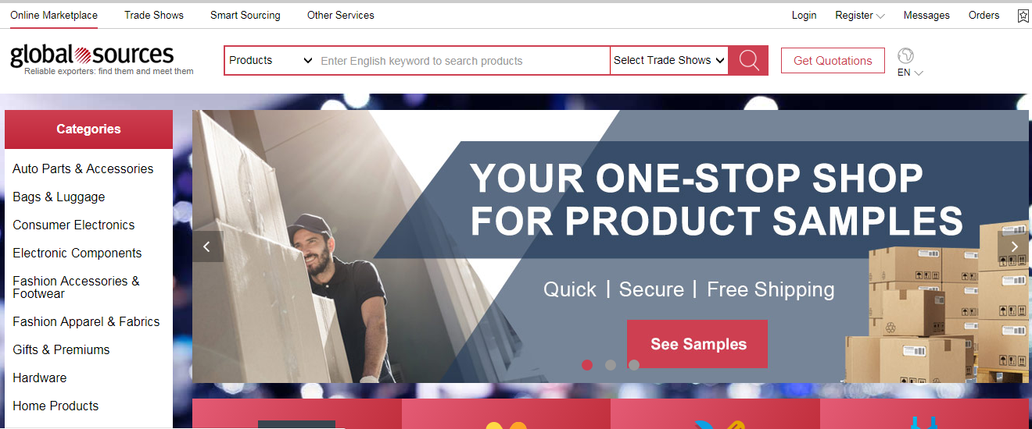

Figure 13 Home Page

Product detail Page

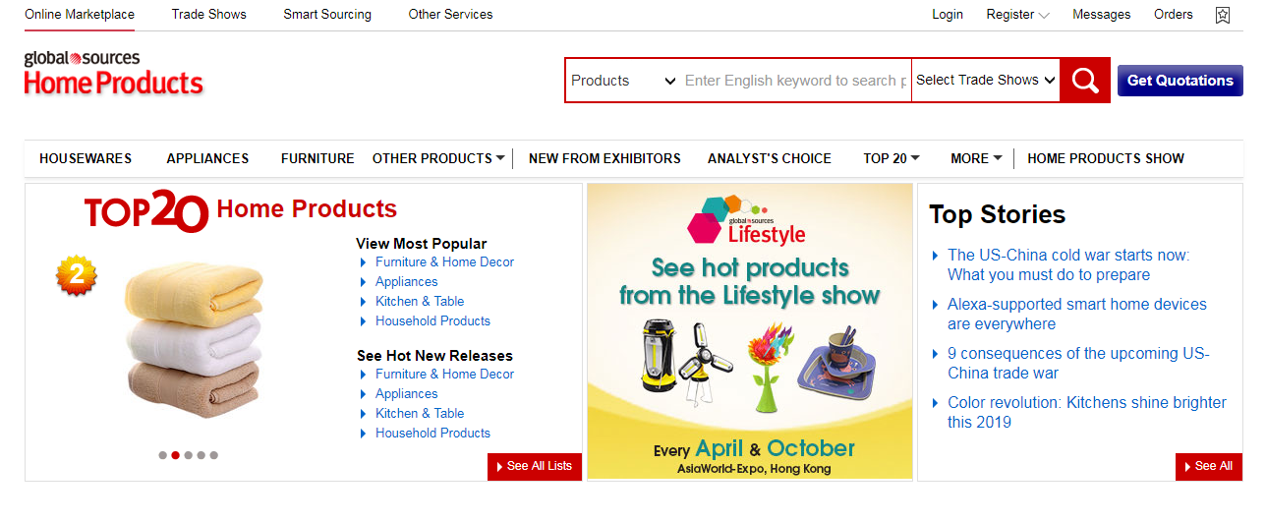

Figure 14 Product Page

