Fazaia Colleges’ Role In Educating Children Of Low Income Class


SUPERVISOR: Ms. Kishwer Sameen Gulzar
SUBMITTED BY: WAQAS WAHEED
ENROLLMENT #: 01-221092-084
SARA REHMAN
ENROLLMENT #: 01-221092-059
HUMA KHALID
ENROLLMENT #: 01-221092-025
AMINA BINT-E-ZAHID
ENROLLMENT #: 01-221092-007

MBA 2009 – 2010

Department Of Management Sciences,
BAHRIA UNIVERSITY ISLAMABAD

ABSTRACT

The project highlights the most vital concerns, Fazaia School Board counteracts’ at the moment. The school network is working on a social agenda to accommodate the needy, which in turn is affecting the funding mechanism of Fazaia Schools. It in effect, adversely impacts the performance of Fazaia School Network. The school’s finance system is burdened with huge expenses relative to revenues it generates. A number of factors contribute in aggravating the situation, One Fazaia Schools’ multiple pricing strategy, gap in performance management and inadequate funding. Primary and secondary research was conducted, followed by a correlation analysis of the variables. It helped in better understanding of relationships among the variables, analyzing the impact of one on another. The project discusses alternative models which are followed by schools in Pakistan and across the world, successfully. These models facilitate in betterment of school systems’. They suggest different funding resources schools rely on, whether they be, partnering with other business enterprises, getting help from volunteer workers, arranging events to raise funds, entering into public-private partnership so on and so forth. The aim is to work the best way out that harmonizes the interest of all. The project proposes an evening school approach to the ease the burden of disproportionate funding that exists within Fazaia School. This endeavor would assist the school in attracting and stabilizing its funding base. Additional recommendations are put forward that relate to Fazaia School’s performance management and other minor problems that have emerged as a result of diversity which exists in the school.

ACKNOWLEDGEMENT

We have no words to express our great and deepest sense of gratitude to Almighty Allah Who enabled us to initiate this work and gave us the potential as well as patience to complete this report.
We wish to express our deepest and heartiest gratitude and profound regard to our advisor /supervisor Ms. Kishwer Sameen Gulzar for her keen interest, sympathetic help and valuable suggestions which she extended to us during our project report.
We pay enthusiastic feelings for our parents who supported us morally and financially throughout our education.

DEDICATION

Dedicated to Allah who gave us the brain to explore, who gave us such loving parents who have spent their today for our tomorrow, to whom we owe our existence, to our teachers who have been provision of ventilation for us and to all our guiders who have warm & lovely feelings for us, who are our assets.
Their prayers made us able to complete this project.

TABLE OF CONTENTS

Chapter 1 1
Introduction 1
1.1 Broad Problem Area/Background 1
1.2 Problem Statement 2
1.3 Objectives of the study 2
1.4 Reaearch Methodology 3
1.4.1 Type of Study 3
1.4.2 Primary Research 3
1.4.3 Secondary Research 4
1.4.4 Population/Sample 4
1.4.5 Instruments and Measures 4
1.5 Scope and Limitation 5
Chapter 2 7
Contemporary Research 7
2.1 Socio-Economic Diversity 7
2.1.1 Socio-Economic Diversity Impact in School 7
2.2 Multiple Pricing 13
2.2.1 Two-Tier Pricing 13
2.2.2 Differential Pricing Objectives 15
2.2.3 Differential Pricing in Education Institutions 15
2.2.4 Students as Input and Human Capital as Output 17
2.3 Perfromance Based Compensation 18
2.3.1 Pay for Performance 18
2.3.2 Introduction 19
2.3.3 Teachers Compensation 23
2.3.4 Benefits of Performance-Based Pay 25
2.3.5 Expectancy Theory and Reinforcement Theory 26
2.3.4 Benefits of Performance-Based Pay 25
2.4 Gap in Performance Management 31
2.4.1 Meaning and Purpose of Performance Management System 31
2.4.2 Education and Training for Performance Management 32
2.4.3 Effect of Perf. Mgt System on Teachers’ Professional Development 33
2.4.4 The appropriateness of performance based pay 34
2.4.5 Poor performance of teachers 35
2.4.6 Student Evaluation of Teachers (SEOT) 38
2.4.7 Appraisals 41
2.4.8 Making Feedback Work 42
2.4.9 Perfromance Appraisal 43
2.5 Inadequate Funding Sources 46
2.6 Low Perfromance of Fazaia Schools and Colleges 59
Chapter 3 60
Industry Overview 60
3.1 Background of Education in Pakistan 60
3.1.1 Formal System of Education in Pakistan 61
3.1.2 Non-Formal Education 64
3.1.3 Present Scenario of Education in Pakistan 64
Chapter 4 68
Organizational Overview 68
4.1 Fazaia Chain Schools and Colleges 68
4.1.1 Fazaia Inter College Islamabad 69
4.1.2 Fazaia Inter College Chaklala 69
Chapter 5 70
Identification of Issues 70
5.1 Students’ Questionnaire Analysis 71
5.2 Teachers’ Questionnaire Analysis 83
5.3 Students’ Correlation Analysis 93
5.4 Teachers’ Correlation Analysis 96
5.5 Interview Analysis 101
Chapter 6 105
Possible Options and Alternatives 105
6.1 Charter Schools Model 105
6.1.1 Andre Aggasi Foundation 107
6.2 Zindagi Trust Foundation 109
6.3 Evening School Model 110
6.4 Parha Likha Punjab Model 112
Chapter 7 115
Best Option and Recommendations 115
7.1 Best Option 115
7.1.1 Evening School Program 115
7.2 Recommendations 119
7.2.1 Inadequate Funding 119
7.2.2 Pay for Performance 119
7.2.3 Gap in Performance Management 121
7.2.4 Socio-Economic Diversity 123
Chapter 8 125
Action Plan 125
8.1 Action Plan For Evening School Setup 125
8.1.1 Salient Features 125
8.1.2 Establishing Credibility at the Initial Level 126
8.2 OBJECTIVES 126
8.2.1 Primary Objectives 126
8.2.2 Secondary Objectives 127
8.3 The Grand Plan 127
8.3.1 Use of Fazaia Schools Buildings 128
8.3.2 Staff Authorization 128
8.4 Salient Features of the Evening Program 129
8.4.1 Identical Syllabus 129
8.4.2 Nominal Fee Rates 129
8.4.3 Administrative Control with PAF 129
8.4.4 Teachers to be trained by PAF 129
8.4.5 Merit 130
8.4.6 Class Strength 130
8.5 Course of Action 130
8.6 Coordination Committee 130
8.6.1 Principals FG Colleges Role 131
8.6.2 Principals Fazaia Colleges Role 131
8.7 Admission Policy 131
8.8 Afternoon Classes Time 132
8.8.1 Periods Breakdown (Afternoon Classes) 132
Bibliography 133
Appendices 137

List of Figures Page Number

Figure 3.1 66
Figure 3.2 68
Figure 5.1a 72
Figure 5.1b 72
Figure 5.2a 73
Figure 5.2b 73
Figure 5.3a 74
Figure 5.3b 74
Figure 5.4a 75
Figure 5.4b 75
Figure 5.5a 76
Figure 5.5b 76
Figure 5.6a 77
Figure 5.6b 77
Figure 5.7a 78
Figure 5.7b 78
Figure 5.8a 79
Figure 5.8b 79
Figure 5.9a 80
Figure 5.9b 80
Figure 5.10a 81
Figure 5.10b 81
Figure 5.11a 82
Figure 5.11b 82
Figure 5.12a 83
Figure 5.12b 83
Figure 5.13 84
Figure 5.14 84
Figure 5.15 85
Figure 5.16 85
Figure 5.17 86
Figure 5.18 86
Figure 5.19 87
Figure 5.20 87
Figure 5.21 88
Figure 5.22 89
Figure 5.23 89
Figure 5.24 90
Figure 5.25 91
Figure 5.26 91
Figure 5.27 92
Figure 5.28 93

List of Tables Page Number

Table 5a 71
Table 5b 71
Table 5.1a 72
Table 5.1b 72
Table 5.2a 73
Table 5.2b 73
Table 5.3a 74
Table 5.3b 74
Table 5.4a 75
Table 5.4b 75
Table 5.5a 76
Table 5.5b 76
Table 5.6a 77
Table 5.6a 77
Table 5.7a 78
Table 5.7b 78
Table 5.8a 79
Table 5.8b 79
Table 5.9a 80
Table 5.9b 80
Table 5.10a 81
Table 5.10b 81
Table 5.11a 82
Table 5.11b 82
Table 5.12a 83
Table 5.12b 83
Table 5.13 84
Table 5.14 84
Table 5.15 85
Table 5.16 85
Table 5.17 86
Table 5.18 86
Table 5.19 87
Table 5.20 87
Table 5.21 88
Table 5.22 89
Table 5.23 89
Table 5.24 90
Table 5.25 91
Table 5.26 91
Table 5.27 92
Table 5.28 93
Table 5.29 94
Table 5.30 95
Table 5.31 96
Table 5.32 97
Table 5.33 98
Table 5.34 99
Table 5.35 100
CHAPTER 1
INTRODUCTION

1.1 BROAD PROBLEM AREA/BACKGROUND
Fazaia network of schools, are one of the few schools, showing a sincere dedication, for the betterment of the society, at large. The school aims to provide equal opportunity education to all the students, regardless of the social background they belong to. The school delivers educational services at a reasonable price, which can be easily accessed by everyone. Fazaia’s targeted student population comes from diverse socio-economic backgrounds. As a result, students belonging to indigent families are offered admission to the school on a discounted fee basis, as compare to students with a more stable financial background. Consequently, the school receives half the amount of money, burdening its finances. The socio-economic gap, poses a huge challenge for the school system, as a higher proportion of students, belong from an underprivileged class of society. This, in effect, is hurting the school standards. Along, there are a varied set of factors identified, that connect to decline of school standards. The factors identified are, multiple pricing strategy; performance based compensation; gap in performance management; and inadequate funding sources.
The differential pricing or the schools un-equalized fee structure is, in effect hurting the schools financing, to sustain an adequate level of funding, for the schools running in the short term. Schools board differential pricing strategy raises the concern for scarcity of financial resources, in the school system. The larger the funding gap, consequently poorly funded facilities, in turn lesser satisfaction for parents, teachers, students and schools administration. Lesser satisfaction leads to less efficient work practices; along school has not designed a performance based compensation package for its staff, to encourage motivation to work, so as a result a gap in the performance standards of the school is, piling up. The focus of the project research is to devise a plan, so as to create harmony in the varied concerns of the school stakeholders – to work the best way out acceptable by all; and strategizing ways to make the best use of the available resources, with the school, to ease the burden of disproportionate funding.

1.2 PROBLEM STATEMENT
To assess the financial viability and socio-economic diversity at Fazaia chain of schools and colleges.

1.3 OBJECTIVES OF THE STUDY
The Project aims to contribute constructively to the PAF school system, by critically reviewing the inherent issues: sufficiency of resources with the school/college; quality of services delivered and cost effectiveness.The purpose of the study is the attainment of the following set of objectives:
- Assessing the financial viability of the school and to reflect on the current method of funding.
- To analyze the gap that exists in the performance management of the schools.
- To evaluate the fee structure adopted by the schools administration.
- To review the schools performance based compensation program.
- To evaluate the socio–cultural reality that exists within the schools, which in turn is posing a big question to the schools administration that how it could be funded given the economic realities of the school.
- To provide a guideline, that covers the reforms, which aim to remove the deficiencies that lie within the school system, by efficient and effective management of resources and cost, and to provide sufficient quality education as the end product.

1.4 RESEARCH METHODOLOGY

1.4.1 Type of Study
Our research will be both qualitative and quantitative as per the demands of our project. The researches that have already been discussed and done will be documented in the literature review to have a complete understanding of our project.

1.4.2 Primary Research
Primary Research has been conducted through personal observation, face to face interviews and questionnaires.
Qualitative data has been gathered through interviews and questionnaires which will be conducted from students and teachers. The respondents will respond to the open as well as close ended questions. The quantitative data has been gathered through a sample of 50 students and 22 teachers from the twin cities.

1.4.3 Secondary Research
Secondary research will be conducted and collected through libraries, internet, journals, articles and published records.

1.4.4 Population/Sample
The population for the PAF Schools is the students who are obtaining education in these schools as well as the teachers.
The sample size of our research is 50 student respondents plus 22 teacher respondents. The research has been conducted among the two schools of twin cities, Fazaia Inter College Islamabad and Fazaia Inter College Chaklala, by taking 25 and 11 student and teacher respondents respectively in each of the two schools.

1.4.5 Instruments and Measures

1.4.5.1 DESCRIPTION OF THE INSTRUMENTATION
This study was conducted from very initial level because there was no data available prior to this research related to Fazaia chain of schools and colleges. Therefore, based on simple rating scale, two questionnaires were developed to find out priorities of students and teachers while rating their preferences. The impact of our variables was analyzed through rating strength of agreement on likert scale from 1 standing for strongly disagree and 5 standing for strongly agree.
The data collected was then analyzed through SPSS using the frequency analysis and the correlation analysis.
1.4.5.2 Correlations
Correlation is a measure of the relation between two or more variables. Correlation coefficients can range from -1.00 to +1.00. The most widely used type of correlation coefficient is Pearson, which we have applied in our research.
1.5 Scope and Limitations
1.5.1 Scope of Study
Our project scope is confined to PAF Schools, located in Islamabad and Rawalpindi districts. A survey questionnaire had been distributed in both the schools. The questions thought out for the survey, in particular, focus on students and staff of the two school districts. The results, from the questionnaire, will infer an in depth knowledge on the problem areas identified in the project research. Subsequently analyzing the complete scenario would help in devising a plan for the school to bring betterment inrunningschools.
1.5.2 Limitations
The research being undertaken had the following limitations:
- The research is confined to the two colleges of the Fazaia Chain of Schools/Colleges.
- Time constraints are to be considered as well, as the project is to be completed and submitted within four months of the acceptance of proposal.
- A total sample size of 50 students from the two schools/colleges is taken, representing a vast majority of students.
- Again a total sample size of 22 teachers from both the schools was taken to in order to assume a viewpoint of all the teachers in the Fazaia Chain.
- The questionnaires were filled by the respondents according to their own perception. Moreover, not all respondents take the questionnaire seriously.

CHAPTER 2
CONTEMPORARY RESEARCH

2.1 Socio-Economic Diversity
2.1.1 SOCIO – ECONOMIC DIVERSITY IMPACTS IN THE SCHOOLS
There has been proved to be many benefits of socio economic diversity if followed through the required way. Although previous studies about the socio – economic diversity were proved to have positive results as it could heighten student curricular achievement but the following perspective points to the likely problems with the socio economic diversity in non – achievement domains. Such issues are significant and they may also remove the magnitude of potential attainment benefits gradually. If the proportion of the student body in the middle or high income increased, low – income students experienced more psychosocial problems and if the proportion of the student body in the low income increased, middle or high income students tend to have different problems and high proportion of low income student affected the standard of education because the low social background they were belonging from.
The standard of education in the schools is dropping due to the reason of socio – economic diversity in the schools where there is high concentration of low – income students due to which on one side the students of high income students are showing significant dropout rate and on the other schools are not getting enough funds to raise the standard of the school environment and providing quality education. The educational standard and quality education is falling down in the schools where there is socio – economic, multiculturalism as the concentration of low – income students is high, and there are students from diverse social backgrounds and families (Robert Crosnoe,2009).
Prior research within the classrooms has proved to have been beneficial in the children’s upbringing on the impact of joint groupings. Our overall study is to determine and figure out the influence of socio – economic diversity in preparing the peers belonging to low – income backgrounds on the basis of their emotional, social and language background in the classrooms (Janet H. Bagby; Loretta C. Rudd; Majka Woods,2005).
Our behaviors and attitudes towards how do we react to the society is based on culture. Children who interact with the people and students having diverse cultures behave accordingly the way they perceive their environment and the way they are engaged in the society as a whole. The achievement of the students is perceived on the basis of their abilities regarding how they take their surroundings (Gwendolyn Cartledge; Scott A. Loe,2001).
Cultural diversity and multicultural education are specific tools to endorse and support full democratic combination in the schools and communities. School environment must contain structural changes within it. Parents and educators play a significant role in making diverse culture that may lead to hope. Educators and parents need to have a strong belief that socio – cultural diversity can improve the meaning of diversity in real sense. One more important thing is that they should make right decisions and should guide their children and students about cultural diversity as a positive thing that can lead to positive results. Teachers and parents play a significant role in helping students to reach their fullest potential and be victorious in whatever and whichever field they choose in life (Anne B.Onyekwuluje, 1998).
Multicultural education programs communicate that teachers should change their behaviors and attitudes with respect to the performance and mental pace of the student to benefit the students for the academic achievement as much as possible. The teachers should even learn the languages of the culturally diverse students in order to make them understand the lecture and topics as nearer as possible.The teachers should also communicate cross cultural understanding among all the students in the class.Yet this doesnot just depend upon teachers but students also play a key role in this(Ogbu&Matute – Bianchi, 1986).
There are many existing intervention and policy discourse strategies which are aimed at making better schools in such kind of circumstances. As the approaches that are so far taken up are not sufficient enough to differentiate the context specifically so it reasons that current methods to improving schools are unlikely to bring success. There is high demand for low performing schools need to improve within the education system according to many aspects that we need to consider in our research. There is urgent need to sustain and generate improvement in the lowest attaining schools and special attention is required to protect means of lifting up the achievement of students in schools established in areas of higher than average socioeconomic deprivation. It stays put that certain groups of students fail to reach their real potential over and over again while on the contrary other groups consistently remain successful. Research has proved that children from low income families do not average prevail over the stumbling block of lower primary achievement (West and Pennell, 2003). Class and status differences affect the children psyche in all ages even before they start their schooling and it prevails when they get older in age (Alma Harris & Christopher Chapman,2004).
There is an elementary shift that has taken place in the relationship between the educational policy making and the images of the past. Education policies have often proved to be deficient in the chronological viewpoint. The past events and issues often appeared to be treated as unrelated disruption to the current problems. However, history consistently impinges on even the most historically unaware of education guidelines and policies (Gary McCulloch, 1997).
The relative impacts of socio- economic status and the intelligence associated with it is examined in the consecutive stages in higher education. Both socio – economic status and intelligence have direct impact on planning in schools and all the educational institutions(William H. Sewell &Vimal P. Shah, 1967).
The teachers play a very important and significant role in this respect they should be aware about each student’s background and his home language in the very class he is teaching in and should not call on the minority child less often.
In a school where there is people having diverse cultures and financial background ,the family of such students in the school should be more particularized about the interests and should provide their children with opportunities for the success of their children in the wider social, economic, and political marketplace. The relationship between family style and school success is addressed by arguing that there are many ways through which families can be structured and can try to successfully prepare their children for school achievement and by guiding them about how to enhance their performance in the school (Thomas J.La Belle,1994).
Parents of the children who belong to favored socio – economic backgrounds often are indulged in deep interest in their offspring’s educational development. As they are in some position to pay and even select for an educational institution which they may consider as a good investment for the future of their children. They select the institution for their child upbringing which suits the criteria on the basis of the quality, standard and individual requisites (BaetensBeardsmore,1977).
The socio economic status of students is measured by the level of parental education. We believe this to be an appropriate measure of socio – economic status. Parental involvement in child studies plays a key role in socio – economic diversity and its impacts in the schools that the children have to tackle with. If we use the data from the fresh and up to date survey of the Australian secondary students, we come to know that the peers from higher socio – economic backgrounds are more expected to be seekers of quality education and concentrate in their studies in the educational institutions. The parents who belong to the background of low – income families tend be more interested in their children’s studies and they play a major role to help their children understand the flip side of life in the schools they put their children in. The parents play a key role in motivating their children in their studies where they are having socio–economic diversity and multiculturalism. There is a significant gap between the aspirations, interests and enrolment levels of the students where the high – income students take less interest and try to go to some other private schools where there is comparatively high quality education (Mark P. Bowden. James Doughney,2009).
The past studies and research of desegregation at the elementary and secondary school levels have shown benefits and improvement on the part of academic achievement of minority students as they are exposed to study in an environment where there is a standard education and there are many students from diverse backgrounds. Likewise, students from different backgrounds and languages gain a better understanding of the environment about how the other people spend their lives and how do they perform certain activities which eventually teaches them to respect the cultural and economic differences in culturally diverse environment(Maureen T. Hallinan,1998).
Schools that are characterized with the socio–economic diversity present the students from low–income group their best chance of educational achievement and provide the middle – class peers with the experience of diversity.
Socio economic diversity can be very beneficial if it isfollowed in a proper way. The benefits may include the lower dropout rates for the low income pupils with better and improved performance on the part of the students. Research proves it to be quiet obvious that the low income students who have come from a school where there are diverse students from socio – economic backgrounds than those who have studied from the schools where there is high concentration of low – income students. Similarly, schools where is high concentration of socio – economic background students are more able to retain the teachers as compared to those where there is more students from the low income backgrounds. So, we can say that if socio – economic diversity is pursued in an appropriate way then there will be less withdrawal on the part of the students as well as the teachers. (Stephanie Aberger, Blair Brown, Ann Mantil and Anne Perkins,2009)

2.2 Multiple Pricing
2.2.1 Two-Tier Pricing
Two tier pricing is the strategy of segmenting the customer in different groups and charging them different prices for the same product or service based on that segment’s willingness to pay for that specific service. This practice can also be termed as “Price Discrimination”, which can effectively be implemented in the market if the following three requirements are met:

- In order to practice price discrimination, the organization must have the market power. This is required so that the firm does have some control over its price, which cannot be attained without the market power. Moreover, it also becomes difficult for the organization to charge different prices if it lacks control over the price itself
- The second requirement that must be met in order to let the organization use the multiple-pricing technique is that it must be capable of identifying and then separating out two different segments of customers having differing elasticity of demand. If, for instance, the organization is incapable of doing so with at least two different segments of customers, then it is not clear and does not have any idea as to which price should be charged to which customer.
- The third requirement is that the organization has to work out the probability of a resale from the segment of customers that buys at lower prices to the one that buys at the higher price. In this case, if the organization is not able to avoid reselling of the product or service from the segment buying at a lower price, then this segment that can buy at the lower price has the is capable of buying more than it wants, and then selling the excess amount to the one that will buy at the higher price, eventually captivating all of the organization’s profits that it intended to make from the multiple-pricing or the price discriminating practice.

In case of educational institutions, this practice of price discrimination can be seen with the institution’s segmentation of students according to different courses, programs offered, shifts, merits and also in the form of scholarships that are either need-based or merit-based.

2.2.2 Differential Pricing Objectives
Differential pricing objectives are when a certain service or product is being sold or offered to diverse segments of consumers at varied prices with every consumer segment providing some advantage to the other consumer segment. For instance, the consumers that are willing to pay high price are helpful in subsidizing the low costs to the price sensitive consumer segment while on the other hand, the price sensitive consumer segment helps in providing an opportunity for over-production in turn lowering the price to all the consumer segments (Duke – 1994).

2.2.3 Differential Pricing In Educational Institutions
Many schools/colleges have been using the differential pricing practices, where this term “differential pricing” depicts the deliberate difference of the tuition fees depending on the institutions academic production costs and various market factors. The costs of production of the educational institution are actually the sum of expenses that are directly incurred in the functioning of the school, department or a program, that is at discretion of the institution, and the pro rata share of the particular overhead expenses of the institution. As far as the market factors are concerned, they comprise certain considerations including any competitive pressure coming from the various other such institutions, availability of any external financial aid to offer discounting, the students' capacity and readiness to pay that tuition fee based partially the anticipated return on investment and the institution’s struggle in reallocating enrollments from one school or program to another school/program. The catalogs published by the universities and colleges use the terms like ‘tuition rate’, ‘tuition charge’ or ‘differential price’ to refer to the undiscounted tuition fees. The discounts given by the schools to the students in the name of scholarships, waivers, grants and many more are not considered part of an institution's base tuition price, but are termed as personal subsidies. Moreover, when we talk about the tuition fees, certain auxiliary services like the accommodation/room, board and books etc. are not included in that basic sum called the tuition charge. In order to clarify the concept of differential pricing in simple terms, as it is implemented to the undergraduate education, a comprehensive college or a typical university has been described by Hans Jenny as a “Multifirm”, viewed as a composite institution (Hans Jenny, 1968).
Some of such institutions’ many distinct schools or departments function autonomously to a considerable extent. These institutions are more often distinguished as set of students, any identifiable programs and faculty as well as by different alumni groups, facilities and various other unique features, but even then the fees of undergraduate education at these academic units rarely reflect this diversity. Instead, there prevails what Estelle James in his paper expresses that a student sample is entitled to a single entry fee according to his taste on contrary to facing a differential fee for each and every item in the menu, and has termed it as the “smorgasbord approach to pricing” (Estelle James 1978). Nowadays, only a few of the educational institutions price the undergraduate tuition fee differentially, which is basically the approach that when viewed as a foundation for identifying institutional revenues, is theoretically similar to some of the existing formulas of the state that differ assumptions according to student level, type of the institution, the instructional level or the undergraduate program mix. Many American states have mixed up the differentials inside the program funding system (YanikoskiWilson,1984).
The establishment of a tuition fee policy at the educational institutions holds a central strategic significance to the college administration that undergoes adverse financial effects aroused from the increase of educational and facility costs and reduction of allocations from the external sources. In order to avoid these environmental circumstances, certain innovations would be needed to avoid the institutional decline. Many colleges have responded to this concern as they have worked out their use of tuition fee differentials as a positioning system. These colleges have taken into account the expenditure plans on enrollment rates, the effects of students' ability to pay the tuition and the institutional aid for a student. However, there has not yet been developed a model by any researcher to price the tuition based on the respective students' willingness to pay, which if established, would help the college administrators in structuring the tuition pricing strategy.
Among the many profits and revenue enhancing options, one is by increasing the tuition rate; but using this tactic would raise a question regarding the current students’ response to the increased tuition fee if no equal increase in their financial aid as well is provided.
Three possible conditions can arise for the current population with the increase in the tuition rate: First could be higher retention with a major increase in tuition revenue, second could be moderate retention with net increase over the tuition revenues or third could be a lower retention with a severe decrease in the tuition revenues (Bryan and Whipple1995).

2.2.4 Students as Input and Human Capital as Output
The educational institutions provide the human capital as outputs and the students collectively as well as individually are inputs for the production process of these institutions. So as a result, the existence of a certain type of student segment may affect the output that is received by other students.
In accordance, it is believed that it becomes appropriate to ask the basic question whether there exists a pricing scheme which is capable of attaining an effective and efficient allocation of the resources and also whether a competitive non-profit industry can attain these competent tuition prices.
Institutions (educational) provide services to their students and in return charge them certain prices (tuitions). These institutions compete for students, which are their customers, through price and non-price means. The enrollment of some students may be desirable to a the institution i.e. they may have positive externality for the educational process or for other students; and consequently these students may hence be the object of price discounts or scholarships (Rothschild and White1995).

2.3 Performance Based Compensation
2.3.1 Pay For Performance
No knowledge management was done in the organizations previously. The reward systems did not encourage employees to engage in behaviors that could create knowledge based organization. There are several pay systems like job based pay, skill based pay and performance based pay that help have a knowledge based organization.
2.3.2 Introduction
The causes of competitive advantage are no longer useful and have changed with time. Knowledge can help us create competitive advantage because with the help of it we can improve its products and services. Previously the organizational structures had a lot of hierarchies and the compensation system was on basis of that. No knowledge was developed and employees were given rewards on basis of their performance in which minimum risk was taken by them. There was no innovation and creativity on part of employees since they were not encouraged to do that and also the organizational structure did not support that. Dud to this no competitive advantage was achieved. Nowadays very different behavior is required of employees in order to have a knowledge based organization. Knowledge has to be developed, transmitted and made use of properly to enhance the products and services in the best way.
The performance of the organization can be improved immensely if the right human capital is attained by the organization. Training should also be given to them in order to develop their skills and abilities. The compensation package should be such that it helps in retaining and motivating the employees. It should try to get the maximum out of employees which will help improve the overall effectiveness of the organization.

      - Job Based Pay
In many organizations the employees are paid on basis of the job that is done by them. The overall job responsibilities of an individual are analyzed rather than analyzing the skills and competencies of them. The worth of the job is found out and that is how the overall worth of the person is established. It is seen that how much the job contributes to the overall mission and vision of the organization. When the employees are paid on basis of their job then they try to move up towards bigger jobs. This does not help create a knowledge based organization because the lateral moves and cross functional learning is not considered important and is not rewarded.
      - Skill Based Pay
There is another compensation system that has been followed by the organizations in which employees are paid not according to the job they have but they are paid with respect to their skills and competencies. This encourages employees to overall develop their skills through training etc. Since the individuals are the most important part of the organization, it makes sense to have a pay system based on them. Competition among employees is reduced because their pay is raised without getting them being promoted to a higher job. This type of compensation system is mostly followed in factories where there is a lot of team work. A compensation system based on skills and competencies helps create a knowledge base organization. Skill based compensation system is useful when individuals are required to perform a particular task. The absenteeism rate also decreases because employees try to attain as much skills as possible. It can be sometimes difficult to do skill assessment.
      - Performance Based Pay
Sometimes behaviors that help create knowledge are difficult to measure and so performance based pay system can sometimes be difficult to implement. Every organization has its own performance reward system.
- Individual Rewards
There has to be a proper link between individual performance and rewards. There are many ways to pay for individual performance like merit pay and onetime payments. Merit pay is done when there are proper procedures to evaluate the performance of employees. When the criteria are set and the supervisor who is going to evaluate the performance is also well trained. Sometimes the individuals are not satisfied with such a system when they think that it is not justified. The context has to be considered in which the employee is working because the performance of employee might differ due to the technological change etc.
- Rewarding Teams
It becomes very difficult to reward teams on basis of their performance because it is very complicated to evaluate their performance. There are three ways to reward a team. One is to reward the individual team member performance. Second is to reward the whole team performance. Third is to reward the team on basis of the whole organizational performance. A company can make use of the combination of all three. One can reward the team work by rewarding the individual performance of team members but this can create competition among the team members which is not productive at all.
One can motivate team performance by linking it to rewards. Specific standards have to be set for team members. On basis of team performance equal pay rise and bonuses can be given to the team members. This will motivate the team members to work together by helping each other in order to achieve the set standards.
- Organizational Rewards
The individual performance can be aligned with the overall strategy or purpose of the organization by giving rewards on basis of organizational performance. It is less difficult to analyze the organizational performance than the individual or team performance. These organizational rewards will encourage the employees of the organization to cooperate with one another in order to achieve the goals of the organization. These rewards will help in retaining the talented workforce. The organizational rewards will help create a knowledge based organization because the employees will attain, develop and share knowledge with one another more frequently.
Organizational rewards include the gain sharing plans, profit sharing and stock plans. In gain sharing plans the performance outcomes of the organizational units that is the employees is found out. Gain sharing plans are not used by knowledge based organizations because they keep on changing with respect to the environment. In profit sharing plan employees tend to focus on profits and make decisions on basis of that. But the disadvantage of profit sharing is that it does not help in motivating the employees and the actions of the employees cannot be linked with the organizations profitability in large organizations. In stock ownership employees are given stock options. This helps in retaining the employees and work towards improving the overall performance of the organization. These stock ownership plans are becoming very popular because it is very difficult to keep track of actions of the employees and these stock options given to the employees motivate them to work towards the overall success of the organization. In high technology companies there are broad based stock options. Stock ownership helps improve the performance of the organization not directly but indirectly. In order to motivate employees to help improve the organizational performance by these rewards it is necessary that the individuals understand that their actions can have a huge effect on the overall performance of the organization. These complex financial measures need to be understood by the employees. When there is proper communication with the employees only then they will be motivated to make organization a success. (S.J.Zhang, W.Shi, X. Wang &G.Q.Liang, 2009).

2.3.3 Teachers Compensation
When the teachers are paid with respect to their performance then they are motivated to perform well. This compensation system also helps in attracting and retaining the talented teachers. In this profession teachers are usually paid with respect to their skills and time worked which is not right. Teachers should be paid with respect to the results that they have achieved. The teaching system can be improved immensely if the teachers are paid with respect to their performance rather than the skills they have and the time they put in. The output of the teachers is difficult to measure because there is a team effort. The purpose of teaching is to make future of the students such that they are able to have a sound earning. Still the teacher’s earnings cannot be tied to the student’s earnings because it takes years for a student to settle and it cannot wait till that. Some even say that the student’s scores can help evaluate the student’s earnings when they are in a profession but using these test scores to evaluate the performance and pay of teachers can create many problems. The student evaluation or the principal’s evaluation can also be taken into account to measure the teacher’s performance but there are negative aspects of both of them.
2.3.3.1 Performance Based Pay of Teachers
The performance based pay system for the teachers can be on the basis of evaluations of students, principals or the test scores. It can be on the basis of teacher’s individual performance or team performance which can then be divided equally among the team members without taking into account the individual performance. There could be a team of all the teachers of a school or teachers of a specific grade. The exceptional teachers can be given rewards such as reduced teaching load, recognition and promotion. The rewards can be given on basis of the test scores of one teacher in a class as compared to other teachers. This is called a relative criterion. Absolute criterion is in which there is a specific standards and the average test score of a class has exceeded that standard. These rewards could be either permanent or temporary. Permanent rewards could include a permanent pay rise or promotion. The number of teachers that could be given a reward could be specific or not. The criteria on which the teacher’s performance is evaluated could include absenteeism of teachers, their performance on a test, their student’s performance in a test etc.
There are three types of performance based pay systems that are followed by the schools. First is the merit pay in which teachers are paid according to the student’s performance. Second is skill based pay in which teachers are paid with respect to the knowledge and skills they have. Third is the school based pay compensation in which school wide incentives are given based on the student’s performance.
2.3.4 Benefits of Performance-Based Pay
When pay is given to the teachers on basis of performance it gives two main benefits. First is efficiency in which output is more than the input that is education is more than the cost itself. Due to this the rewards are directly linked with the teachers and students performance. If teachers are paid with respect to the student’s performance then they will give knowledge to the students’ that is of utmost importance. Even the quality teachers will not try to run away from their responsibilities and will give valuable information to the students. Teachers should not teach while keeping in mind the individual benefits that they will get but they should see that how they are giving benefit to the whole society. If a student is thinking of leaving school because the costs are too high then only that teacher will try to stop him who looks at the costs and benefits of the whole society.
When teachers are paid with respect to their individual performance then they don’t try to run away from their responsibilities. Forexample a teacher might not give homework to students because of the burden of work from home while this homework might add value to the knowledge of students. Pay for performance compensation system encourages the teachers to give homework to students no matter how much their work load is increased by that.
Second most important benefit of paying teachers on basis of their performance is retaining and selecting the quality teachers. When pay of teachers is based on the test scores of students then the teachers try to increase the performance of their students in order to have a good output. Quality teachers will try to come in those schools where there is pay for performance because that is where their talent will actually be recognized. Teachers will try their best to have professional development by increasing their classroom performance. More wages will be given to teachers that are highly qualified as compared to other low quality teachers. This will increase the satisfaction level of those teachers and will help in retaining them.
Pay for performance encourages a flow of information. Knowledge is shared among the teachers and principals also try to observe the behaviors of teachers because they have to evaluate their performance and link rewards to that. Feedback is given to the teachers on an ongoing basis in order to improve the performance and total outcome. (Victor Lavy, 2007).
2.3.5 Expectancy Theory And Reinforcement Theory
Pay for performance is based on the expectancy and Reinforcement theory. The expectancy theory states that individuals will exert more effort if they know that they will get something in return. The employees will work more hard if their efforts are linked to the rewards. In Reinforcement theory there is a direct link between performance and pay. If there is high performance then pay will be according to that.
As shown in the figure below employee characteristics, organizational characteristics, environmental conditions and pay system design affect job characteristics, perceived pay system and job affect. These employee characteristics, environmental conditions and organizational characteristics help make the pay system design. Job characteristics that are status, feedback and security are made with respect to the environmental conditions such as competition in market and organizational characteristics like organization size, unionization and appraisal structure. The employee characteristics help in deriving the pay expectations and how much employees will be satisfied by the pay. The job characteristics, job affect and pay system design help make the perceived pay system. With the job affect and perceived pay system the commitment, motivation, trust and satisfaction of the employees with the job is derived. Performance outcomes are also on the basis of the affective outcomes and pay system.

Employee Characteristics
- Seniority
- Age
- Sex
- Past performance
- Past Pay
Job affect
- Pay and ob satisfaction
- Pay expectations

Affective outcomes
- commitment
- Motivation
- Trust
- Pay and job satisfaction

Pay System Design
- Pay levels
- Non monetary incentives
- Individual Vs Group
- Bonus or added to base

Pay systems as perceived
Performance outcomes

Job characteristics
- Managerial status
- Measurability of Goals
- Goal origin and clarity
- Nature of feedback
- Professional Norms
- Job security
Environmental Conditions
- Political influence
- Competition
- Job market alternatives

Organizational
Characteristics
- Fiscal Health
- Unionization
- Climate
- Size
- Appraisal structure

Lesson 1: When the employee’s perception hardly changes with Performance-related pay then there is no increase in the motivational level
We have to see if the performance related pay has any effect on the outcomes mentioned above in the diagram. If the employees get motivated to perform better and organizational commitment increases. Researchers give more importance to the employee perceptions because the organizational success depends on that. We need to see that what is the employee’s opinion in pay for performance system and if they take it positively or not. Performance related pay is a success in which goals are communicated to the employees clearly, guidance is given to them and compensation is more than enough. Employees need to be satisfied that the effort put by them will be rewarded accordingly. Pay for performance in many cases was not a success because employees did not think there was a direct link between pay and performance. Also they did not think that the compensation was sufficient. The incentives that were given to them did not have much value. It is necessary that proper communication is done with the employees to make this pay for performance system a success. Employees also do not feel comfortable with such a compensation system because it creates competition among employees due to which employees might end up having conflicts with one another.
Lesson 2: Many contextual factors decrease the effectiveness of performance related pay systems
Performance related pay is a success when the employees highly trust the organization in doing their evaluation, when sufficient rewards are given to the employees with respect to their performance, performance appraisal system is adequate and there is close geographic proximity. Studies done in the medical context showed positive results for the pay for performance compensation system whereas studies done in the financial sectors showed that the pay for performance compensation system is actually disruptive. In the education sector there was a negative impact in the employee behavior and internal motivation due to performance related pay system. For the police officers the pay for performance system results in setting clear goals due to which there is actual decrease in crime.
Lesson 3: Performance-related pay is more effective at the lower organizational levels than the higher levels because job responsibilities are clearer at the lower levels
Performance related pay is a success where job responsibilities are clear and are easily measurable that is why we have to see if the performance related pay system is for managers or non-managers. However there was a slight difference since 20% of non-managerial studies showed that performance related pay system has a positive impact whereas 14% of managerial studies showed that performance related pay is a success. Employees at the lower ranks encouraged performance related pay system more. However in other studies it showed that the supervisors and managers were more supportive of the performance related pay system. It is true that those individuals that were directly involved in the performance related pay system were most supportive. The majority of the employees considered performance related pay system to be unfair that is why they were highly dissatisfied by it. The reason behind this is the lack of trust and no proper communication with the employees. There is also lack of transparency since employees don’t know what is the evaluation criterion and on what basis they are being evaluated. Employees also do not trust the appraiser completely and think that there may be favorism and biasness in the evaluation process. When specific standards and goals are set then the performance of the employees increases gradually. When training is provided to the supervisors then proper evaluation is done by them. Making use of these performance standards prove to be the most useful aspect of performance related pay.
Lesson 4: Pay for performance systems should be adapted according to the context
The performance pay system is a success for many organizations but it should not be followed blindly because it may be a success for other companies but that might not be the case in your situation. The public organizations try to imitate the private organizations and implement performance related pay system. Performance related pay system that is adopted widely is the result of isomorphism. The public organizations need to first experiment by applying performance related pay system on a smaller scale. Mostly no experimentation is done and performance related pay system is applied on a larger scale by looking at the private organizations which in turn results in a disaster if not implemented properly. ( James L. Perry, Trent A. Engbers& So Yun Jun, 2009).

2.4 Gap in Performance Management
2.4.1 Meaning and Purpose of Performance Management System
Armstrong and Baron (1998, pp. 51-6), Williams (2002, pp. 219-24), Poister (2003, pp. 9-15) believe that organizations do performance management due to many purposes. It might be because an organization needs information on organizational effectiveness, employees’ effectiveness and also wants to improve it. Also because it wants information on organizational efficiency, employees efficiency and wants to develop it. By performance management an organization can also increase awareness of employees in issues of great priority. With proper performance management and feedback the motivation of employees increases. By evaluating the performance of employees, their pay can also be linked with it. Employees and organizations objectives can also be aligned with the help of performance management. When a drastic change is required in the organization with respect to a more performance oriented culture then a proper performance management system has to be followed. Customer service can also be improved immensely with the help of performance management system. Last but not the least a proper performance management system can help the implementation of an organization’s mission or strategy.
Reason why a performance management system varies across schools is because the individuals do not know the purpose of existence of such a system. This creates confusion and implementing a performance management system properly becomes very difficult. There is lack of conformity because education and training required highly differs among the various stakeholders.
2.4.2 Education and Training for Performance Management
The training programs that were adopted by the schools were very different from one another due to which the teachers did not think they were appropriate at all. This led to demotivation since they believed that the system was unfair. So it is very important to have training in implementing the performance management system properly because it could easily lead to wrong results and the basic purpose of it may not be achieved. The school governors also have their doubts if they have the ability to measure the performance of head teachers so training is required by them highly. If they don’t have any training it could lead to complete failure. The quality and quantity of the performance management training that is being followed in schools differs a lot among the stakeholders, even within one school because of its needs.
2.4.3 Effect of Performance Management System on Teachers’ Professional Development
According to a government’s principal, the reason to have a performance management system is to have the professional development of teachers and improve their performance. Some teachers are even satisfied of the system they have in which they have an annual performance review and in the end there is a formal meeting in which the team leader and teacher itself sit jointly and formulate an appropriate individualized professional developmental plan which is on basis on the needs of teachers. Some of teachers also confessed that they did have a proper performance management plan but it could not be implemented because of lack of resources and time. There were some who also believed that they did not need a performance management system because they know themselves best. They are very much aware of their strengths, weaknesses and developmental needs because of which they did not think that they need a performance review.
2.4.4 The appropriateness of Performance Related Pay
The appropriateness of performance related pay is still a question because teachers who have a low salary can progress to zero, one or two points sometime in their academic year on basis of their performance but when a survey was done, 30 schools were studied and all of the teachers got a single point. In progression it is believed that when the teachers reach to particular performance standards they can move from lower to the upper spine. But 97% of teachers in England they had a progression not because of their improvement in performance. It was done in order to retain them and to avoid conflict. It was done by thinking that the teachers are underpaid and they need a pay rise. Their pay was increased because of the union involvement and also to help motivate the teachers. So the pay rise that was given to the teachers was not really deserved by them and they were not paid for their performance at all.
Pay of head teachers is also not related to their performance. It is supposed to move zero, one or two points according to their performance but it doesn’t. Performance is not considered at all in giving pay to the heads. There were many heads that had their performance up the satisfactory level but they were told by the governors that their pay cannot be increased because of the low budget. On the other hand pay of some of the heads was increased in order to retain them so that they don’t leave the job. There was also a head that was given a pay rise so that its pay matched with the pay given to the heads in the neighboring schools. (Andrew Brown, 2005).

2.4.5 Poor Performance of Teachers
Teachers not performing well do not have results up to mark and they also effect work of other people by their bad behavior. Time which is a very valuable resource of a principal is wasted a lot by such teachers. The principal is also not able to give time to other teachers who are very much needed by the school. The school’s reputation also comes at stake due to such teachers. Such teachers consist of almost 5-10% of the teacher’s population. There is lack of planning on part of these teachers due to which to they are not able the course in time. They do not have enough knowledge and are incapable of grabbing the student’s attention. There is poor class control and classroom organization. Feedback given to parents about their children’s performance is also inadequate and is given in an ineffective manner. Such teachers are constantly in denial and it becomes difficult for the principals to handle the entire situation. A drastic step is not taken by the principal because of their hesitation. Principals’ are unwilling in confronting the teachers and they try to run away from it. They also try to leave the whole thing behind which does not make the situation any better and is not at all the solution to the problem.
In order to maintain good relationships with the existing teachers they miss the opportunity of hiring high professional teachers which are above the standards. Also the appraisal that is done of poor performing teachers is not good and they try not to do any criticism which may demotivate them. The head teachers do not speak until and unless they face the major crisis situation in which the teachers are brutal to the students or when there is any external threat in which the school’s reputation comes at stake and the information is about to get leaked by the local newspapers.

For the performance management system to be successful for an organization it is necessary that managers take full responsibility. Managers need to properly plan the process. Firstly goals are need to be set and then performance problems need to be identified accurately. Steps should be taken in order to eradicate these problems and relevant feedback is to be given to the individuals. Active role should be played by the managers. Culture also has a deep impact on the performance management system and so it should be applied by keeping in mind the social context. In collective societies giving direct feedback can have a negative impact and so it should be avoided. Cultures where there is high uncertainty avoidance proper schedules need to be made. The tasks should be divided and one should also look into the details in order to reduce the risks. Masculine cultures are more result oriented and so stress should be made more on achieving the desired goals. (Hofstede, 2001)

During the performance management process meetings are set in order to give feedback to the individuals. Teachers need to know how they are performing their duties. With the help of these meetings they may also trust the performance management process. Results will be accepted by them easily. When a feedback discussion is not taken place then the teachers will not know if their performance is not up to the mark. This will make the situation even worse. First the principal may be reluctant in discussing the problems with the specific teacher. After a while the principal might want to have a soft discussion in order to have things at ease and the relationship good. Even then when the performance is not improved there will be a more critical oral discussion. This will have no positive effect on the teacher which will lead to a written formal letter in which the teacher will actually be accused of his or her behavior. One stage leads to another when the principal thinks that the situation is quite serious and when it is believed that the previous action has had no positive effect on the teacher. These steps are followed in order to resolve the situation.

These steps are taken by the principal when he is reluctant to give feedback to the teacher. They first try to overlook the problem and be passive but eventually realize that it is not enough to solve the problem. The principal is actually going through an emotional difficulty in facing the failing teacher and tries to delay the confrontation as much as possible. Following steps are taken by the principal:

- Soft Negative Feedback
When the problems still remain, principals make up their mind and try to face the situation. They think that it can also be solved if they interfere in it directly and they agree to do that. A pleasant style is followed by the principals and they try to have a discussion with the teachers and solve their problems.

- Critical Discussion
When the first stage is not successful that is when the principals lose patience and start criticizing on the work of teachers. They think that this will help in improving the situation but it doesn’t and they end up having a negative impact on the teachers. A survey was done in which it was found out that most of the principals, almost 80% go through this stage.

- Formal Letter
When the principals are still not satisfied they try to show their disagreement with the help of a formal letter. In some countries like Israel if an employee gets a criticizing letter three times it means that the procedure to dismiss the employee has started. Employee and employer both know that these letters may lead to the termination of the employee. Most of the principals give these letters when they are very much disappointed by the performance of the teachers. (EliezerYariv, 2006).

2.4.6 Student Evaluation of Teachers (SEOT)
In evaluating the performance of teachers, students’ evaluation holds great importance. It is a nationwide policy and helps improving the teaching quality immensely. There are three major difficulties in the development of SEOT which are as following:

- Doubt From Traditional Culture
The evaluation of teachers cannot be given in the hands of some immature kids. These students can be highly misguided. They can base the whole evaluation of a teacher on a single grudge that they have against them. A sense of power that is felt by the students can be taken quite negatively. The results that are achieved by the student’s evaluation of teachers may not also be trusted by the teachers. If the teachers cannot actually believe in their performance evaluation then the outcome or the results of the performance management system may not be achieved at all.

- Teaching Quality Challenged By SEOT Mechanism
For the performance management system to be successful it is necessary that the criteria on basis of which the teachers are evaluated is very much clear to the students. There are students who might rate a teacher good just because she gives good grades and there might be students who rate a teacher bad because she gives low scores. The evaluation results may also be linked by the institutions to the pay of teachers which is not fair because the evaluation done by students may not be authentic at all. Since the teachers get to know that their evaluation depends on the students then they try to be lenient with them and give high grades despite their performance. This decreases the overall level of teaching.

- Theoretical Development Difficulties
SEOT faces a theoretical development difficulty because the perception of students is quite different from one another and when this happens the actual problem to the situation cannot be found. When the evaluation of one group is entirely different from the evaluation of another group then it results in a paradox.

We can take this from an example of a heated uproar which was in the past about a teacher from Changjiang University who got insulted by the students because he failed 31 out of 39 students in his class. After going deep into the case the teacher confessed that he was teaching another class in which all the students passed because the students were vigilant and did their homework in time. There were many teachers from different universities who supported the strictness of this teacher. A blog was opened on internet concerning this issue and one group of students commented that the teacher was not good enough and should not be a teacher at all whereas another group of students encouraged the teacher and said that he did his work with great responsibility and he did the right thing.

- Advantages of SEOT
The advantage of student evaluation of teachers is that we get feedback from the whole class and knowing their point of view is very important. The teaching quality can be immensely improved like this in which the whole class gets involved in the process.

- Disadvantages of SEOT
If the SEOT is quite valued by the institutions then it is believed that the teachers will be very stressed and the relationship between the teacher and the student will be effected in a negative way because if the results are bad then the teachers might not feel the same about their students. Teachers have to be quite dignified in the eyes of students and if this is put into question then the whole teaching profession will fall because the students will no longer honor and respect their teachers. The SEOT can seriously result in breaking the bond between the student and the teacher.
Also the students cannot evaluate the teachers performance accurately because it is thought that they are not mature enough and do not have enough knowledge. The evaluation of teachers cannot be done fairly by the students. They might deliberately give poor evaluation to the teachers.

Before doing the evaluation of teachers by the SEOT it is necessary to find out the motive of students who are going to do the evaluation. It should be made sure that evaluation is not done by students who simply want to degrade the teacher and get rid of them. Also the relationship between SEOT and personnel policies needs to be found out properly. If the teachers believe that the evaluations done by SEOT are going to affect their compensation then they are going to be against the performance management system on the whole. Also they are going to be lenient with their students in order to get good evaluations which will result in the overall decline of teaching quality. The teachers respect should be kept foremost white designing the SEOT. (Suhong Yang, 2009).

2.4.7 Appraisals
Appraisals are actually very good for the organization and it’s not like they end up demotivating the employee but they actually try to help improve the performance. The criteria on basis of which the employees are being evaluated needs to be clear. The criteria may be flawed in case of evaluating the performance of engineers and other professionals because they work not as individuals but as teams. Forced ranking which is used by General Electric and Enron is also considered very unfair because the employees are divided into set percentage of groups of top performing, middle and bottom employees. Due to this ranking system the bottom employees feel highly dissatisfied.

- Forced Distribution
Forced distribution is considered very wrong by the workers and they believe that discrimination on basis of age, race and national origin has been done. Companies like Ford and Microsoft follow this forced distribution system. The employees may file lawsuits against such companies which can affect the reputation of the company a lot. But forced distribution can be used by managers with respect to quotas which can help them in doing downsizing the best way and getting rid of the bottom employees which are of no use to the company.

The annual review that is done of the employees helps in finding the basic problems that the employee is facing and then giving training to the employees. It helps in giving feedback and compensation. Also the staffing decisions are made accordingly. In the end the organizations and employee goals are aligned and improvement is done for both. Jenkins and Coenssays that these functions need to be performed separately and a proper process should be made and followed for each function. Compensation decisions should not also be entirely dependent on feedback because it might be the first priority of the employee and it may not be enough to motivate or satisfy the employee.

2.4.8 Making Feedback Work
In order to make feedback work and have a successful meeting with the employee it is necessary that the needs of the employees are known. The manager needs to carefully listen to the employee to help improve his performance. The intrinsic motivation of employees should not be overlooked. Some of the employees want challenging work assignments and so they should not be led down. There should be an ongoing feedback during the whole performance management system. Proper communication should be there among management, employees and colleagues. Person who is giving feedback to the employee needs to be trustworthy. That is when the employees actually believe in the feedback that they are given and they don’t try to run away from it. It’s usually the supervisors who are evaluating the employee’s performance but in a 360 degree performance management system it could be the employee’s colleagues, customers, management etc. Employees need to know that the appraiser has his best interest in mind. (Harry Goldstein, 2001).

2.4.9 Performance Appraisal
The performance appraisal or evaluation of teachers is a very important process in increasing the skills and competencies of teachers in schools. In order to improve the quality of teaching it should be made sure that the process is very much accurate. The performance appraisal system has a deep impact on the behaviors of teachers. It could go wrong if the teachers believe their reputation will be affected and the relationship between teachers and students is destroyed. The teachers need to know that the performance evaluation system is valid and reliable enough. Only then the required outcomes will be achieved.

- Teacher Appraisal in Singapore
In order to make Singapore’s educational system meet the standards of the 21st century the Ministry of Education (MOE) involved consultants from the Hay Group to reform the career structure of teachers (Teo, 2001). Focus groups were made and surveys were done of 3000 teachers that gave their feedback. MOE had a vision of “Thinking Schools, Learning Nation”. The objective was to develop skills and competencies of teachers that can help face the global competition in future. They wanted to bring innovative thinking, support collaborative learning and make more use of information technology. (Bartlett, 2000; Darling-Hammond, 1990)

The first change was that MOE wanted to bring was the development of teaching track, leadership track and senior specialist track. Teaching track means improving the teaching quality in classrooms. The professional development will be provided to the teachers by MOE with the help of coaching, training etc. By having a leadership track teachers will attain leadership skills by which they will be able to perform roles like principals and head of departments. By becoming senior specialists they can become an expert in curriculum and teaching. Also the ability to do educational testing will be enhanced.

The second change was to have pay with respect to performance that creates a competitive environment for the teachers. The monthly salaries of teachers were increased and $2,200 to $4,800 was set aside for each teacher every year. The amount was added up and given to the teacher after 3-5 year. This helped in retaining the existing teachers. At the 15th year of service a larger amount was given. The bonus was also increased so that the performances may improve. After 2001 if the teachers performed well or reached a certain target then they were given performance based bonuses up to 3 times of their monthly salary. The reward structure was restructured which increased the salaries of teachers by 5-15%.

There are advantages of performance based pay but there are some disadvantages also. It is quite difficult and time consuming to evaluate each teachers performance. We need to see how teachers feel about this system before actually implementing it because if the teachers are against it then having a performance based pay system can have quite an adverse effect

The third change was to improve the assessment of teachers. This will help in the professional development of teachers and also having a performance based pay system. The performance appraisal system needs to fulfill both purposes of formative and summative. Formative purpose is to improve the performance of teachers by training and guidance and also giving feedback. Summative means having it linked to the administrative decision making. In some of the areas performance appraisals are only used for the developmental purposes only and not administrative.

Previously the performance appraisal system was standardized in Singapore but now it is customized on basis of different career tracks. MOE helps teachers in finding their long term career paths. The appraisers also help the apraisees in selecting suitable career tracks. For example the teaching track would require the teachers to have good knowledge, communication skills and relationship with parents and students. Standards are set for each career track. Short term work targets are then made by the appraisers to guide and improve the overall performance of teachers. It can be difficult to evaluate that which teacher has the ability to perform best in which career track. It is tricky to come to a conclusion after analyzing all the multiple attributes. Appraisers need to be an expert in evaluating the teachers. They also need to gain trust of them. Subjective judgments are to be made by them and only then this new performance appraisal system will be a hit. (KhimOng Kelly, Shi Yun Angela Ang, Wei Ling Chong and Wei Sheng Hu, 2007).

2.5 Inadequate Funding Sources
It is an open fact that as resource requirements of school rise and the capital remains tight; the schools board faces increased pressure in funding the school expenditures. The boards’ assessment regarding the cost structure directly influences the performance of school, as a result attainment of high standards, require more cost efficiency. So, the adequacy of funding truly depends upon how efficiently and effectively the funds are allocated, to carry out the desired targets (Lee, 2009).
The schools financial system reflects a diverse set of funding practices, to invest in education and each financial support contributes its share in the school spending, to cover its cost and generate earnings (Croix and Monfort, 2000). Schools board intends to sustain an adequate level of funding, to keep going and aiming to provide an ample education to all. The board determines the price to be paid, to continue playing its role in educating those who are deprived from the benefits of the society and are financially weak, but they show the willingness to obtain education. Along with, making out that sufficient funds are available, to meet the expenses in the short run and devising a strategy for the long term sustainability (Augenblick et al, 1997).
Schools make an effort to generate a varied set of financing options, to create more equity for the school. The concept of equity mirrors, the revenues generated by the school, to make it run without any hassle. The level of equity with the school plays a very important role in the school’s development. More equity, endows the school with greater edge over other competitor schools and as a result more admissions for the school, and ultimately producing greater earnings. Apart, calculating an adequate level of funding, to meet the present need of the school (i.e. wages and benefits of the employed staff etc…), is a not an easy task – especially for schools that cater to a diverse set of student population and to fulfill their need for education. Meeting the short run expenses requires higher proportion of resources. Targeting students, whose parents cannot afford an expensive education but show the willingness to get their children educated, if possible, within the resources they own, are offered admission on a concessionary fee basis as compared to students with a more stable background - ultimate aim to provide an adequate education to all. Schools board devises strategy seeking to spend the school finances in the most justifiable way, to satisfy the needs of the beneficiaries to the best they can, within the resources the school owns. School cannot rely on a single source of funding to finance the educational services provided to the students during a year; wages and benefits for the employed staff; teacher training; availability of supplies and materials…devoting loyalty to attract funding from varied sources, to meet the targeted per student income generation, in particular, those schools educating a proportion of students from destitute families, who are given special consideration. So, in this case, the school board has to finds ways to cover the funding gap – to collect a sum sufficient enough to assure an ample education for all. To contribute to the difference, it is necessary to devise a realistic measure, which reflects the gap in funding (Augenblick et al, 1997).
One of the most vital aspect; is to create steadiness in the funding process – stabilizing the inflow and outflow of funds. This would, in effect, balance out the funding, that requires a strong commitment and setting of accountability measures. The schools - where the needy, strive to pay beyond their capacity – the gap in student-on-student basis funding, is reduced to a certain degree. The school’s board must make every attempt possible to assure fair funding and do their utmost to even-out the funded amenities, in the school, and not let the situation proliferate. The school board set rules, to make sure the money requirements of the school are satisfactorily fulfilled. The funding received by the school, is totally independent of the differing needs that exist within a school (Augenblick et al, 1997).
A number of years back, there was no prospect available for financially weak parents, to get their children enrolled in schools. With the advent of schools, which cater to the low-income class, opportunities have aroused for the needy – fairness for all. Financial support has been offered for the needy – amplifying the weaker fraction of the society, making them stand beside their peers, belonging to a well-off family (Callender, 2008). Researchers discussed the concept of charter schools. Charter schools aim to serve the under privileged segment of the society. The school provides an opportunity, to the destitute to receive quality education, which is the foremost right of every citizen. Charter schools attract that fraction of population, whose right to get a quality education and getting equal attention - as the children of high income families receive – have been deserted in the long-established public schools. So, consequently, a large proportion of students move to charter schools – specifically established to serve the needy (Abowitz, 2002). Promoting social equality is the motto of charter schools. The quality of education delivered is independent of the social background of the students. Every individual has an in born aptitude of doing things, thus, what they need is to come into limelight, irrespective of the social class they belong to. Education is essential get a good living. Provide an equal opportunity platform, so that nobody is deprived of their right – promoting good to the society as a whole. Schools trade adequacy with promoting equality, depending upon the resources available (Brighouse, 1998).
To cover up the gap that exists in school funding, the school board tries hard to stabilize the funding process. With a steep rise in expenses, in comparison, with the income increase, the financing gap widens. Marking out a boundary, for school expenditures, further daunts the funding process. Deciding on a particular financial policy is greatly influenced by the, magnitude of funding gap and determining, to what extent, the desired policy would assist in promoting betterment, in the system (Mintrom, 1993). Schools would have to revise their strategies, to amend the existing practices to keep within the funding range available. The magnitude of funding with the school compels the school board to alter the existing practices, in the most practical way – keeping the school’s community satisfied. If the demand for funding is not managed vigilantly, the school may encounter losing their qualified staff; less admissions and as a result declining revenues. At present, there are a variety of financing options available to choose from. Allotting funds is dependent upon the varying requirements of capital, within a school. While, the funds are tight, revising financing practices aims at assigning a higher portion of funds to the most imperative fraction of the school and a smaller amount to the other part. However, the method of funding keeps on shifting, as prerequisites for the school change (Augenblick et al, 1997).
The larger the funding gap, consequently poorly funded facilities and, high turnover of qualified faculty, in turn lesser satisfaction (Ogbu, 1987). The most central issues, which need to be addressed, so as to keep the system run on a steady pace, are school financing; school amenities and; school working as a team. These are of great concern for the school, assuring to deliver value, for the school beneficiaries. Delivering a quality product, at a reasonable cost, which can be accessed by everyone, regardless of the social background they belong to. The school try’s to guarantee, that a sufficient quantity of staff is available, at all times and giving the surety that they are well-learned, to reproduce their knowledge to the students in the most meaningful way, ensuring each individual student gets their part of understanding. Most of the school dilemmas arise as a result of inadequate funds with the school. The concerns appear, to manage the circumstances, to cope with the staff turnover, make up for the low salaries, and keep the parents satisfied, so that they do not turn over to other institutions. However, in some of the cases, personnel turnover helps in easing, the finance issues. The schools board finds supplementary sources of funding, to be able to alleviate the conditions. That’s clear, parents who cannot afford expensive school fees, can only contribute to the extent of their capacity. To prevent the situation from aggravating, entails a need for giving precedence to issues that are of main concern, and concentrating on improving the existing conditions rather than thinking of opening out newer amenities (Halpern, 1999).
In few of the cases, parents of students, from a more financially stable background, are not content with the school facilities. They feel that their money is not being valued, the way it should be. They are not getting the full of what they deserve, what they pay for. While, catering to deprived fraction of society, places a financial burden on the school. So, the school trades adequacy with promoting betterment (Ron Zimmer and John T. Jones, 2005). At times, the school may have to bear the cost of being socially responsible, sooner or later concerning scarcity of resources, if not managed properly, especially at some point in time, when school may face tight budgets (Daniel, 2005).
Constructing a financial policy for the school requires, discussing the various elements that can influence it, by consulting with the precedent, socio-economic state of affairs, of the school. Deciding on a particular funding approach, that satisfies’ the need of the system as a whole, in a justifiable way (Daniel, 2005). Looking at one school, with varied set of resources and, another school with not many resources, so consequently, the former school would have greater autonomy over the latter one. More diverse funding; boosts the schools’ autonomy and allows flexibility in decision making and of setting standards (Chiang, 2004).
Like every other sector, Education sector incorporates a demand and supply mechanism. Parents demand information, for their children and educational institutions live, to satisfy that demand. Each educational institution has a purpose to serve, ‘to supply/deliver quality learning’. Demanders seek to get the most out of, what they have paid for –receiving the value for money. Schools’ try to deliver the best they can, within the resources available. A fierce competition remains among private and public schools. Parents prefer public schools over private schools, because of the cost benefits the school provide, in comparison with private schools. However, public schools, which are not supervised correctly, become vulnerable to, losing its students and a massive drop in funding, to private schools. Parents choose private schools over public schools because they feel that their money is being valued – the services provided by private schools are worth to be paid for – however, leaving public schools at the expense of, reasonably priced educational services, easily accessible by students from all backgrounds. To cope with private school competition, schools strategize means to secure funding and as a result investing in education, so as to keep hold of, qualified staff and students (Marlow, 2010).
To work out an absolute figure of the expenditures to be incurred during a year – in a school where varied requirements exist – is not possible. However, a realistic estimate about the amount of funds needed can, be drawn out and these estimates are revised from time-to-time. The school’s financial structure should be unbiased in the dispersion of funds. Deserving the best education or schooling is the first and foremost right of every citizen. The funds allocated for the purpose, to achieve the desired goal should be rightly used and be supervised (Augenblick et al, 1997).
Trimming down the gap in funding and, eradicating the deficiencies in delivering a quality services, entails the need to work-out a reform. Executing the reform, requires conducting a feasibility study and making sure the reform is flexible enough, to satisfy the needs of all, school stakeholders. A more refined result can be achieved through conducting an empirical research. A winning reform requires, harmonizing the varied concerns of the school stakeholders, making some tough decisions on which areas to extend and wiping out the ones that are causing disruptions in the school system. To attain educational adequacy requires, increasing financing to areas that are most imperative and cutting back on expenditures, on comparatively less important part of school education. Along with, ensuring that the desired reform doesn’t impair the rights of anyone, who is part of the school community. Loyal and a focused support are accepted of the school staff and administration, to make the reform successful, to assure a more, smooth implementation of the reform. Researchers have introduced the concept of “weighted student funding”. The notion behind the concept is to help encourage social equality schooling, on a wider scale. Every individual has an aptitude to learn, what they need is an equal opportunity platform. The shortcoming of this theory is; schools with a large influx of students, from diverse socio-economic backgrounds, have to undergo the complexities of managing schools administrative activities; to sustain a sufficient funding level in schools with a high proportion of underprivileged students; and assuring teachers receive time–to–time training, to deliver a quality education to all. It is often seen, staff in schools, where disadvantaged students in higher proportion, are less qualified – they lack the skills and motivation to work – though staff in schools, where higher proportion of students are from well-off families, get the incentives to work and have the required knowledge and skills, to contribute to a quality learning environment for the students. Nevertheless, the conditions of poorly performing schools can change, only by focusing their efforts on devising reforms, acceptable by all, to make these schools stand head-to-head over with other schools. Having access to varied set of funding sources would facilitate in offsetting the various dilemmas of the school and also assists in lifting up the performance level of the school. However, some schools do not strive for additional funds, rather try to derive a near to absolute figure of finances by connecting it to exact number of served student population in the school. Additional funds mean additional expenses, investing in areas that would complement the schools, operations (Ladd and Fiske, 2009)
Schools have been making use of various financial models lately: “load” and “contribution” models. The two models are interconnected to each other. The former one places an economic value to the expenditures of the school and the latter one signifies the varied funding sources, to finance those expenditures. The former model facilitates the latter one in assessing the size of financing required for the schools running, forming a budgeting plan, to follow. The models should be rationally scrutinized, to be aligned ot the school’s policy. Following the allocation of the necessary funds to different fractions of the school, the left over sum is at the discretion of the school’s management to allot for the enhancement of existing school facilities. A management information system with the school would produce a more timely and accurate budget for the school’s board. Determining the final budget entails a meticulous approach and experts’ verdict. The models should be flexible enough to be modified over time, to meet the demands of the changing environment. Systems should be in place to observe the changing surroundings; and to scrutinize the impact. As circumstances change, prerequisites change. The successful execution of models, demands a strong support from top management, school’s administration, school’s staff and parents. (Filby and Higson, 2005).
Studying the practices of other schools, helps better understand where the school stands in the league and what steps to be taken to improve the current scenario. The school’s board endeavors to devise a plan, forming the rational of the actual measure that should be earned, comparing with, and the amount that is being actually earned. Intending to analyze the objectives that have been set; taking into account, the differing needs of fractions within school; identifying ways of accomplishing those objectives and determining the cost associated with their execution. The plan is reworked periodically, attempting to provide an ample education to all (Augenblic et al, 1997).
Today, there are a diverse set of financing options available with the schools. They may include student fees, donations, fund raising, philanthropists support, government support etc. Multiple methods of financing have evolved with time. One of the methods is “foundation funding” and the other one is “Categorical funding”. The former method assures that sufficient level of funds, are available with the school to meet the short run demands. The latter method categorizes the funding into groups, allotted for special purposes. This method of funding often faces confrontation from the school’s board, administration and school’s staff, for the reason that it seizes the flexibility of spending the finances with discretion. The ultimate goal is to sustain a long term funding source for the school. The performance of many schools has been connected to the school financing. The objective is to invest an adequate level of funds in the school; to keep teachers, parents, administration and school’s board satisfied (Howell and Miller, 1997). Devising wise reforms for the, outlay of, finances to enhance the productivity of the school operations – working out a focused strategic direction for the school. The school’s funding reforms, directly affects its performance. Performance levels of school can be raised, by allotting a defined portion of funds in staff training (Yarnit, 1997).
Schools have derived finance models, to predict the need for funds in the school, with diligence. The model facilitates in producing a more rational estimate of the cost of running an education institution. Determining the calculated approximation, how it would affect the school’s performance, while at the same time, taking into consideration the foremost fraction of the school – a large students proportion from a poverty-stricken background given special consideration - which can strongly impact the school’s finance. Schools exercise a historical approach. According to this approach, the school makes use of the preceding year’s numbers – the expenses incurred during the former years – and place a minimum cost estimate. The cost estimate is attuned with inflation and alterations made in the education products offered, accordingly. The model fails, when expenses incurred in the foregoing year surpassed the funding support during that year. So, as a result, the funding estimate for the succeeding year would be higher, to meet up the gap and satisfy the needs. It would pressurize the school board, to place larger funds for the future, to compensate for the past, deficiencies. This approach also pictures in detail the resource requirements, considered necessary for the school’s functioning (Augenblick et al, 1997).
Social service organizations counteract the dilemma of scarcity of resources, by building strong relationships with funding agencies. Getting hold of a sustainable financing is of vital concern. The organization would have to go through an assessment process, to be verified by funding source to make sure that the funds are being used with prudence. Integrity and stability of social service organizations make them credible. Relationships in acquiring funds are the most vital part of the funding procedure. Funding agencies play a dominant role among the two groups involved in the process, since they are in direct control of resources desired by the social service organizations. The magnitude of dependency of social service organizations on funding agencies, will determine the extent of involvement of funding agencies in decision making of the funded organization – sharing autonomy. Reliance on a single source of financing makes the funded organization vulnerable to losing its autonomy to the funding agency. However, a diversified finance base would assist in upholding a balanced relationship. While distributing funds, the funding agencies may inflict a control on the allocation of funds in special categories (Potuchek, 1986).
The educational institutes have introduced a notion of “capacity funding”, so as to lessen a strong reliance on a single source of financing, while searching for other means to sustain survival for the long term. The funding can be categorized as basic and performance driven i.e. funding has a direction relation with the performance standards. Standardized cost figures are allocated to meet basic requirements also known as budgeting; however, on the other hand, the administration may have discretion in allotting a certain portion of funding, categorized to specific areas - the extent of flexibility the individual institutes hold in dispersion of funds, also called “open ended funding”. The categorized funding is demand driven. Finances are distributed at the start of every year, in lump-sum, to be utilized for that year. The superfluous funds at the end of year may be retained as savings or are allocated for additional improvements. Each year the financing system is reviewed, to make the necessary changes to cope with the environment (Koelman, 1998).
2.6 Low Performance of Fazaia Schools and Colleges
Schools performance can be low if a constructive environment is not in school. This could be because of unavailability of professional teachers, no regular staff meetings and improper infrastructure. The learning materials should also be accessible in school. If the students are not able to pay their school fees in time it could affect the school performance in a negative way. The performance of school can be further improved if in-service training is provided to the teachers frequently. The infrastructure can be made better by having school buildings in excellent condition. Encouragement from teachers is also a must if good performance is expected from the students. (DrKafuiEtsey, 2005)

CHAPTER 3
INDUSTRY OVERVIEW
3.1 Background of Education in Pakistan
During independence, 1947 Pakistan did not have a strong educational setup. Most of the people were uneducated and the educational institutions were also not enough to educate the people. The administrative setup has somehow improved with time and the government is also trying to improve the educational system by implementing educational laws and policies but the educational system of Pakistan is basically centralized.
The centralized educational system of Pakistan is reducing the overall performance. The output received is insufficient and ineffective. The delivery of service is not up to the mark. The government has tried to eradicate the problem by implementing policies and trying to make the educational system decentralized.
In 1959 due to the “Report of the Commission on National Education” separate sections were made which were given the decision power with respect to the responsibilities they had. This resulted in transfer of authority.
In 1970 a National Education Policy was proposed which helped in creating decentralization by giving academic freedom and financial autonomy. This was done in order to improve the performance of all the educational institutions.
In 1979 National Education Policy, the educational institutions were given more control and facilities. Decentralization was done of the educational administration and control was given to the management.
In 1992 the National Education Policy stressed that the decision making be decentralized. Management will be enhanced and the developmental plans of the educational system will be well corresponded and observed.
Decentralization was done of education administration in 1973 in Punjab and Sindh. In NWFP decentralization was done in 1979. For decentralization to take place a province was divided into different divisions and further into districts. The divisional office was headed by a Divisional Director and the district level was headed by District Education Office.
3.1.1 Formal System of Education in Pakistan
Following are the stages of formal system of education of Pakistan:
3.1.1.1 Pre Primary Schooling:
Pre-primary schooling is provided to students everywhere in Pakistan. Children from 3-5 year of age enter at this stage. Pre-primary schooling helps in the socialization process where children try to interact with other children. Students that attend pre-primary schooling are called Kachi.
3.1.1.2 Primary Schooling:
Primary schooling is for 5 years from I-V. In 1947 when Pakistan got independent primary education was decided to be free for everyone. Student of 5-9 year of age enter into primary schooling. According to Pakistan Integrated Household Survey in 1999 71% people entered into primary schooling which included 80% of male and 60% of female, 92% female from urban areas and 50% female from rural areas. It also included 47% male from urban areas and 37% male from rural areas.
3.1.1.3 Middle Schooling:
Middle schooling is for three years. It consists of class VI, VII and VIII. From 2000 to 2001 34% people entered into middle schooling. This included 36% male and 33% female. Students who are 10 to 12 years old enter this stage.
3.1.1.4 High Schooling:
High schooling is for two years, classes IX and X. The boards of intermediate and secondary education take the exams. People who entered high school in Pakistan from 2000 to 2001 is 22%. This includes 24% males and 20% females. After completion of high schooling many vocational jobs are offered to the students.
3.1.1.5 Higher Secondary Education:
This includes the college education which includes 2 years XI to XII. Students at this stage can choose among many fields. They could go for medical, computer science, engineering etc. Examination is taken by Board of Intermediate and Secondary Education (BISE) and certificate of Higher Secondary School Education (HSSC) is awarded.
3.1.1.6 Higher Education:
This is four years of education. A four years bachelor degree is given to the students on basis of their chosen field. This could be either arts or science. In order to do masters four year education is required.
3.1.1.7 Madrassah Education:
This is a religious education system. The government does not interfere in the management of religious institutions. Islamic education is gained by many students now days. In 200 there were 6761 religious institutions and 934000 students took admission in these institutions which included 132000 female.
3.1.1.8 Private Education Sector:
The performance of the private educational institutions in Pakistan is very good. According to the Federal Bureau of Statistics survey till 2000 there were 36,096 private institutions in Pakistan. In urban areas there are 61% institutions and in rural areas there are 39%. 18% of the population enters into the private institutions at primary level and 16% at middle school level.
These are English medium schools and their education is quite different from the public schools. They have their own course and books. Parents are charged high fees for sending their students to such schools.
According to the National Education Policy 1998-2010 proper rules and regulations should be followed by the private schools. Grants-in-aid are to be given to the private schools. There should not be any lack of facilities in such schools. In rural areas schools should be made by public-private partnerships. Free land should be provided by the government and also some cost of construction should be paid by the government. Banks should also give the loan facilities to the private institutions of Pakistan.
Quality education is provided by the private schools and so in recent years the admissions taken by students in public schools is gradually declining. Parents who can afford the fees of private schools are sending their children there because education is very good as compared to the public schools. Then overall performance of the public schools is gradually decreasing and is not satisfactory.
3.1.2 Non-formal Education:
Due to the growing population of Pakistan not everyone can gain access to formal education. It is because of this that a system of non-formal education is present there which is very cost effective. In this primary education is given to students in 40 months. Government does the funding of these schools. Teachers’ salary is given by the government and the community helps in building the school. There are 6371 non formal education schools in Pakistan which are present in those areas where no formal education is given.
3.1.3 Present Scenario of Education in Pakistan
The economic development of a country depends on the education system. The current government of Pakistan realizes that the literacy rate has to be increased in order to improve the current situation of the country. This will result in eradicating poverty and so much importance is given to the education sector of Pakistan. From 2001 to 2002 the literacy rate in Pakistan was 50.5% which includes 63% male and 38% female. Literacy rate in urban areas was 70% and in rural areas was 30%. Pakistan net primary enrolment rate was 66 percent (male 82 percent, female 50 percent) and gross enrolment rate was 78 percent (male 91 percent, female 64 percent) during 2000-01.
There are 68 universities in Pakistan with the number of students taking admission 1.1 million. 40 universities are public. There are 202,439 educational institutions in Pakistan out of which 36,096 and private.
Many challenges and issues are being faces by the educational sector in Pakistan. The literacy rate is very low whereas the dropout rate is high. Management is weak and also well trained and qualified teachers are less. The course taught to the students in not up to date and the teaching techniques are also poor.
The total education budget for the year 2002-03 was Rs.69.874 billion which is 1.7 of the GDP the share of private education is 0.6 percent of GDP. (Dawood Shah, 2003)
Percentage of Students by Level of Education, Pakistan,2006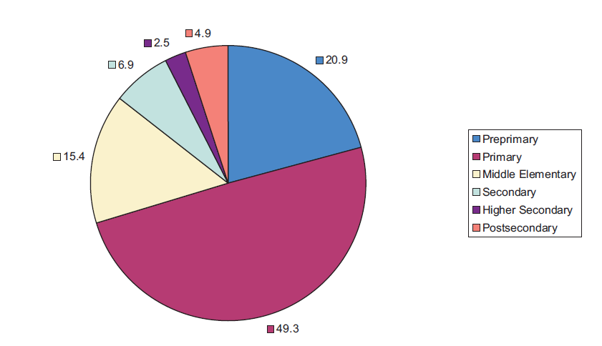
Fig. 3.1
Source: “Pakistan Education Statistics 2005-06”
The graph above shows that Pakistan gives a lot of importance to the primary education sector. Still there is a huge population that is not attending school at all so the primary education needs to be enhanced further. As compared to other countries the amount of students taking admissions at primary level is very less. There should also be help by the government so that students who want to continue their education beyond this stage are able to. There should be growth at the primary as well as higher levels of education. This is good for the well being of the country. In 2005-2006 there were 36 million students in Pakistan’s education system. 49.3% were at the primary level, 20.9% at the preprimary level, 15.4% at the middle elementary, 6.9% at the secondary level, 2.5% at the higher secondary and 4.9% at the postsecondary level. Almost half of the education system is of the primary level. The educational system needs to be enhanced such that more students can be accommodated and it has to be made affordable for the public. More facilities are also to be provided. (Dr. Lynd, 2007).

Net Enrollment Rates by Level of Education and Province, 2006
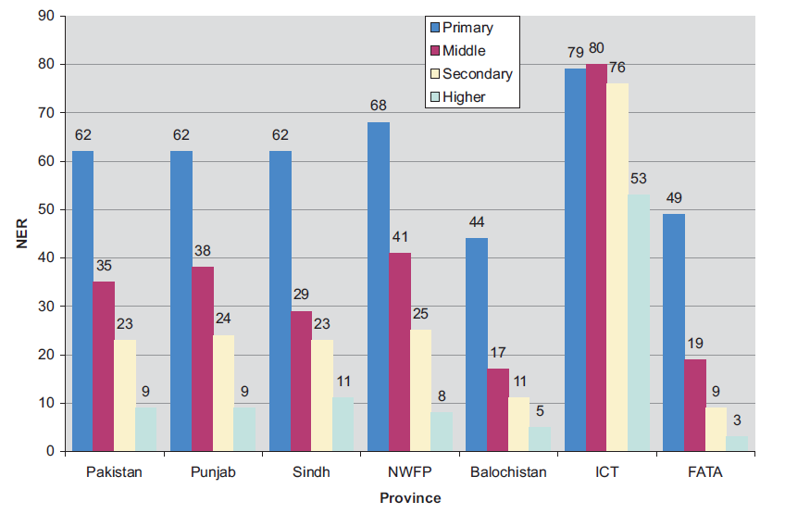
Source: AEPAM, Shami, Butt, Mushtaq, EFA Indicators Draft (NEC 2005-06) p.2.
Figure: 3.2
NER is the number of students at a specific level of education who are of the official age of that level. The Net Enrollment Rate of Pakistan at the primary level is 62% which means that from 2005-2006 62% students from age 5-9 were attending primary school. Primary education in Islamabad which is the capital of Pakistan is 80% and in Baluchistan is 50%. At the middle elementary level 35% of children who were 10-12 years old were studying, at the secondary level 23% of students who were 13-14 years were studying and at higher secondary level 9% students who were 15-16 years old were studying. (Dr. Lynd, 2007).
CHAPTER 4
ORGANIZATIONAL OVERVIEW

4.1 Fazaia Chain of Schools/Colleges
Starting with single barrack-welfare-school back in 60s, today Fazaia Schools and Colleges boast of 24 well established branches. The chain has over 47000 students, 2500 teaching staff and 1100 non-teaching staff supporting these institutions. In the 24 Fazaia Schools, there are 28% NEC (Non Entitled Civilians) students, while the rest of 72% are studying on concessionary rates. The major policy making body of Fazaia schools is its Board of Governors headed by Chief of the Air Staff. The ACAS (Edu) serves as Secretary of the Board.
Fazaia Schools have been providing useful services to the PAF community along with creating goodwill among the local civilian population. Fazaia chain is the biggest welfare project of the Pakistan Air Force, which:
Facilitates the officers’ children education
Has changed the fabric of airmen families by enabling airmen’s children to compete
Has brought job satisfaction to PAF personnel
For maintaining uniformity in the standard of education in all the 24 Fazaia Colleges, the institutions with higher %age of concessional category of students are financially supported by the AHQ.

4.1.1 Fazaia Inter College Islamabad

Located in the premises of PAF Complex, E-9, Islamabad; Fazaia Inter College Islamabad, an English medium institution, is a well reputed college currently serving the children of retired as well as serving PAF personnel as well as Non Entitled Civilians. The college was formerly known as “PAF Inter College Islamabad”. In 2004, a new campus of Fazaia Inter College Islamabad was built with state of the art facilities. It directly comes under the supervision of the education branch of the Pakistan Airforce and is affiliated with Federal Board of Intermediate and Secondary Education. Fazaia College E-9 has a faculty of about 50 teachers and with a student to teacher inter ratio of 1 to 40.

4.1.2 Fazaia Inter College Chaklala
Fazaia Inter College Chaklala is another college in the twin cities, supervised by the education branch of Pakistan Airforce. Prior to 1965, the institution existed as St. Mary School at the airforce base in Chaklala, and was renamed as Fazaia Inter College Chaklala in February, 2004. The institute has a college section and a senior section, both of which offer a wide variety of programmes like Pre-Engineering, Pre-Medical, General Science, Humanities etc. This branch of the Fazaia chain of schools also has state of the art facilities including laboratories, libraries and offers its students a variety of co-curricular and extra-curricular activities.

CHAPTER 5
IDENTIFICATION OF ISSUES
This chapter will highlight the important findings with comprehensive explanation of the frequencies and the correlations results that have been obtained by entering the questionnaire data of both students and teachers into the SPSS tool. The results are shown below.
Frequency Table of Students

Frequency Distribution of the responses with respect to Gender (n=50)
 |  | Frequency | Percent | Valid Percent | Cumulative Percent
Valid | Male | 25 | 50.0 | 50.0 | 50.0
Valid | Female | 25 | 50.0 | 50.0 | 100.0
Valid | Total | 50 | 100.0 | 100.0
Table 5a

Frequency Distribution of the responses with respect to Entitlement (n=50)
 |  | Frequency | Percent | Valid Percent | Cumulative Percent
Valid | Airforce | 25 | 50.0 | 50.0 | 50.0
Valid | Civilian | 25 | 50.0 | 50.0 | 100.0
Valid | Total | 50 | 100.0 | 100.0
Table 5b

5.1 STUDENTS’ QUESNTIONNAIRE ANALYSIS

Q1. I am satisfied with the tuition fee the college charges me.
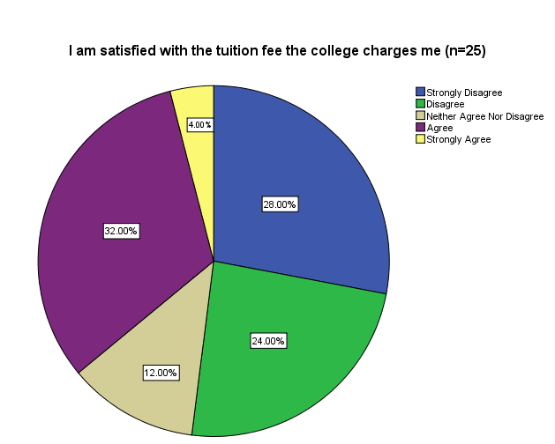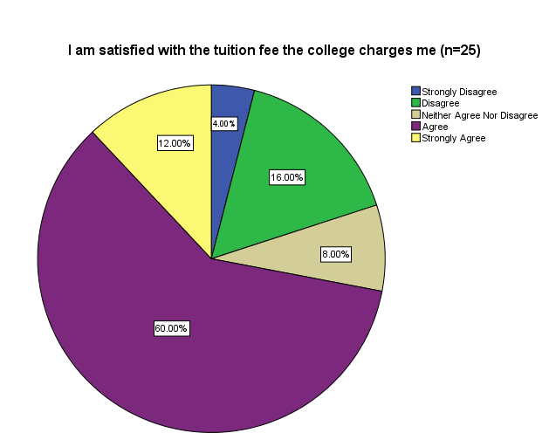
I am satisfied with the tuition fee the college charges me (n=25)
 |  | Frequency | Percent
 | Strongly Disagree | 7 | 28.0
 | Disagree | 6 | 24.0
 | Neither Agree Nor Disagree | 3 | 12.0
 | Agree | 8 | 32.0
 | Strongly Agree | 1 | 4.0
 | Total | 25 | 100.0
 | Table 5.1b
Fig. 5.1a Fig. 5.1b
I am satisfied with the tuition fee the college charges me (n=25)
 |  | Frequency | Percent
 | Strongly Disagree | 1 | 4.0
 | Disagree | 4 | 16.0
 | Neither Agree Nor Disagree | 2 | 8.0
 | Agree | 15 | 60.0
 | Strongly Agree | 3 | 12.0
 | Total | 25 | 100.0
Table 5.1a
Analysis:
A higher proportion of children from civilian families are content with the fees charged to them. They are satisfied with the school amenities. The services provided by Fazaia School are worth to be paid for. They are getting the facilities in accordance with the fees they are paying to the institution - whereas, airmen children benefit by paying less comparatively and gain more. However, children from Airforce families moderately agree with the present fee charges. The reason behind is that a greater percentage of airmen families find it hard to pay even the discounted fee rates, in these tough economic times. They struggle to provide their children with good quality education even when they are battling to make both ends meet at home.
Q2. The tuition fee should be lowered to accommodate the needy.
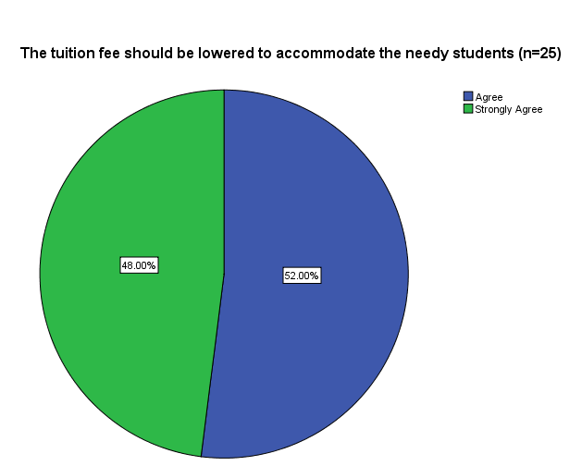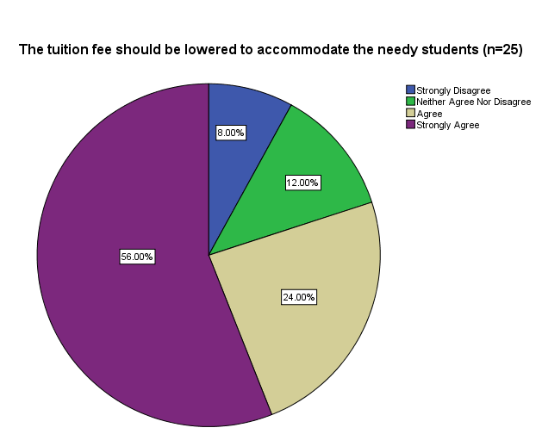

Fig. 5.2a

The tuition fee should be lowered to accommodate the needy students (n=25)
 |  | Frequency | Percent
 | Strongly Disagree | 2 | 8.0
 | Neither Agree Nor Disagree | 3 | 12.0
 | Agree | 6 | 24.0
 | Strongly Agree | 14 | 56.0
 | Total | 25 | 100.0
Fig. 5.2b

The tuition fee should be lowered to accommodate the needy students (n=25)
 |  | Frequency | Percent
 | Agree | 13 | 52.0
 | Strongly Agree | 12 | 48.0
 | Total | 25 | 100.0
Table 5.2a Table 5.2b
Analysis:
A higher proportion of civilian student population strongly supports lowering fees to accommodate children from needy families - showing their concern for the destitute. Equivalently children with Airforce background who are not financially strong wish to pay less than what they are actually paying at present. On the other hand, the school has to harmonize the interests of all school stakeholders. Lowering fee would put a load of expenses on school finances and elevate gap in funding. The school board would have to find a middle way, good for all, searching for alternative options to diverse the funding base, rather than relying on a single source of funding (i.e. school fees) in return burdening the finances.

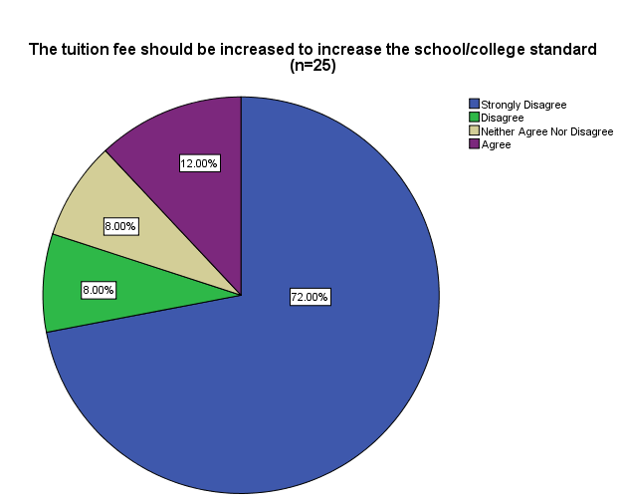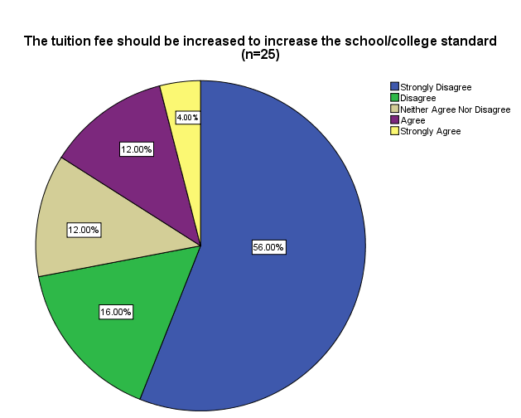Q3. The tuition fee should be increased to increase the school/college standard.
Fig. 5.3a

The tuition fee should be increased to increase the school/college standard (n=25)
 |  | Frequency | Percent
 | Strongly Disagree | 14 | 56.0
 | Disagree | 4 | 16.0
 | Neither Agree Nor Disagree | 3 | 12.0
 | Agree | 3 | 12.0
 | Strongly Agree | 1 | 4.0
 | Total | 25 | 100.0

Fig. 5.3b

The tuition fee should be increased to increase the school/college standard (n=25)
 |  | Frequency | Percent
 | Strongly Disagree | 18 | 72.0
 | Disagree | 2 | 8.0
 | Neither Agree Nor Disagree | 2 | 8.0
 | Agree | 3 | 12.0
 | Total | 25 | 100.0

Table 5.3a Table 5.3b

Analysis:
A significant percentage of students with civilian and air force back ground strongly oppose to, raising school standard by increasing school fee. Increasing school fee would demand a strong cooperation on part of the destitute, which make a larger fraction of Fazaia School student population. Increasing fee would hurt the interests of the needy fragment of Fazaia school network. The opinion sights that school fees should not be the only single source to raise quality of education. The school administration should go for additional funding resources to support school operations and consequently increasing school standard rather than pressurizing the parents who cannot afford expensive school fees, when at the moment they are struggling to pay current fee charges.

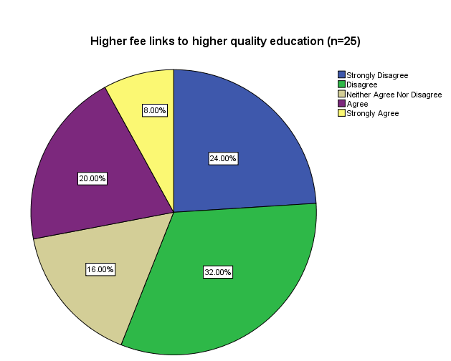Q4. Higher fee links to higher quality education.
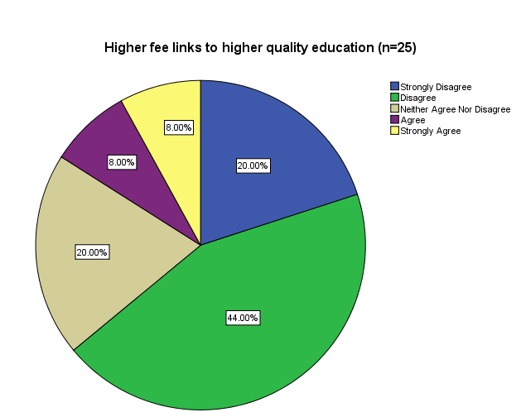
Fig. 5.4a
Higher fee links to higher quality education (n=25)
 |  | Frequency | Percent
 | Strongly Disagree | 5 | 20.0
 | Disagree | 11 | 44.0
 | Neither Agree Nor Disagree | 5 | 20.0
 | Agree | 2 | 8.0
 | Strongly Agree | 2 | 8.0
 | Total | 25 | 100.0
Fig. 5.4b
Higher fee links to higher quality education (n=25)
 |  | Frequency | Percent
 | Strongly Disagree | 6 | 24.0
 | Disagree | 8 | 32.0
 | Neither Agree Nor Disagree | 4 | 16.0
 | Agree | 5 | 20.0
 | Strongly Agree | 2 | 8.0
 | Total | 25 | 100.0
Table 5.4a Table 5.4b
Analysis:
A considerable proportion of Civilian and Airforce students disagree with the point of linking quality with higher fee. Raising school fee would place a huge cost burden on the needy and would hurt the social agenda the Fazaia School Network is working on. The school board should take a step forward by finding other varied means, which would consequently, supplement the finances to fill the gap and raise quality standard of school activities and enhance prospects for the school attempting to nurture responsiveness from the society to the plight of poor and be part of a noble cause; a contribution made by the society which would alleviate the cost burden of parents.

Q5. Tuition fees should be equal for all students
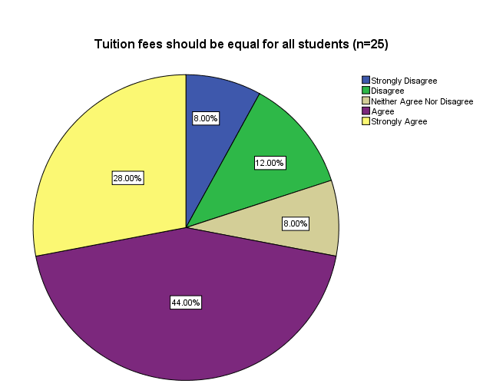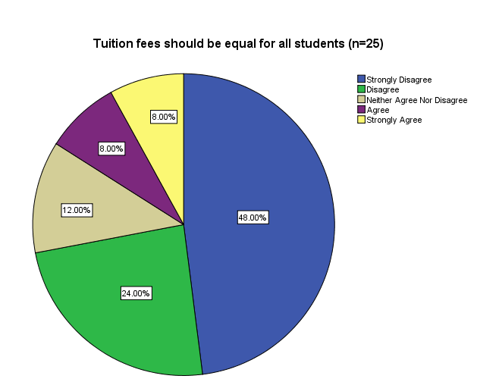
Fig. 5.5b
Fig. 5.5a

Table 5.5a Table 5.5b
Tuition fees should be equal for all students (n=25)
 |  | Frequency | Percent
 | Strongly Disagree | 12 | 48.0
 | Disagree | 6 | 24.0
 | Neither Agree Nor Disagree | 3 | 12.0
 | Agree | 2 | 8.0
 | Strongly Agree | 2 | 8.0
 | Total | 25 | 100.0

Tuition fees should be equal for all students (n=25)
 |  | Frequency | Percent
 | Strongly Disagree | 2 | 8.0
 | Disagree | 3 | 12.0
 | Neither Agree Nor Disagree | 2 | 8.0
 | Agree | 11 | 44.0
 | Strongly Agree | 7 | 28.0
 | Total | 25 | 100.0
Analysis:
A higher proportion of students who come from civilian families agree with the view that tuition fee should be charged equal to all students studying in Fazaia Schools, for the reason that airmen children receive the same level of school services at lower cost. The needy fragment of the school cannot agree with the notion of parity with regard to fee the school charges seeing the wealth status of destitute families. Uniform fee structure on one hand would alleviate the gap in funding and on the contrary, it would make education expensive for the indigent. This step may impair the social agenda Fazaia School Network has undertaken.
Q6. School management is approachable, supportive and sympathetic.
Table 5.6a Table 5.6b
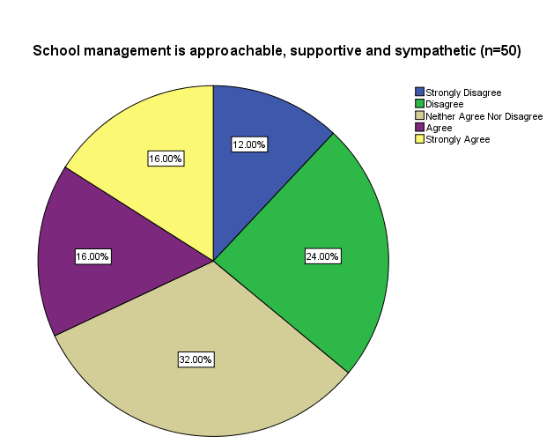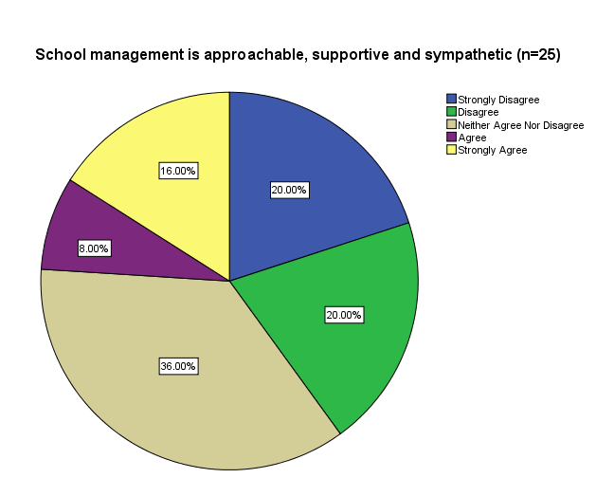
Fig 5.6a Fig 5.6b
School management is approachable, supportive and sympathetic (n=25)
 |  | Frequency | Percent
 | Strongly Disagree | 5 | 20.0
 | Disagree | 5 | 20.0
 | Neither Agree Nor Disagree | 9 | 36.0
 | Agree | 2 | 8.0
 | Strongly Agree | 4 | 16.0
 | Total | 25 | 100.0
School management is approachable, supportive and sympathetic (n=25)
 |  | Frequency | Percent
 | Strongly Disagree | 3 | 12.0
 | Disagree | 6 | 24.0
 | Neither Agree Nor Disagree | 8 | 32.0
 | Agree | 4 | 16.0
 | Strongly Agree | 4 | 16.0
 | Total | 25 | 100.0
Analysis:
A greater student population at Fazaia School is happy with school management behavior. The school promotes an environment that is open to all. Management is available at all times to listen to queries; is supportive; and is perceptive to their concerns. The school management aims to elevate a receptive environment in the school. Fazaia School Network nurtures an environment where everyone is encouraged to raise their concerns and ensures fair dealing without any partiality of background. The school board strives to provide a secure, disciplined and knowledgeable environment for its students.
Q7. My teachers strongly encourage me to attend college.

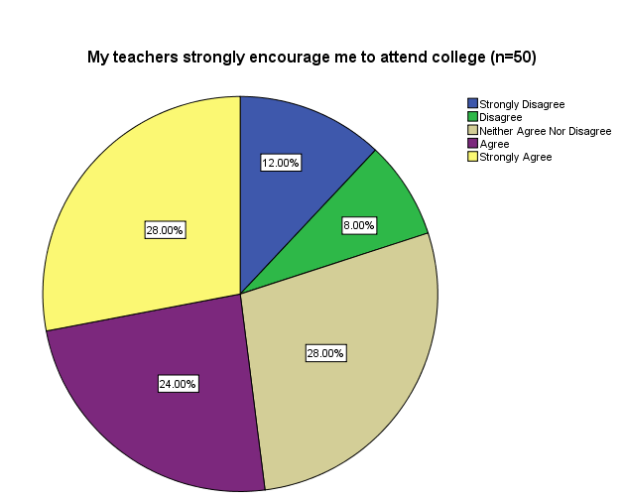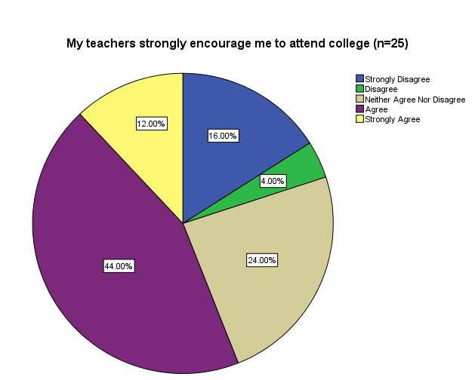
Fig 5.7a Fig 5.7b
My teachers strongly encourage me to attend college (n=25)
 |  | Frequency | Percent
 | Strongly Disagree | 4 | 16.0
 | Disagree | 1 | 4.0
 | Neither Agree Nor Disagree | 6 | 24.0
 | Agree | 11 | 44.0
 | Strongly Agree | 3 | 12.0
 | Total | 25 | 100.0
My teachers strongly encourage me to attend college (n=25)
 |  | Frequency | Percent
 | Strongly Disagree | 3 | 12.0
 | Disagree | 2 | 8.0
 | Neither Agree Nor Disagree | 7 | 28.0
 | Agree | 6 | 24.0
 | Strongly Agree | 7 | 28.0
 | Total | 25 | 100.0

Table 5.7a Table 5.7b
Analysis:
Higher percentage of the civilians as well as the airforce students agreed to the statement that their teachers encourage them in attending college and small a small percentage of them thinks that their teachers do not encourage them in attending college.

Q8. My teachers encourage me to work with the students of low income background.

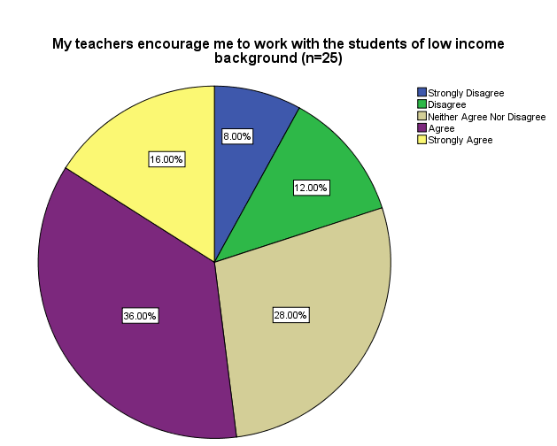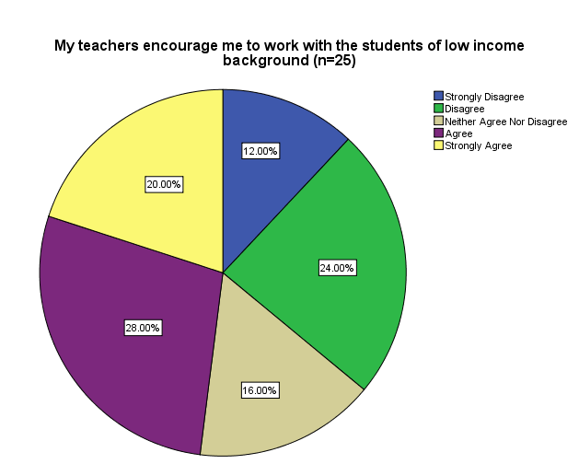
Fig 5.8a Fig 5.8b
My teachers encourage me to work with the students of low income background (n=25)
 |  | Frequency | Percent
 | Strongly Disagree | 3 | 12.0
 | Disagree | 6 | 24.0
 | Neither Agree Nor Disagree | 4 | 16.0
 | Agree | 7 | 28.0
 | Strongly Agree | 5 | 20.0
 | Total | 25 | 100.0
My teachers encourage me to work with the students of low income background (n=25)
 |  | Frequency | Percent
 | Strongly Disagree | 2 | 8.0
 | Disagree | 3 | 12.0
 | Neither Agree Nor Disagree | 7 | 28.0
 | Agree | 9 | 36.0
 | Strongly Agree | 4 | 16.0
 | Total | 25 | 100.0

Table 5.8a Table 5.8b

Analysis:
Most of the civilians and Airforce students agree with the fact that their teachers motivate them in working with the students who belong to financially low income background and create such environment and opportunities where the students get mixed up with the other students without getting involved in the class-difference.

The caliber of the students is suitable for their class levels and they can cope up with the academic burden (n=25)
 |  | Frequency | Percent
 | Strongly Disagree | 6 | 24.0
 | Disagree | 8 | 32.0
 | Neither Agree Nor Disagree | 3 | 12.0
 | Agree | 6 | 24.0
 | Strongly Agree | 2 | 8.0
 | Total | 25 | 100.0
Q9. The caliber of the students is suitable for their class levels and they can cope up with the academic burden.
The caliber of the students is suitable for their class levels and they can cope up with the academic burden (n=25)
 |  | Frequency | Percent
 | Strongly Disagree | 4 | 16.0
 | Disagree | 9 | 36.0
 | Neither Agree Nor Disagree | 8 | 32.0
 | Agree | 4 | 16.0
 | Total | 25 | 100.0
Table 5.9a Table 5.9b
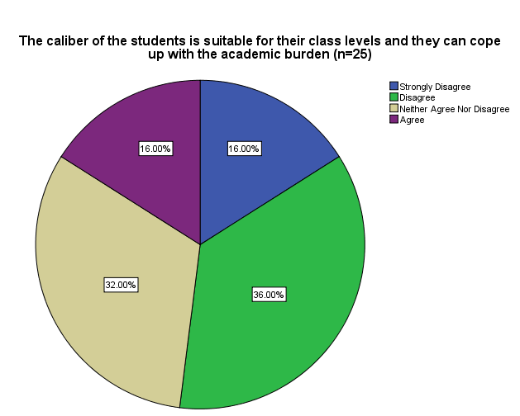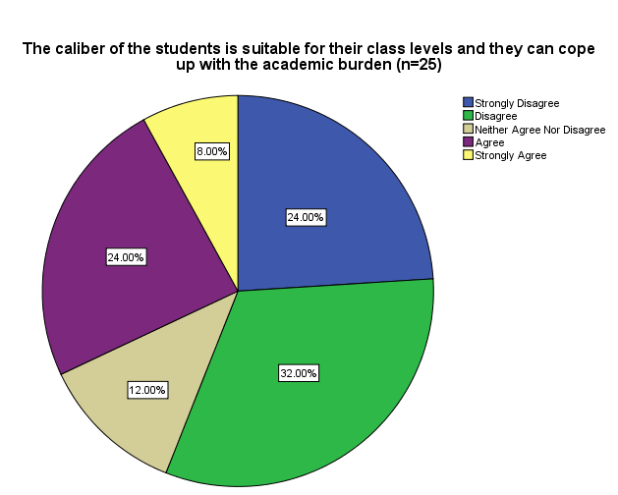
Analysis:
Most of the civilian as well as the Airforce students think that the academic load is much more than their capacity to learn and they feel it becomes difficult to deal with the burden of studies that is carried on their shoulders.

Fig 5.9a Fig 5.9b
Q10. Socio–economic diversity in the academic institutions/schools is in favor of students and should prevail in the classrooms and schools.

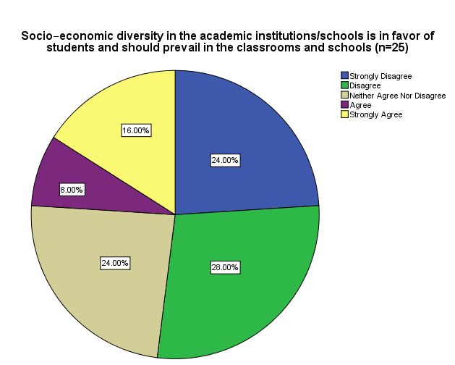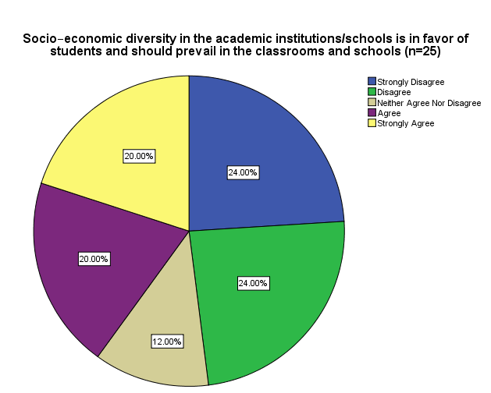
Fig 5.10a Fig 5.10b
Table 5.10a Table 5.10b

Socio–economic diversity in the academic institutions/schools is in favor of students and should prevail in the classrooms and schools (n=25)
 |  | Frequency | Percent
 | Strongly Disagree | 6 | 24.0
 | Disagree | 7 | 28.0
 | Neither Agree Nor Disagree | 6 | 24.0
 | Agree | 2 | 8.0
 | Strongly Agree | 4 | 16.0
 | Total | 25 | 100.0
Socio–economic diversity in the academic institutions/schools is in favor of students and should prevail in the classrooms and schools (n=25)
 |  | Frequency | Percent
 | Strongly Disagree | 6 | 24.0
 | Disagree | 6 | 24.0
 | Neither Agree Nor Disagree | 3 | 12.0
 | Agree | 5 | 20.0
 | Strongly Agree | 5 | 20.0
 | Total | 25 | 100.0
Analysis:
Civilian students are having contradictory opinion over this statement and they are not in favor of having students from multiple backgrounds in their classrooms while on the contrary there is slight difference between the percentage of the students who are in favor and are against this statement so they probably have less issues with having diverse background students in their class.

Q11. My teachers treat all the students the same way.
My teachers treat all the students the same way (n=25)
 |  | Frequency | Percent
 | Strongly Disagree | 7 | 28.0
 | Disagree | 9 | 36.0
 | Neither Agree Nor Disagree | 3 | 12.0
 | Agree | 3 | 12.0
 | Strongly Agree | 3 | 12.0
 | Total | 25 | 100.0
My teachers treat all the students the same way (n=25)
 |  | Frequency | Percent
 | Strongly Disagree | 9 | 36.0
 | Disagree | 5 | 20.0
 | Neither Agree Nor Disagree | 3 | 12.0
 | Agree | 3 | 12.0
 | Strongly Agree | 5 | 20.0
 | Total | 25 | 100.0
Table 5.11a Table 5.11b
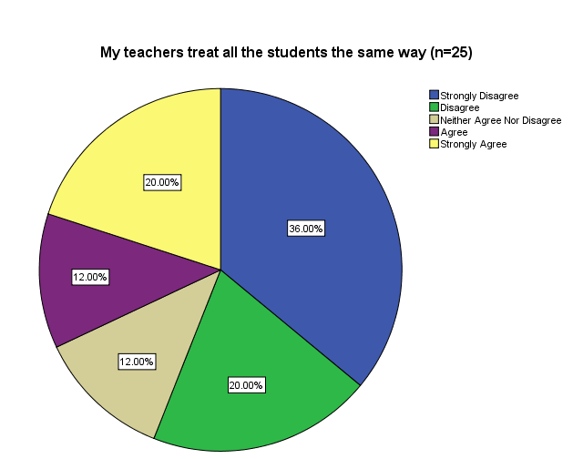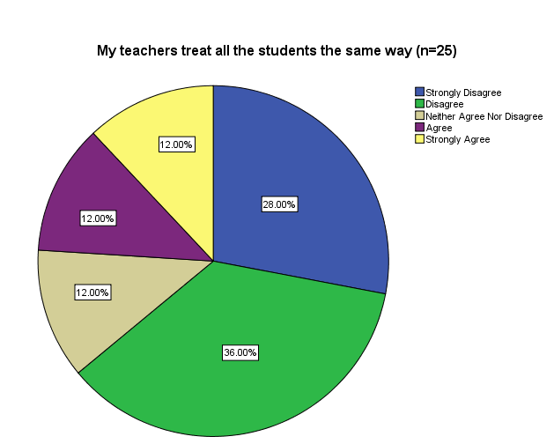
Fig 5.11a Fig 5.11b
Analysis:
Larger proportion of Civilian and Airforce students think that they are not treated equally in their classes. Their teachers might have personal biasness with them on the basis of socio–economic background, gender, confidence and on the learning capacity every student has in class.

Difference in the background of the students affects their studies in the school/college (n=25)
 |  | Frequency | Percent
 | Strongly Disagree | 3 | 12.0
 | Disagree | 4 | 16.0
 | Neither Agree Nor Disagree | 4 | 16.0
 | Agree | 4 | 16.0
 | Strongly Agree | 10 | 40.0
 | Total | 25 | 100.0
Difference in the background of the students affects their studies in school / college (n=25)
 |  | Frequency | Percent
 | Strongly Disagree | 5 | 20.0
 | Disagree | 3 | 12.0
 | Neither Agree Nor Disagree | 5 | 20.0
 | Agree | 7 | 28.0
 | Strongly Agree | 5 | 20.0
 | Total | 25 | 100.0
Q12. Difference in the background of the students affects their studies in the school/college.
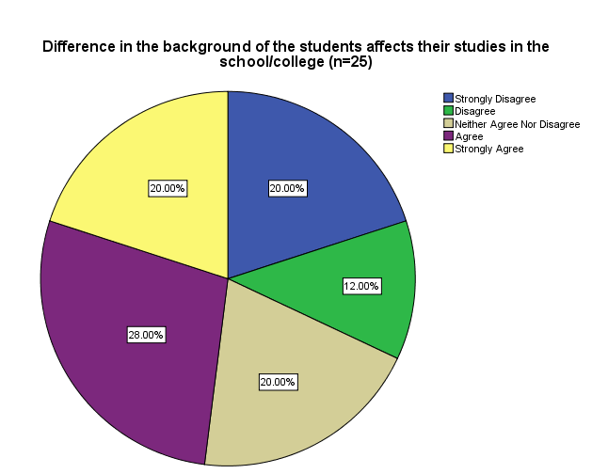
Table 5.12a Table 5.12b
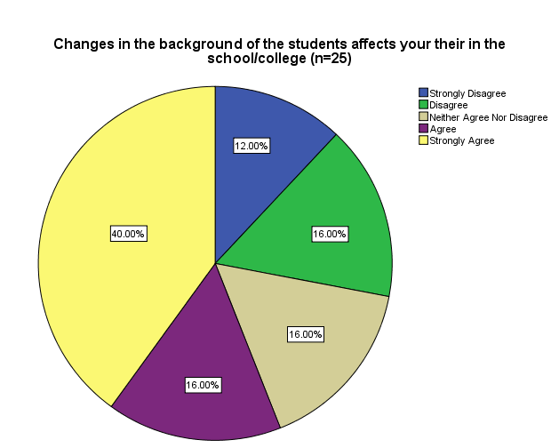
Fig 5.12a Fig 5.12b
Analysis:
Most of the Civilian and Airforce students agree with the statement that the class differences and diverse financial background affect the studies of the students in a negative way.

5.2 TEACHERS’ QUESNTIONNAIRE ANALYSIS

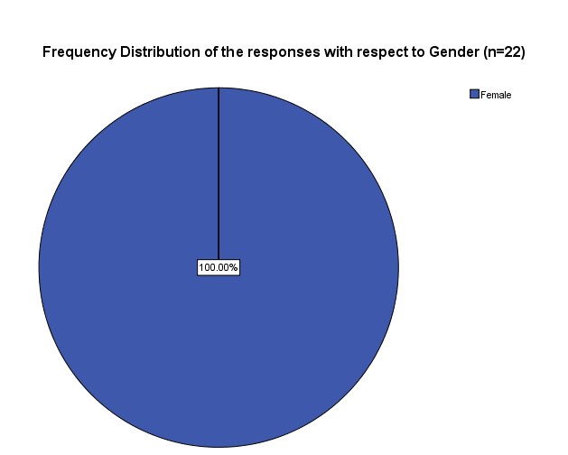

Frequency Distribution of the responses with respect to Gender (n=22)
 |  | Frequency | Percent | Valid Percent | Cumulative Percent
 | Female | 22 | 100.0 | 100.0 | 100.0

Table 5.13 Fig 5.13
Analysis:
This clearly shows that the questionnaire that was distributed by us in Fazaia school/college of Islamabad and Chaklala has been filled by all the female teachers.
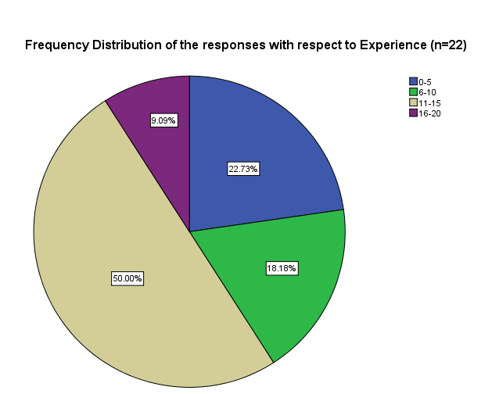
Frequency Distribution of the responses with respect to Experience (n=22)
 |  | Frequency | Percent
 | 0-5yr | 5 | 22.7
 | 6-10yr | 4 | 18.2
 | 11-15yr | 11 | 50.0
 | 16-20yr | 2 | 9.1
 | Total | 22 | 100.0

Table 5.14 Fig 5.14
Analysis:
Total 22 questionnaires were distributed among the teachers, 11 in each branch. The teachers that filled out our questionnaires were mostly experienced. Majority had an experience of 11-15 years. Only 22.7% of teachers had an experience of less than 5 years which shows the validity of our result.
Q1. My Performance Appraisal is conducted (n=22)
 |  | Frequency | Percent
 | Annually | 21 | 95.5
 | Monthly | 1 | 4.5
 | Total | 22 | 100.0
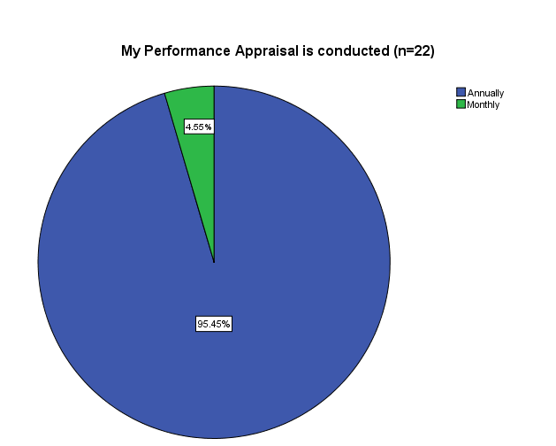

Table 5.15 Fig 5.15
Analysis:
95% of teachers said that their performance appraisal is conducted annually which should not be the case. For the performance management system to be successful the performance appraisal should be conducted quite often. Conducting performance appraisal of teachers annually is not enough to improve the performance.

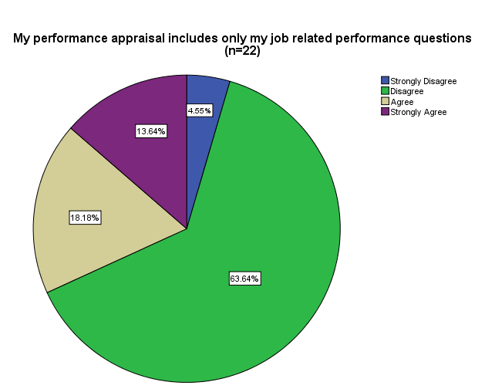Q2. My performance appraisal includes only my job related performance questions.
 |  | Frequency | Percent
 | Strongly Disagree | 1 | 4.5
 | Disagree | 14 | 63.6
 | Agree | 4 | 18.2
 | Strongly Agree | 3 | 13.6
 | Total | 22 | 100.0

Table 5.16
Analysis: Fig 5.16
68% teachers disagreed that their performance appraisal system includes job related questions. This shows that majority of the teachers do not agree with the performance appraisal system of Fazaia school/college. The performance appraisal system should be made with the agreement of the teachers so that they are satisfied with their evaluation otherwise the purpose for which the performance management system is conducted will not be achieved.
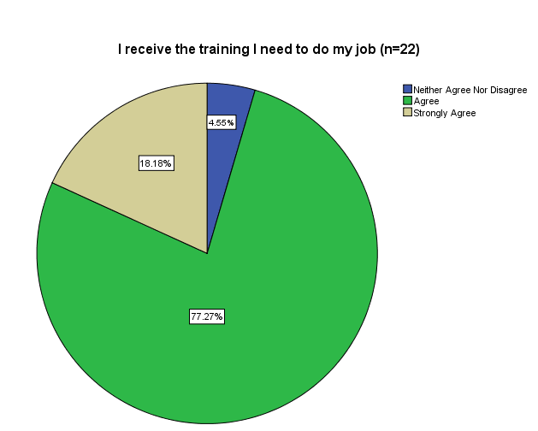Q3. I receive the training I need to do my job.
 |  | Frequency | Percent
 | Neither Agree Nor Disagree | 1 | 4.5
 | Agree | 17 | 77.3
 | Strongly Agree | 4 | 18.2
 | Total | 22 | 100.0

Table 5.17
Analysis: Fig 5.17
77% teachers agree that they get training. This shows that Fazaia Schools consider their teachers as an important asset and are investing in their teachers in order to improve their skills and performance. This is very much important in today’s competitive environment.

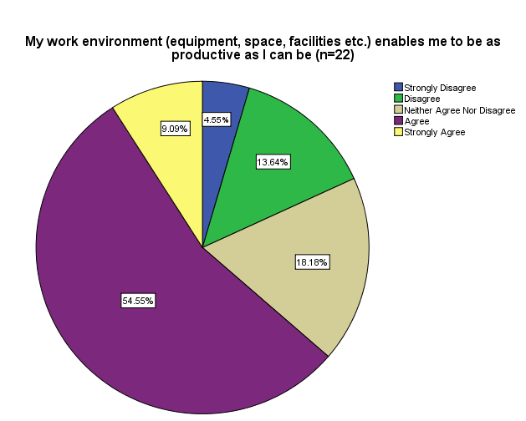Q4. My work environment (equipment, space, facilities etc.) enables me to be as productive as I can be.
 |  | Frequency | Percent
 | Strongly Disagree | 1 | 4.5
 | Disagree | 3 | 13.6
 | Neither Agree Nor Disagree | 4 | 18.2
 | Agree | 12 | 54.5
 | Strongly Agree | 2 | 9.1
 | Total | 22 | 100.0

Table 5.18 Fig 5.18
Analysis:
A large number of teachers agreed to the fact that their work environment enables them to be productive. Schools performance depends highly on the performance of teachers. The resources should be readily available. Work environment makes a huge difference in the performance of teachers. It also acts as an internal motivator.

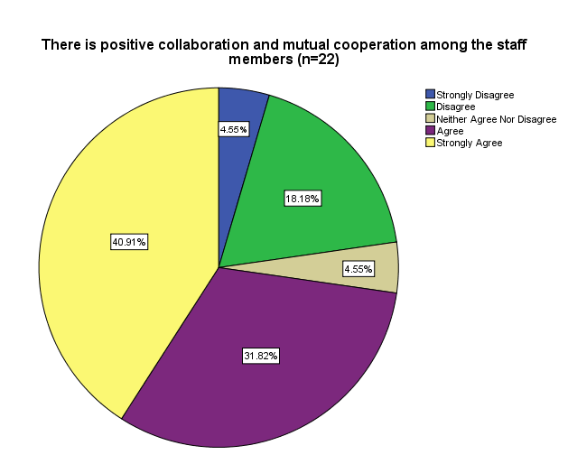Q5. There is positive collaboration and mutual cooperation among the staff members.
 |  | Frequency | Percent
 | Strongly Disagree | 1 | 4.5
 | Disagree | 4 | 18.2
 | Neither Agree Nor Disagree | 1 | 4.5
 | Agree | 7 | 31.8
 | Strongly Agree | 9 | 40.9
 | Total | 22 | 100.0
Table 5.19
Analysis: Fig 5.19
40.91% teachers strongly agree and 31.82% agree that there is positive collaboration among the staff members. This shows that the work environment is friendly and the culture of mutual cooperation is being followed in Fazaia Schools. This can prove very good for the schools since the environment of Fazaia Schools is very productive.
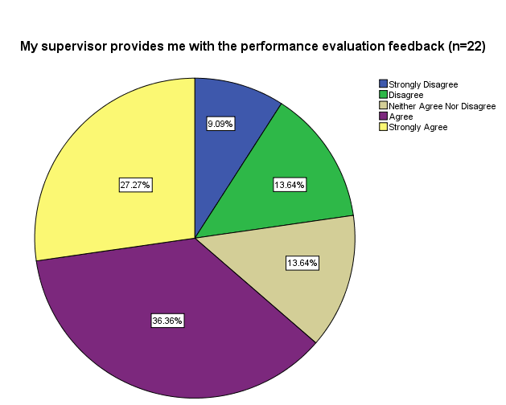
Q6. My supervisor provides me with the performance evaluation feedback.
 |  | Frequency | Percent
 | Strongly Disagree | 2 | 9.1
 | Disagree | 3 | 13.6
 | Neither Agree Nor Disagree | 3 | 13.6
 | Agree | 8 | 36.4
 | Strongly Agree | 6 | 27.3
 | Total | 22 | 100.0
Table 5.20 Fig 5.20

Analysis:
In the performance management system, giving feedback is the most important step. Majority of the employees agree that feedback is given but still there is a small percentage of teachers who do not agree. 22% of teachers are not satisfied with the feedback that is given to them which should not be the case because the feedback given should help the teachers realize where they are lagging and a proper developmental plan should be made.

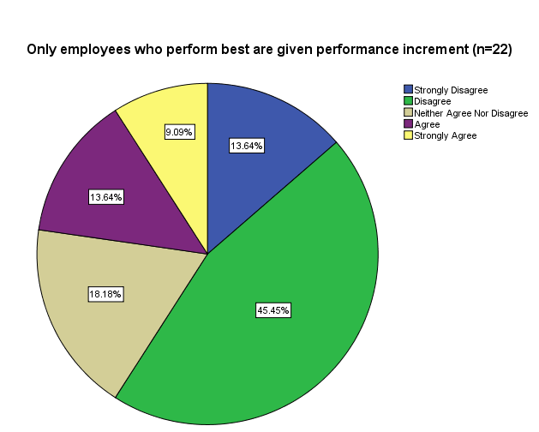Q7. Only employees who perform best are given performance increment.
 |  | Frequency | Percent
 | Strongly Disagree | 3 | 13.6
 | Disagree | 10 | 45.5
 | Neither Agree Nor Disagree | 4 | 18.2
 | Agree | 3 | 13.6
 | Strongly Agree | 2 | 9.1
 | Total | 22 | 100.0

Table 5.21 Fig 5.21

Analysis:
59% of the employees disagree that the best employees are given performance increment. This shows that a proper compensation plan is not being followed by Fazaia Schools/colleges. Teachers should be paid according to their performance and merit pay plans should be made. Only by paying teachers with respect to performance the best employees will be satisfied and retained.

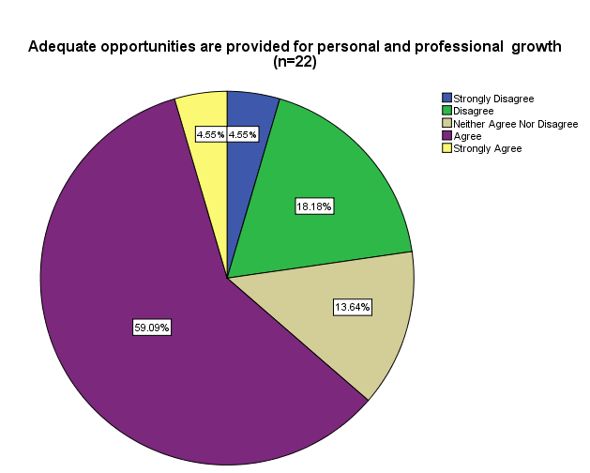Q8. Adequate opportunities are provided for personal and professional growth.
 |  | Frequency | Percent
 | Strongly Disagree | 1 | 4.5
 | Disagree | 4 | 18.2
 | Neither Agree Nor Disagree | 3 | 13.6
 | Agree | 13 | 59.1
 | Strongly Agree | 1 | 4.5
 | Total | 22 | 100.0

Table 5.22 Fig 5.22

Analysis:
Majority of the employees agree that opportunities are provided for personal and professional growth but still there are employees who do not agree to this statement. The growth opportunities should be available for everyone and training and developmental plans should be made implemented.

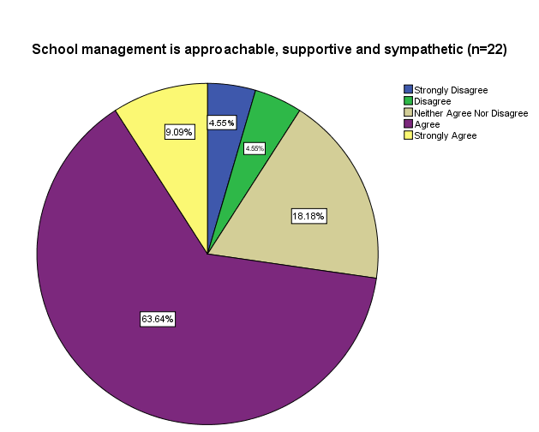Q9. School management is approachable, supportive and sympathetic.
 |  | Frequency | Percent
 | Strongly Disagree | 1 | 4.5
 | Disagree | 1 | 4.5
 | Neither Agree Nor Disagree | 4 | 18.2
 | Agree | 14 | 63.6
 | Strongly Agree | 2 | 9.1
 | Total | 22 | 100.0

Table 5.23 Fig 5.23

Analysis:

63.64% employees agreed and 9.09% employees strongly agreed that the management of both the schools is supportive. School management should be helpful in such a way that the teachers are able to confide in them whenever there is a problem. There might be some difficulties faced by the teachers due to which they are not able to give their utmost performance. This should be shared by the management so that the barriers can be removed.

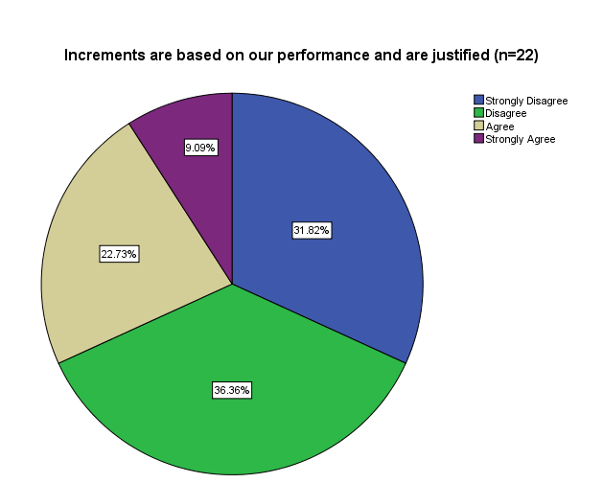Q10. Increments are based on performance and are justified.
 |  | Frequency | Percent
 | Strongly Disagree | 7 | 31.8
 | Disagree | 8 | 36.4
 | Agree | 5 | 22.7
 | Strongly Agree | 2 | 9.1
 | Total | 22 | 100.0

Table 5.24 Fig 5.24

Analysis:
For the performance management system to be a success it is necessary that the increments given are based on performance. 31.82% of the teachers strongly disagreed and 36.36% teachers disagreed that increments are given on basis of their performance. This shows that the compensation plan of teachers in Fazaia School/college is not proper. If increments are not given on basis of performance then the employees will not be motivated to perform well. Merit pay plans should be made and standard schedules of pay should not be followed. This will increase the overall performance of the teachers and will help achieving the goals of Fazaia schools/colleges.

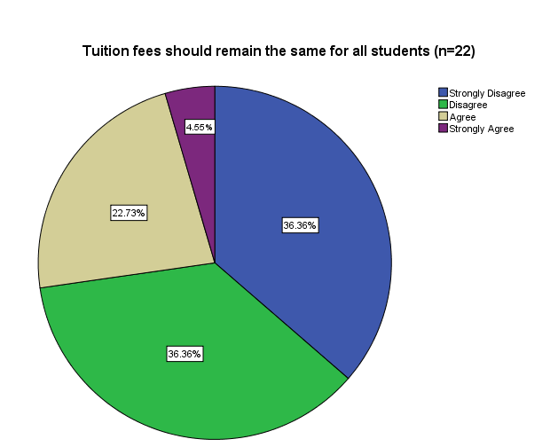Q11. Tuition fees should remain the same for all students.

 |  | Frequency | Percent
 | Strongly Disagree | 8 | 36.4
 | Disagree | 8 | 36.4
 | Agree | 5 | 22.7
 | Strongly Agree | 1 | 4.5
 | Total | 22 | 100.0

Table 5.25 Fig 5.25
Analysis:
Since there is a multiple pricing system in Fazaia schools/colleges, we took the teachers point of view regarding this issue. Majority of the employees disagreed that the tuition fee should be same for all the students. Since 73% teachers disagreed it shows that they are deeply against it and believe that students coming from wealthy families should pay more even if the facilities provided to them and the underprivileged students are the same.

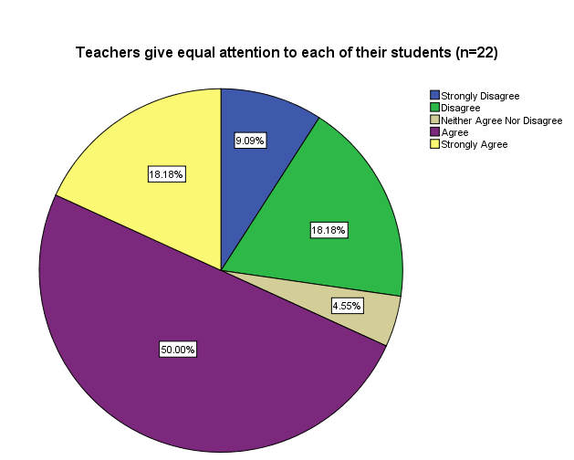Q12. Teachers give equal attention to each of their students.
 |  | Frequency | Percent
 | Strongly Disagree | 2 | 9.1
 | Disagree | 4 | 18.2
 | Neither Agree Nor Disagree | 1 | 4.5
 | Agree | 11 | 50.0
 | Strongly Agree | 4 | 18.2
 | Total | 22 | 100.0

Table 5.26 Fig 5.26
Analysis:
68% teachers agree that equal attention is given to the students by them. Students want to be treated equally regardless of their background. There is a socio economic difference present among the students which makes an imbalance in the knowledge that the students already have. The educational background to which the students belong is quite different from one another. Such a situation becomes difficult to be handled by the teachers but they try their best and treat their students equally.

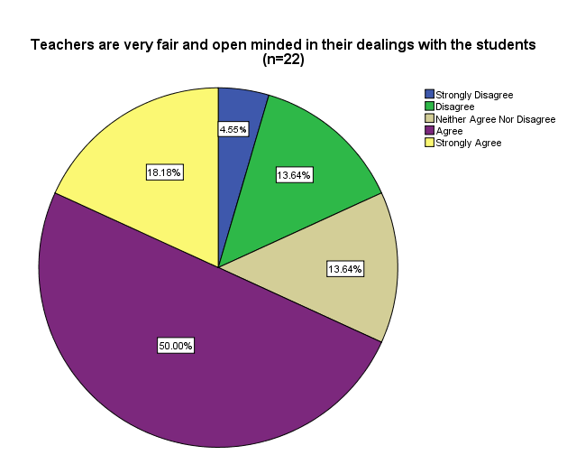Q13. Teachers are very fair and open minded in their dealings with the students.
 |  | Frequency | Percent
 | Strongly Disagree | 1 | 4.5
 | Disagree | 3 | 13.6
 | Neither Agree Nor Disagree | 3 | 13.6
 | Agree | 11 | 50.0
 | Strongly Agree | 4 | 18.2
 | Total | 22 | 100.0

Table 5.27 Fig 5.27

Analysis:
A situation where a socio-economic difference exists, treating all the students equally is the key. Students from the low economic background should not be overlooked because this can create discontent among the students. Most of the teachers of Fazaia school/college are fair and open minded in dealing with the students. No favorism and biasness is done with respect to the economic background that a student belongs to.

Q14. Monetary benefits are adequate in accordance with the work load.

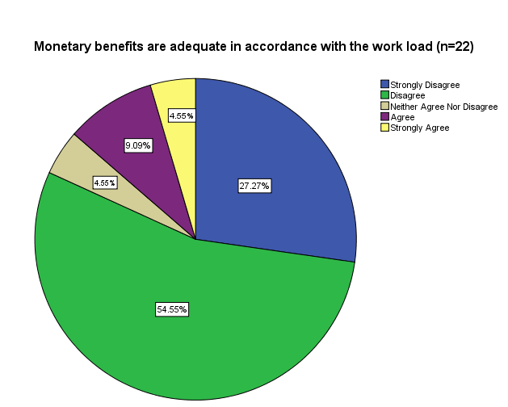
 |  | Frequency | Percent
 | Strongly Disagree | 6 | 27.3
 | Disagree | 12 | 54.5
 | Neither Agree Nor Disagree | 1 | 4.5
 | Agree | 2 | 9.1
 | Strongly Agree | 1 | 4.5
 | Total | 22 | 100.0

Table 5.28 Fig 5.28

Analysis:

27.27% teachers strongly disagreed and 54.55% teachers disagreed that the monetary benefits are adequate with respect to the work load given. The monetary benefits include the housing allowance; travelling allowance etc. These benefits are given to the employees in order to motivate them to perform well. However the monetary benefits that are given to the teachers of Fazaia school/college are not satisfactory so the benefits given no longer help to retain and attract the qualified teachers.

5.3 CORRELATION ANALYSIS (STUDENTS)
Correlations
 |  | The tuition fee should be lowered to accommodate the needy students (n=50) | The tuition fee should be increased to increase the school/college standard (n=50)
The tuition fee should be lowered to accommodate the needy students (n=50) | Pearson Correlation | 1 | -.360*
 | Sig. (2-tailed) |  | .010
 | N | 50 | 50
The tuition fee should be increased to increase the school/college standard (n=50) | Pearson Correlation | -.360* | 1
 | Sig. (2-tailed) | .010
 | N | 50 | 50
*. Correlation is significant at the 0.05 level (2-tailed).
Table 5.29
Analysis:
The correlation depicts a moderate negative relation between the two, for the reason that Fazaia School is working on a social agenda, so raising tuition fee is out of question. Increasing school fee would impair the ability of indigent to get their children educated. They struggle to provide their children with good quality education even when they are battling to make both ends meet at home. Consequently lowering fee would put a load of expenses on school finances and elevate gap in funding. A mere solution is to search for alternatives, to support school finances from deteriorating. The additional resources would in effect supplement the finances by filling up the gap, raise quality standard, and enhance prospects for the school. Attempting to nurture responsiveness to the plight of poor and share in alleviating the cost burden which at the moment is lifted by parents alone. Alternative choices may include partnering with other business, volunteer workers, arranging events to raise money and so on.

Correlations
 |  | Socio–economic diversity in the academic institutions/schools is in favor of students and should prevail in the classrooms and schools (n=50) | Changes in the background of the students affect your studies in the school/college (n=50)
Socio–economic diversity in the academic institutions/schools is in favor of students and should prevail in the classrooms and schools (n=50) | Pearson Correlation | 1 | -.417**
 | Sig. (2-tailed) |  | .003
 | N | 50 | 50
Changes in the background of the students affect your studies in the school/college (n=50) | Pearson Correlation | -.417** | 1
 | Sig. (2-tailed) | .003
 | N | 50 | 50
**. Correlation is significant at the 0.01 level (2-tailed).

Table 5.30
Analysis:
There is negative/inverse correlation between both the statements because if there are students with diverse backgrounds in the classrooms, the students would lack interest in their studies, as there would be a significant gap between the statuses of both the kinds of students. It also affects the learning capacity of the students in the class. The correlation does not indicate that there should be no diversity at all in the classrooms but instead, the teachers should be trained in such a way that they deal with both level of students the same way and make them interact among themselves as much as possible.

Correlations
 |  | The tuition fee should be increased to increase the school/college standard (n=50) | Higher fee links to higher quality education (n=50)
The tuition fee should be increased to increase the school/college standard (n=50) | Pearson Correlation | 1 | .412**
 | Sig. (2-tailed) |  | .003
 | N | 50 | 50
Higher fee links to higher quality education (n=50) | Pearson Correlation | .412** | 1
Higher fee links to higher quality education (n=50) | Sig. (2-tailed) | .003
Higher fee links to higher quality education (n=50) | N | 50 | 50

Table 5.31
Analysis
There is positive correlation between the two since it is a fact that if tuition fee is boosted up it would lead to increased facilities and better infrastructure in the institution with highly professional and skilled teachers available to instill their valuable knowledge into the minds of the students. Hence, the perception is, that is also clear with the above correlation table, that higher fees may lead to upgraded standard and quality of the education in the school/college.

5.4 CORRELATION ANALYSIS (TEACHERS)

Correlations
 |  | My performance appraisal includes only my job related performance questions (n=22) | I receive the training I need to do my job (n=22)
My performance appraisal includes only my job related performance questions (n=22) | Pearson Correlation | 1 | .559**
 | Sig. (2-tailed) |  | .007
 | N | 22 | 22
I receive the training I need to do my job (n=22) | Pearson Correlation | .559** | 1
I receive the training I need to do my job (n=22) | Sig. (2-tailed) | .007
I receive the training I need to do my job (n=22) | N | 22 | 22
**. Correlation is significant at the 0.01 level (2-tailed).
Table 5.32
Analysis:
A strong correlation exists between job related performance appraisal and the training that the teachers receive. In Fazaia school/college most of the teachers do not agree that their performance appraisal is with respect to their job characteristics but most of the teachers do agree that they receive training. This clearly shows that the training they receive is not adequate. More the performance appraisal system is related to their job, more adequate training will the teachers receive.

Correlations

 |  | My work environment (equipment, space, facilities etc.) enables me to be as productive as I can be (n=22) | There is positive collaboration and mutual cooperation among the staff members (n=22)
My work environment (equipment, space, facilities etc.) enables me to be as productive as I can be (n=22) | Pearson Correlation | 1 | .788**
 | Sig. (2-tailed) |  | .000
 | N | 22 | 22
There is positive collaboration and mutual cooperation among the staff members (n=22) | Pearson Correlation | .788** | 1
 | Sig. (2-tailed) | .000
 | N | 22 | 22
**. Correlation is significant at the 0.01 level (2-tailed).

Table 5.33
Analysis:

A strong positive correlation exists between a productive work environment and mutual cooperation among the staff members. When the work environment (equipment, space, facilities) will be good then the teachers will be more motivated to help each other. Also when there is mutual cooperation and positive collaboration among the teachers then the sharing of ideas will be more. This will in turn create synergy. There will also be more creativity and innovativeness. As a result a productive work environment will be created.

Correlations

 |  | My supervisor provides me with the performance evaluation feedback (n=22) | Increments are based on our performance and are justified (n=22)
My supervisor provides me with the performance evaluation feedback (n=22) | Pearson Correlation | 1 | .568**
 | Sig. (2-tailed) |  | .006
 | N | 22 | 22
Increments are based on our performance and are justified (n=22) | Pearson Correlation | .568** | 1
 | Sig. (2-tailed) | .006
 | N | 22 | 22
**. Correlation is significant at the 0.01 level (2-tailed).
Table 5.34
Analysis:

Giving Feedback is an ongoing process and it should be provided to the employees often. Trust can be built by the supervisor by communicating well with the employees. Most of the teachers in Fazaia school/college do agree that feedback is given to them but 68% teachers disagreed that increments that are given to them are based on their performance and are justified which means that the feedback that is given to them is improper. An appropriate performance evaluation feedback needs to be given to the employees which makes them believe that the increments given to them are justified and related to their performance. A performance related pay system should be adopted which will improve the overall performance of Fazaia school/college.

Correlations

 |  | Teachers give equal attention to each of their students (n=22) | Teachers are very fair and open minded in their dealings with the students (n=22)
Teachers give equal attention to each of their students (n=22) | Pearson Correlation | 1 | .724**
 | Sig. (2-tailed) |  | .000
 | N | 22 | 22
Teachers are very fair and open minded in their dealings with the students (n=22) | Pearson Correlation | .724** | 1
 | Sig. (2-tailed) | .000
 | N | 22 | 22
**. Correlation is significant at the 0.01 level (2-tailed).
Table 5.35
Analysis:
When the teachers will give equal attention to their students then they will be considered as fair and open minded in their dealings with them. A strong and positive correlation of .724 exists between the two. A socio economic difference exists among the students in Fazaia school/college and so teachers need to handle the situation accordingly. They should not give preference to specific students because this will in turn reduce the performance of rest of the students. Equal attention should be given to everyone and specific strategies need to be followed by the teachers to handle the socio economic difference that exists among the students of Fazaia school/college.

5.5 INTERVIEW ANALYSIS
Our interview sitting with the school administrators focused on an analogous series of financial matters concerning the Fazaia School. Purpose of the interview was to look into and analyze a range of funding related queries. The questions press on the most central issues faced by the school at the moment; the varied sources of funding the school relies on to support school activities and the steadiness of incoming funding; flexibility and equity in the school finance system; and the adequate level of funding requisite for the school.
Being a socially driven institute, Fazaia School Network also has costs associated with it. Currently Fazaia School board is facing a grave challenge to meet the funding requirements of the school. The school caters to a diverse set of student population, out of which a higher proportion of children belong from financially weak families. Consequently, the school devised a disproportionate fee structure to accommodate students from destitute families, providing them with an equal opportunity platform. School fees as the only source of financing for the school coupled with asymmetrical fee charges, the chain built up a gap in school financing. The school is loaded with huge expenses in relation to earnings. A major fraction of school financing constitutes staff expenditure. The cost outlays include teacher salaries, training cost and staff bonuses. However there are supplementary expenses that school incurs, which consist of the administrative expenses, maintenance cost, extension of existing facilities and opening out newer amenities at the school.
The school administration meets from time to time to determine an adequate level of funding requirement for the Fazaia school network. Trimming down the gap in funding arising from the socio economic diversity prevalent in the school, entails the need to work-out a plan to assure a stable and an adequate funding level to support school activities. Fazaia School management team forms a rational measure of financing needed to accomplish the objectives set, along harmonizing the varied concerns of the school stakeholders. The team meets up once in a while to revise the analysis. The board of governors of Fazaia School strives to work on a focused strategic direction for the school, for short term and long term to ensure stability of funding resources for the school operations; to cover the funding gap by generating a sum sufficient enough to ensure ample education for all. Deciding on a particular initiative is influenced by the magnitude of funding gap and by determining, to what extent, the desired program assists in promoting betterment in the school financial system. The larger the funding gap, poorly funded facilities and high turnover of qualified faculty in turn leads to lesser satisfaction. Not letting the circumstances to aggravate the school board is making every step possible to cope with staff turnover issues, teachers receive training from time to time , make up for the low salaries and keep the parents satisfied, so that they don’t turn over to other institutions.
The decision making power and the dispersion of finances to Fazaia School network across the districts rest with Fazaia School board of governors. The individual school districts do not carry flexibility in spending the finances with discretion and/or establishing their own personalized set of standards. Uniform standards are set and are followed by all school districts. To ensure that standards are met, the school board members have set accountability measures. It assures fair funding and is doing its utmost in not letting the situation proliferate. Fazaia Schools’ financial structure is unbiased in the dispersion of funds across school districts. Each school district goes through an assessment process, to make sure that funds are being used with prudence.
Fazaia school network pursues an annual budgeting plan. Determining a budget entails a meticulous approach and expert’s verdict whether be internal i.e. board members or from an external source. Budget planning demands a strong support from top management, administration, staff and children parents. School budget constitutes a number of expenditures incurred during a school year. It includes staff salaries, maintenance and administrative cost and other basic school amenities. Each year the school budget is revised as requisites change. Requisites change with changing demands of the surrounding environment. Fazaia School faces a tight budget plan for the reason that they cater to a higher proportion of children from destitute families while on the other hand, the school enjoys the benefits of being recognized on the social agenda.
Fazaia School Board of Governors has laid down future priorities for improvement in the following spots: staff, syllabus, and school infrastructure and performance assessment mechanism. Fazaia school board has taken measures to support the school primary concerns. The school has established a training institute for enhancing the proficiency level of its staff; ensures an adequate level of funding to support school operations and retain qualified teaching staff by paying them well so that they do not turn over to other institutions; and providing a conducive learning atmosphere to the children. These initiatives would enhance the performance of Fazaia school network.

CHAPTER 6
POSSIBLE OPTIONS AND ALTERNATIVES
Provided below are some of the possible options that can serve as alternatives for the Fazaia Chain of Schools and Colleges. We have described four models in this section, some of them already being followed in Pakistan, while a few being run successfully in the USA. These chartered school models can be benchmarked by the Pakistani Government, specially the Pakistan Airforce, in order to streamline their education sector in all aspects, one of them being the ‘Funding Resources’.
6.1 Charter Schools and Their Funding Procedure
Charter schools are a public choice and facilitate parents with a choice in educating their children in a better way. Charter schools are innovative and new schools that are accountable to bring out the best results in the students and are designed to deliver programs tailored to educational excellence and the needs and demands of the communities they serve. Charter schools are actually part of a overwhelming educational improvement that proposes alternatives for parents who want to provide their children with a high level education. Every charter school must remain within the restrictions and limits and demonstrate success otherwise it will lose its charter unlike the traditional public schools. These schools are controlled by municipalities, individuals or private companies.
These schools are new and modern public schools that are responsible for the students’ better outcomes. The first charter school was opened in St. Paul, Minnesota in 1992.
Funding of the chartered schools is much like a public school, but each of these schools are governed privately. Charter schools are public schools that are funded according to enrollment and receive funding aid from the district and the state according to the number of students that are attending the schools. These schools receive most of their revenue from a per – pupil allocation of state and local public school funding. Charter school operators must hunt for additional sources of revenues and profits, such as state federal or foundation grants and individual contributions to meet the full cost of educating their children in a better way. Charter schools receive a portion of the state and district operating
There needs to be strategic revenue planning for the schools funding base. Several public and private funding opportunities are available but charter school operators should align their funding targets with their specific fundraising needs in order to make the best use of other fund raising sources and time. Operational costs of the charter schools is covered by the funds received from a portion of the government and district operating funds generally based on students enrollments.
Charter schools are such public schools where if a child leaves for the charter school the money follows that child. This thing gives benefit to the government schools system by inculcating a sense of responsibility into the system regarding its services to the parents and students and its financial commitments. Charter schools have proved to be efficient financially.
Being Public schools, charter schools are financed through a combination of government, federal and local tax dollars. Although unlike non – charter public schools , charters are free to decide about the way funds should be spent and used in exchange for being held accountable for their academic, financial , functional and operational results. There are actually wide differences regarding the actual mechanism of the funding procedure of the charter schools. Some of the most serious funding issues arise with the restrictions over the utilization of funding by the charter schools, delays in payments to these schools and imposing charter schools to pay for their facilities and services out of the operational financial plan or budget.
6.1.1 Andre Agassi Foundation: An Attempt Towards Charter School Model
Andre Agassi “a non-profit charity” is an endeavor undertaken by a retired tennis player Andre Kirk Agassi with an aim to serve the neediest districts. The foundation started off with its first school opening in Las Vegas’ in 2001. The school board pursued a charter school approach and took an initiative to contribute in the lives of those, which are deprived of the opportunity to attend school because of their financial constraints. The school offer programs for the needy as a means to uplift their act in the society; preparing them to compete with their peers in the challenging environment surrounding them. The programs intend to harness the skill of every student therefore capitalizing on a bright future. The success of the program relies on students’ ability to take full advantage of the opportunity available to them. These programs are free from schooling fee. The funding for the school therefore requires a strong support from all the sectors.
Funding Support
Andre Agassi School Education is supported by a number of initiatives both from state and private sector. Together they contribute their respective share of funding so as to enhance the quality of education in the school. Private funding supplements the school financing so as to fill the gap of undersized public funding. The Charter school synthesizes a few elements of public and some from private; and is substitute for public and private schools.
The school board has strategically entered into partnership with other businesses, devoting a percentage of their earnings to school education. The affiliation helps out in the development of school services consequently delivering an education rich in quality and enhance prospects for school. The school arranges a Grand Slam, a fund raising event devoted to the school each year. Concerts and auction ceremonies are organized to nurture responsiveness to the plight of poor. Celebs place their accessories for auction. It attracts a great amount of money by presenting public icon image. These events help celebs - be they are from sports or from television cinema, to be part of a philanthropic activity designed to raise funds for the school children. The movement seeks to rouse support from public followers, to be part of a noble cause. The public idols make use of their repute to raise a significant amount of money to donate to Andre Agassi Foundation. This bountiful effort empowers the school promote good on a bigger scale by expanding its services. The focused effort of Andre Agassi has created a monstrosity of financing for the children school, sustaining school effort to support the educational services. Along the school financing is supported by number of anonymous donors, who acknowledge this endeavor of Andre Agassi. Financing is the central to build a quality educational setting- whether it be hiring and training of staff to providing advanced educational services to its students making them deserve the same facilities as children from financially sound families.
6.2 Zindagi Trust Foudation and Its Funding Procedure
Zindagi Trust is a non – profit philanthropic organization that aims to provide quality education to the under privileged children of Pakistan. It was started in 2002 by a Pakistani pop star Shehzad Roy on the humanitarian basis and he is currently working at improving the country’s public school system. It has developed I am Paid to Learn schools where over 2800 children are being educated across Pakistan. Additionally, Zindagi Trust is committed to promoting quality Government school reform and bringing an improvement in the curriculum and textbooks of the educational system of Pakistan.
Zindagi Trust (ZT) aims at reaching out to the working children of the country and providing them with basic and indispensible functional literacy at doorway of their places of work and residences and removes their worries of bread and butter by supplementing their earnings through the provision of take – home salary to them. A group of eighty to hundred working children is provided with literacy in some government or private schools for five days a week.
Furthermore, Zindagi Trust is the foundation where students are paid take – home salaries for the time they take out of their work routines and coming to ZT schools to get some basic education, skills and ethics which are generally lacking in their family lives. This motivates the children to continue their formal education once some literacy has been imparted upon them by the ZT schools. There are over 2800 students currently studying in schools that are operating in Karachi, Lahore and Rawalpindi.
Students in the Zindagi Trust Foundation are provided with education in a three year period that starts from kindergarten (KG) level and finishes at class five levels. They are taught English, Urdu, Social Studies, Science, Mathematics and Computers. The teachers are trained on yearly basis on the current teaching/learning methodology where they are encouraged to move away from the typical rote memorization and motivate children to learn through the conduct of interactive sessions .The students are appraised on a regular basis and dependence over the end of term examination is kept at minimum level with a view to ultimately do away with the end of term assessment through examination.
The funding of the schools is raised through the philanthropists and the pop star of Pakistan acquires maximum amount of his fund raising from his music and concerts.

6.3 Evening School
Evening school programs have gained significant importance over a period of time. A large fraction of schools have taken up this endeavor, seeking to magnetize and stabilize additional funds for the school. Evening school approach positively contributes in school’s growth alongside easing the burden of scarcity of resources. A proposal supporting the evening school program called “MOST – Making the most out-of-school time” came into limelight, to reinforce the school operations. The success of the program hinges on the inclination of parents, adequacy of financial resources and amenities; and a sufficient level of staff literacy with the school. The smooth running of school operations is dependent on financing – better funding = Improved quality.
Funding Support
Schools’ facing tight budgets need a strong strategic plan to transfigure the existing practices. Evening School Program provides an opportunity for schools in need for funds. The program helps in raising additional sum of funds to support school operations. Major fraction of school funding comes from student fees along with the strategic play of evening school attracts an additional array of money backing from different divisions of the society that could be both from private and public sector, philanthropists, and donors. The added sponsors help in stabilizing and sharing the burden of families who at that time are contributing a large portion to fund the school services and also assists in narrowing the funding gap. Many schools are negotiating a partnership with other schools in its competition or/and with other so as to assure a stable and continuous expansion of services in the evening program.
The paradox of the program is the additional cost spending on the services in the evening school. The increased cost expenditures are offset by the revenues coming from more admissions to the school and retaining the existing student population by keeping them satisfied. There are defined fixed costs i.e. operating expenses/overhead expenses and general administrative cost, which a school has to incur during a school year. These expenses remain constant over the years; saves an assured percentage of cost, which presents a prospective to cater to a bigger student population, without facing the hassle of scarcity of resources.
6.4 Parha Likha Punjab
Punjab Education Reform is a venture undertaken by Chief Minister Punjab, Pervaiz Elahi. The program aims to create literacy across the province and alleviating child labor from streets. The program scales to the poorest localities of districts. It seeks to educate children who desire to learn - to nurture the future of the economy. Marketing campaigns have been carried out to raise awareness for the program and stimulate demand for school education. Everyone has the right to equal quality education regardless of their social economic background. The schools services are liberated from schooling fee - an effort to eradicate the hindrances in way of attaining education. Books and other school accessories are provided free of cost and staff training sessions are conducted, assuring a conducive atmosphere. Education brightens the prospects to get hold of fine employment opportunities and a sustainable income for the family unleashing the finance burden. The program intends to ensure uniformity in standard of education across the region.
Funding Support for Schools
Funding is the most challenging aspect of the program. It requires a firm effort to gather finances to cover the schools costs along sustaining an investment base – essential to bring about a positive change in the education of Pakistan. Financial institutions have been established as a means to secure funds specifically for education. These centers have been built at all provincial levels. The educational program is partially supported from varied sources: from World Bank to Asian Development Bank etc. contributing in this effort. A donor affiliation group has been designed, who meet every now and then to debate on the progress of development and future initiatives to be taken in the education sector. This attempt aims at developing a strong harmonization between financial support bodies and the education ministry of Pakistan.
Share of finances allotted for education to the provinces is dependent on the size of residents of that region. The funds are further allocated at district levels in proportion to requisites district wise. Expenses incurred by a district school are on the following: salaries, basic amenities, school books etc., as well it incorporates the cost estimates for conducting training sessions and adjusting for the supplementary sum of admissions each year. A fraction of total funding is contingent on borrowing from outside sources. The government has a fairly small portion in funding relatively; attributable to the more grave concerns demanding a larger financing base to alleviate the circumstances. To prevent the situation from igniting, the government has deemed an important role for the private sector to rectify the conditions. The government has negotiated partnerships with private institutions and NGO’s. The private sector takes the management of public schools into its hand, in collaboration with the government. The Zindagi Trust Model is one example.

CHAPTER 7
BEST OPTION AND RECOMMENDATIONS
7.1 Best Option
The Fazaia Chain of Schools has a huge infrastructure, spread throughout the country with 24 institutions in operation. They have excellent buildings with all the basic facilities present in them. The chain’s administration can utilize its infrastructure other than the morning shifts, as for now the buildings and facilities are only used in the morning, and they are not being utilized in the evening. Hence, we have concluded that if they are able to work out a plan to run evening shifts/school with the current infrastructure, they can save huge costs pertaining to the buildings, laboratories, play fields and other administrative facilities. This would in turn result in low operating costs of the school, hence reducing the funds requirement to a great extent.
7.1.1 Evening School Program
Evening school programs have been implemented in some schools here and abroad where in some cases it boosted up the profits, while in other they did not work well, but nevertheless they have generally gained significant importance over a period of time. Fazaia Schools can take up this endeavor to in order to magnetize and stabilize additional funds for the school together with escalating its role in the social welfare by giving away an equal opportunity platform especially for underprivileged students at even more affordable prices. The School board can devise strategic ways so as to cope with the burdened school finances as a result of serving needy. Moreover, the evening school approach will positively contribute in the school’s growth alongside easing the burden of scarcity of resources. In the due course of time as the program is acknowledged at a greater level, the demand for serving a greater fraction of students, strengthening the school’s work force and assuring a sustainable financing base by finding varied sources of funding for the school is going to increase.
With a streamlined plan of the evening school, the school administrators can make the most out-of-school time, to reinforce the school operations. The success of the program hinges on the inclination of parents, adequacy of financial resources and amenities; and a sufficient level of staff literacy with the school. The smooth running of school operations is dependent on financing – better funding = Improved quality.
Funding Support
With the schools facing tight budgets, loaded with huge expenses in relation to earnings, comes a point in time which requires devising a strategic plan to revolutionize the existing practices. The school boards face increased pressure either to raise the fees, cutting down on salaries/downsize or to reducing the school amenities. The above mentioned options may give rise to a number of sub-problems. Nevertheless, an Evening School Program provides an opportunity for schools in need for funds. Cost plays most central role in sponsoring the evening school approach. The program helps in raising additional sum of funds to support school operations. Major fraction of school funding comes from student fees along with the strategic play of evening school attracts an additional array of money backing from different divisions of the society that could be both from private and public sector, philanthropists and donors. The supplementary support ensures an equal quality education to all students regardless of the social background they belong to and alleviates the financial dilemmas of the school. The added sponsors help in stabilizing and sharing the burden of families who at that time are contributing a large portion to fund the school services and also assists in narrowing the funding gap.
The harsh hitting of raising demand of cash for the school is pressurizing the Fazaia Schools board to take tough decisions. It is hard to attract a significant amount of investment from outside sources as an excess investment needs to be done in the initial phases. Many private schools abroad are negotiating a partnership with other schools in its competition or/and with other schools so as to assure a stable and continuous expansion of services in the evening program. A larger portion of school budget comprises of staff salaries. To save cost, Fazaia school can have openings for volunteers from the morning session as well as it can strike a deal with the Government and demand for the Government paid teachers, while using their own infrastructure.
The irony of the program is the additional cost spending on the services in the evening school – school costs increase overtime as a result of the foreseen benefits accruing from the program during a term. To benefit on a bigger scale, a small amount of investment in relation to achievement, is foregone by the school. The increased cost expenditures are offset by the revenues coming from more admissions to the school and retaining the existing student population by keeping them satisfied. The total expenses incurred on each student go down as program gains more awareness and acknowledgment, consequently attracting more students and revenues. This symbolizes the concept of economies of scale. There are defined fixed costs i.e. operating expenses/overhead expenses and general administrative cost, which a school has to incur during a school year. These expenses remain constant over the years; saves an assured percentage of cost, which presents a prospective to cater to a bigger student population, without facing the hassle of scarcity of resources.
What is needed is a guideline with defined objectives; an agile movement, requisite for a bright future. The School board, in our opinion, should make every effort possible; spotting the areas that entails devising a strategic long term plan and prioritizing focus for the short term. The concept of utilizing its infrastructure in in the name of evening schools seems the best possible option to us for this prestigious chain of schools in order to save it from the increasing funding burdens, putting at stake the future of thousands who might not be able to continue with increasing fees that might be resulting with increasing costs and expenditures.

7.2 Recommendations
7.2.1 Inadequate Funding
To narrower the performance gap that may exist as a result of socio-economic disparity that prevails in the school, the more measures would be required to be taken. The home environment in which children are nurtured may influence their performance in school. Children, who come from indigent families lack adequate learning environment at their home. They grow in an environment of distress. Consequently when they join school in the start they may trail behind the students who were nurtured in a more stable and stress free environment. Fazaia School’s initiative to cater to low-income class has contributed for betterment in the society, where everyone has equal access to quality education and fostering future of the country. To narrow the performance gap, the school can reduce the class size and may divide students into different sections. This initiative would provide individual attention to students; it would boost their confidence level when they are given recognition in class. Other means include arranging additional class sessions for weak students, giving chance to every student to get involved in extracurricular activities i.e. debates, sports, quiz shows so on and so forth.

7.2.2 Pay for Performance
In the past teachers have been rewarded for their longevity and course taking. At that time the skills required by the teachers were fixed and goal accomplishment was not considered the responsibility of the teachers but of the management. But now in the 21st century a lot is required of the teachers. Teaching is now considered as a complex task and teachers are considered to have high knowledge of their subject. Now Fazaia schools need to make such organizational structures that support the teachers. Also resources need to be provided to them because they are the ones that are going to make the ultimate difference.
- Steps should be taken by the schools in order to make goals achievable to the teachers. In order to make improvements in the Fazaia Schools the policy makers need to consider the compensation system as most important part of the system because the teachers need to be satisfied and motivated in order to perform well and achieve the standards.
- The single salary schedule should be eradicated from the compensation system of Fazaia Schools. The policy makers should consider making a compensation system based on skill or competency based pay, team and school performance rewards etc. This will help in completely eliminating the system of paying teachers on seniority basis.
- Fazaia schools can also attract qualified teachers by increasing the entry level pay. Teachers do want to have a good standard of living. Having qualified teachers could result beneficial in today’s competitive environment.
- There are different compensation models that could be followed but Fazaia Schools need to focus on their own goals, values, and structures and make such compensation policies that help in achieving their goals.
- Specific standards need to be made and teachers should be rewarded on basis of achievement of performance goals, knowledge attainment, skill improvement etc. Incentives and rewards should also be given to the teachers for performing up to the mark.
- There are some of the non-monetary rewards that help attracting qualified teachers and retaining the existing ones. Some teachers along with good compensation plans need good working environments so a restructured pay system could also include reduced class sizes so that teachers could give proper attention to their students.
- More growth opportunities could be provided to the teachers of Fazaia Schools. They should be given a chance to perform under effective leaders. There should be opportunities present for long term career advancement. Also such a culture should be created that allows them to rotate and move to different areas from which they can learn.
7.2.3 Gap in Performance Management
The performance management system can help to improve the overall performance of Fazaia Schools immensely. However there are some factors that can diminish the overall effectiveness of the performance management system of Fazaia Schools. The following factors should be considered while designing a performance management system.
- While implementing a performance management system in school, the head should make it clear to the teachers of Fazaia School the purpose of performance management system. Teachers should know the reason why it’s going to take place. The purpose should be well clear among everyone so that it can be achieved easily.
- The stakeholders who are involved in the performance management process need to be well trained to perform. The appraiser should be well trained to appraise the performance of the teachers.
- Such a culture should be created in Fazaia schools such that all the teachers and heads should take performance management system in a positive manner and consider it valuable for the school.
- The performance standards and the evaluation criteria that is set for the teachers need to be specific, appropriate and measurable. The criteria should be made clear to the teachers of school as well such that they are ultimately satisfied with the system.
- The methods that are going to be used by the appraiser in evaluating the performance of the teachers needs to be fair, such that the teachers are satisfied with it. There should be no biasness and favorism.
- At the end of the performance management system resources should be available to train the teachers and further improve their performance. Also growth opportunities should be there. Proper developmental plans should be made while giving feedback to the teachers.
- There should be no communication gap between the appraiser and the appraisee. The teachers should feel free to share whatever they want with respect to their performance with the performance appraiser.
- There should be trust between the appraiser and the appraisee such that a proper cooperative working environment is created. This will make the teachers of Fazaia School to believe in their evaluation. They will not go in denial and will be motivated to improve.
- A continuous feedback should be given to the teachers which will help them improve. Also feedback should be given in a proper manner such that it does not discourage the teachers at all and also they do not take it the negative way.
7.2.4 Socio – Economic Diversity
- In order to get good results from the socio – economic and cultural diversity there should be schools in the public places that are authentic and the place should be suitable for students to easily interact and share their experiences with each other in order to fill the gap that is created due to the cultural and economic diversity. The students should feel free in having their own say with each other and everyone should have a better understanding of the people’s point of views. There should be classroom activities and conversations where diverse peers in the informal school environment should think in collective manner about the complex as well as simple issues. In other case, many students may withdraw from the opportunities to get benefit from the diverse environment of the schools in order to find settings within their academic institutions that they get familiar with and that replicate their home atmospheres.
- Furthermore, it is the need of the hour not just to have proper diverse schools but it is more important that there should be varied and diverse classrooms within those schools which will help benefiting in gaining from the integration that is to occur through this.
- There should be a proper way to follow the socio economic diversity where both of the high income as well as low income students can do well without any dissatisfaction on the part of both the type of students, for that we may split them into different sections where there should be equal enrollment of both the kind of students and this way both can take advantage of each other without dropping the standard and quality of education down of the schools.

CHAPTER 8
ACTION PLAN
8.1 Action Plan for Evening School Setup
As part of a grand strategy to improve the performance of the Fazaia Schools and to lower the financial burden on the low paid employees whose children are studying in the Fazaia Schools, the Fazaia Chain can established four pilot institutions at Islamabad, Chaklala (Rawalpindi), Lahore and Peshawar, which would run in the evening/afternoon with the same infrastructure. Their number shall rise with increase in demand for admissions.
As part of a grand plan to turn all the institutions into Evening Schools, Airforce can name these evening institutions as FG Fazaia Schools. In addition, in order to save the expenditures on the teachers’ salaries, Fazaia Schools can get the required teachers from the Federal Government Directorate. The possibility of recruiting teachers from the FG Directorate has been discussed with some of the school administrators, who have assured this option to be a practical one which can be effectively implemented.
8.1.1 Salient Features
The salient features of FG Fazaia schools are that they would have:
- Nominal fee structure
- Identical curriculum as of Fazaia schools
- Equal participation in all spheres of training
- Teaching /non-teaching staff members paid out of defense budget

8.1.2 Establishing Credibility at the Initial Level
In order to effectively manage these schools and establish their credibility among the parents sooner than later, the administration would first need approval of the Regional Board headed by Deputy Chief Air Staff (Training). Once approved, it would establish Station Boards in these four cities that would be headed by respective Base Commanders of those stations. Necessary administrative support in terms of uniform men and material by Pakistan Airforce would supplement the commencement of these evening institutions. The Civilian staff can then finally be attained from the FG Directorate. Once these initial mandatory steps have been undertaken, the schools would automatically gain reputation and recognition among the parents at the initial level.
8.2 OBJECTIVES
8.2.1 Primary Objectives
The primary objective of the Evening Schools would be to optimize the students’ strength from 45 to 50 students per section in some of the Fazaia schools that are overcrowded already, to less than 35 students per section. This one major change would help streamline the strength of students in the morning session as well, in turn improving the standard of education in the morning schools.

8.2.2 Secondary Objectives
The secondary objective of the Evening School will be the welfare aspect, for which Fazaia has been working leaps and bounds over the past few decades in order to provide quality education to the underprivileged students, children of the low income staff of the Airforce. This would provide a platform for affordable education to the low-paid employees of PAF as well as the low paid civilians working in PAF. Apart from the welfare aspect, it’s another objective would be to offset increasing pressure for admissions especially from children of retired personnel.
8.3 The Grand Plan
The conversion of the Fazaia Day-Schools to the FG Fazaia Evening Schools in a whole should be undertaken in three phases
1ST PHASE – In the first phase, as recommended by us, only the Most Crowded Fazaia Schools should be taken to start the evening shift. e.g. initially, Fazaia schools at Islamabad, Chaklala, Peshawar and Lahore should be considered. This would also act as a pilot model and the administration would be able to identify its strengths and weakness.
2ND PHASE – In the second phase, the crowded schools will be considered and will be converted to the evening shifts after the successful implementation of the first phase.
3RD PHASE - Once the first two phases are rolled out and completed successfully, then the administration can look into and start restructuring the other manageable schools so that they can operate in the evening.

8.3.1 Use of Fazaia Schools Buildings
In the initial phase of the restructuring of the four most crowded schools, the following facilities would be sufficient to run the evening shifts as basic education providing institutions. The facilities should be confined to the following for each school:
20 Classrooms
01 Staffroom
04 Laboratories
01 Principal’s Office
For 20 classes to be operated effectively, a staff of 30 teachers per school would be sufficient in the beginning phase. The Staff will be provided by the FG Directorate; however any shortfall in the staff and facilities can be replenished by the Fazaia morning shift.
8.3.2 Staff Authorization
The Grade Scale and the number of the required staff for the four schools in the first phase are as follows:
Principals (BPS 19) : 4
VPs (BPS 17) : 4
Librarians (BPS 17) : 4
PTIs (BPS 15) : 8
Accountants (BPS 11) : 4
Lab Assistants (BPS 7) : 12
Drivers (BPS 4) : 4
Lab Attendants (BPS 2) : 12
Class IV (BPS 1) : 16
Total : 68
8.4 Salient Features of the Evening Program
8.4.1 Identical Syllabus
The evening schools would have identical syllabus as of the morning schools so that there no difference in the studies quality and other academic materials like books. This will ensure the standard of education even in the evening session and will help the parents convince that the evening session does not mean any compromise on standard or quality.
8.4.2 Nominal Fee Rates
Compared to the morning session, this evening session would have very nominal fee rates as the operating cost of the school would be decreased to a great percentage. Hence, the evening session of the school would be very affordable to the low-income class with no difference in the quality of education.
8.4.3 Administrative Control with PAF
Although high percentage of the teachers would be acquired from the FG Directorate, the administrative control of the FG Fazaia School will still lie with the Education Branch of the Pakistan Air Force.
8.4.4 Teachers to be trained by PAF
Fazaia Chain has a state of the art Teachers Training Institute (TTI) located in the federal capital Islamabad. The teachers training institute is already underutilized as all the training that takes place in it is mostly done till the afternoon. The TTI can be utilized to train the teachers
8.4.5 Merit
The admission of the students would be 100% based on merit in order to maintain the rating of the school.
8.4.6 Class Strength
One of the main aims of establishing these evening schools is to reduce the strength of students in the classes, as it gets difficult for the teachers to manage a big class with high number of students. So this session would have a maximum of 30 – 35 students per class, which would also be a plus point for the students as well as easier for the teachers to handle.
8.5 Course of Action
- Staff establishment for the four FG schools
- Staff authorization from FGEI approved budget
- Selection of Staff
- Approval from Ministry of Defense
- Academic Session from August, 2011
8.6 Coordination Committee
The coordination committee of the FG Fazaia Schools would have the following members:
Principal Fazaia College: Chairman
Principal FG School: Member
V. Principal FG School: Member
Headmaster Fazaia College: Member
8.6.1 Principals FG Colleges Role
- Administrative Facilities (Infrastructure)
- Principal’s Office
- Publicity
- Welfare Meetings
- Parents’ Meetings
- Retired Personnel’s Meetings
- Banners in Fazaia Schools
- Canvassing to new candidates
- Funds Availability
- Authorized to spend Rs. 100,000/- from Fazaia Schools Funds
- Authorize Honorarium to morning staff working in the afternoon
- Accounts Section
- Laboratories
- Activity Room
8.6.2 Principals Fazaia Colleges Role
- Administrative Facilities (Management)
- Member of Managing & Coordination Committees
- Active Participation in Selection of Staff
- Appoint Custodian Morning Admin Staff for Afternoon
- Involvement of Morning Teaching Staff in The Afternoon
- Appoint Good Fazaia Teachers as Trainers for Afternoon
- Afternoon Teachers Training
8.7 Admission Policy
- No admissions would be guaranteed for any category of students, if seats are not available.
- The quota is to be calculated on the basis of class strength (35 per section) and not on the basis of total strength of the school.
- If there are no applicants for transfer from Fazaia Colleges or uniform personnel, in the first year, the seats must be kept vacant for the succeeding years.
- Transfer cases from Fazaia colleges are to be given top priority.
- All admissions are to be carried out on the basis of merit determined through admission tests.
8.8 Afternoon Classes Time
Total time: 0730 Hrs – 1830 Hrs: 11-45 Hrs
Morning shift: 0730 Hrs – 1315 Hrs: 5-45 Hrs
2nd shift: 1345 Hrs – 1805 Hrs: 5 Hrs
8.8.1 Periods Breakdown (Afternoon Classes)
1st Period - 1345-1420
2nd Period - 1420-1455
3rd Period - 1455-1530
Break - 1530-1545
4th Period - 1545-1620
5th Period - 1620-1655
6th Period - 1655-1730
7th Period - 1730-1805
8th Period - 1805-1840
08 Periods/day, 06 days a week: 48 Periods/week

Bibliography
Duke C.R. (1994), “Matching Appropriate Pricing Strategy with Markets and Objectives”, Journal of Product & Brand Management, Vol.3 No.2
Jenny,H. (1968), "Pricing and Optimum Size in a Nonprofit Institution: The University", American Economic Review, 58, pp. 270-83.
James, E. (Spring 1978), "Product Mix and Cost Disaggregation: A Reinterpretation of the Economics of Higher Education”, Journal of Human Resources, 13, pp. 157-86.
Yanikoski R.A. and Wilson R.F. (Nov. - Dec., 1984), “Differential Pricing of Undergraduate Education”, The Journal of Higher Education, Vol. 55, No. 6, pp. 735-750.
Bryan G.A. and Whipple T.W. (Sep. - Oct., 1995), “Tuition Elasticity of the Demand for Higher Education among Current Students: A PricingModel”, The Journal of Higher Education, Vol. 66, No. 5, pp. 560-574.
Rothschild M. and White L.J. (Jun., 1995), “The Analytics of the Pricing of Higher Education and Other Services in Which the CustomersAre Inputs”, The Journal of Political Economy, Vol. 103, No. 3, pp. 573-586.
Crosnoe R.(2009). Low – Income Students and the socioeconomic compositon of Public High Schools. Sage Journals: University of Texas at Austin,Vol.74.
Onyekwuluje A. B. (1998). Multiculturalism, Diversity , and the Impact Parents and Schools have on societal race relations. The School Community Journal: Vol. 8.
Ogbu J.U. (1992). Understanding Cultural Diversity and Learning Educational Researcher: Vol.21.
Ogbu, J.U. & Bianchi, M.E. (1986). Understanding sociocultural factors in education: Knowledge, identity, and adjustment in schooling, pp.73– 142.
Harris A. & Chapman C. (2004) .Improving Schools in Difficult contexts: Towards a Differentiated approach British Journal of Educational Studies. University of Warwick: Vol.52
McCulloche G. (1997). ‘Privatizing the past, History and education policy in the 1990s’ British Journal of Educational Studies, University of Sheffield: Vol.45, pp.69–82.
Sewell W.H. & Shah V.P. (1967), ‘Socioeconomic Status, Intelligence, and the Attainment of Higher Education’, University of Wisconsin. Sociology of Education: Vol.40.
Belle T.J. & Ward C.R. (1994), “Book: Multiculturalism and education, Diversity and its impact on schools and society”.
Beardsmor B. & Hugo (1977). An investigation into Bilingual Education for Children from favored socio – economic background.
Bowden M.P. &Doughney J. (2009) .Socio economic status, cultural diversity and the aspirations of secondary students in the Western Suburbs of Melbourne. Springer
Hallinan M.T. (1998) Diversity Effects on Student Outcomes: Social Science Evidence
Gurin P. &Gratz (1998) .Conceptual Model of the Impact of Diversity .
Professor Mehta J. (2009). Closing the student achievement gap: The overlooked strategy of socioeconomic integration
Cartledge G. &Loe S.A. (2001) .Cultural Diversity and Social Skill Instruction, Published in: Exceptionality, Vol.9, pp.33 – 46.
Bagby J. H., Rudd L.C. & Woods M. (2005). The effects of socioeconomic diversity on the language, cognitive and social-emotional development of children from low-income backgrounds. Publised in: Early Child Development and Care: Vol.175, pp. 395 – 405.
Teo, C.H. (2001), “A high quality teaching force for the future: good teachers, capable leaders, dedicated specialists”, speech at the Senior Education Officer Promotion Ceremony, April 14, available at: www.moe.gov.sg/speeches/2001/sp14042001.htm
Hofstede, G. (2001), Culture’s Consequences, 2nd ed., Sage, Thousand Oaks, CA.
Armstrong, M. and Baron, A. (1998), Performance Management: The New Realities, Chartered Institute of Personnel and Development, London.
Williams, R. (2002), Managing Employee Performance: Design and Implementation in Organizations, Thomson, London.
Poister, T. (2003), Measuring Performance in Public and Nonprofit Organizations, Jossey-Bass, San Francisco, CA.
Perry, J.L., Engbers, T.A., & Jun, S.A. (2009) “Back to the Future, Performance-Related Pay, Empirical Research, and the Perils of Persistence”, Indiana University Bloomington, Public Administration Review.
Lavy, V. (2007) “Using Performance Based Pay To Improve The Quality of Teachers”, Princeton University, The Future of Children, Vol. 17, No. 1, Excellence in the Classroom, pp.87-109.
Zhang, S.J., Shi, W., Wang, X., & Liang, G.Q. (2009) “Adaptability of Reward System for Knowledge-Based Competition”, School of Management, North-western Polytechnical University, Xi’An, P.R.China.
Goldstein, H., (2001) “Appraising the Performance Of Performance Appraisals”, IEEE SPECTRUM.
Yang, S., (2009) “Emphasis on the Computational Quantitative Research on Mass Motivation of Students’ Evaluation of Teaching”, First International Workshop on Education Technology and Computer Science, Management School Hangzhou Dianzi University Hangzhou, China.
Brown, A., (2005) “Implementing performance management in England’s primary schools”, Wolfson College, University of Cambridge, UK, International Journal of Productivity and Performance Management Vol. 54 No. 5/6, 2005 pp. 468-48.
Yariv, E., (2006) “Mum effect”: principals’ reluctance to submit negative feedback”, Gordon College for Education, Haifa, Israel, Journal of Managerial Psychology, Vol. 21 No. 6, 2006, pp. 533-546.
Bartlett, S. (2000), “The development of teacher appraisal: a recent history”, British Journal of Educational Studies, Vol. 48 No. 1, pp. 24-37.
Darling-Hammond, L. (1990), “Teacher evaluation in transition: emerging roles and evolving methods”, in Millman, J. and Darling-Hammond, L. (Eds), The New Handbook of Teacher Evaluation: Assessing Elementary and Secondary School Teachers, Sage, Newbury Park, CA, pp. 17-32.
Ong Kelly, K., Angela Ang, S., Ling Chong, W. and Sheng Hu, W. (2007), “Teachers Appraisal and its outcomes in Singapore Primary Schools”, Nanyang Business School, Nanyang Technological University, Singapore, Journal of Educational Administration Vol. 46 No. 1, 2008 pp. 39-54.
Lynd, D., (2007). “The Education System in Pakistan”, UNESCO Islamabad, Pakistan.
Shah, D., (2003).“Country Report on Decentralization in the Education System of Pakistan: Policies and Strategies”, Academy of Educational Planning and Management Ministry of Education, Government of Pakistan, Islamabad.
Abowitz, K. K. (2002). From Public Education to Educational Publics. Heldref Publications: The Clearing House, Vol. 76, No. 1, pp. 34-38
Augenblick, J. G., Myers, J. L. & Anderson, A. B. (1997).Equity and Adequacy in School funding. Princeton University: The Future of Children, Vol. 7, No. 3, pp. 63-78.
Brighouse, H. (1998). Why Should States Fund Schools. Blackwell Publishing: British Journal of Educational Studies, Vol. 46, No. 2, pp. 138-152.
Callender, C. (2008). Access to Higher Education in Britain: The Impact of Tution Fees and Financial Assistance. Springer, 105-132.
Chiang, L. C. (2004). The Relationship between University Autonomy and Funding in England and Taiwan. Springer: Higher Education, Vol. 48, No. 2, pp. 189-212.
Croix, D. D. L. &Monfort, P. (2000).Education Funding and Regional Convergence. Springer: Journal of Population Economics, Vol. 13, No. 3, pp. 403-424.
Daniel, Y. (2005). The Textual Construction of High Needs for Funding Special Education in Ontario. Canadian Society for the Study of Education: Canadian Journal of Education, Vol. 28, No. 4, pp. 763-783.
Filby, J. Higson, H. (2005). The contribution model: A school-level funding model. Routledge, Perspectives: Policy and Practice in Higher Education, 9: 3, 86 — 91.
Halpern, R. (1999). After-School Programs for Low-Income Children: Promise and Challenges. Princeton University: The Future of Children, Vol. 9, No. 2, pp. 81-95.
Howell, P. L. & Miller, B. B. (1997).Sources of Funding for Schools. Princeton University: The Future of Children, Vol. 7, No. 3, pp. 39-50.
Koelman, J. B. J. (1998). The Funding of Universities in the Netherlands: Developments and Trends. Springer: Higher Education, Vol. 35, No. 2, pp. 127-14.
Ladd, H. F. & Fiske, E. B. (2009).Weighted Student Funding for Primary Schools: An Analysis of the Dutch Experience. Duke SANFORD School of Public Policy: Working Papers Series SAN09-02.
Marlow, M. L. (2010). The influence of private school enrollment on public school performance. Routledge: Applied Economics, 42: 1, 11 — 22.
Mintrom, M. (1993). Why Efforts to Equalize School Funding Have Failed: Towards a Positive Theory. Sage Publications, Inc.: Political Research Quarterly, Vol. 46, No. 4, pp. 847-862.
Ogbu, J. U. (1987). Variability in Minority School Performance: A Problem in Search of an Explanation. Blackwell Publishing: American Anthropological Association, Vol. 18, No. 4, pp. 312-334.
Potuchek, J. L. (1986). The Context of Social Service Funding: The Funding Relationship. The University of Chicago Press: The Social Service Review, Vol. 60, No. 3, pp. 421-436
Yarnit, M. (1997).Funding schools in four European cities: a comparative study in educational resourcing policy.Routledge: Research Papers in Education, 12: 3, 283 — 298.
Zimmer, R. & Jones, J. T. (2005).Unintended Consequence of Centralized Public School Funding in Michigan Education. Southern Economic Association: Southern Economic Journal, Vol. 71, No. 3, pp. 534-544.
“Pakistan Education Statistics 2005-06” AEPAM/NEMIS Statistics Study No. 215, Ministry Of Education.
AEPAM, Shami, Butt, Mushtaq, EFA Indicators Draft (NEC 2005-06) p.2.
Searching for the funding support for Zindagi Trust
Accessed on: 29th Oct, 2010
Available at: http://www.zindagitrust.org/about-us.asp
Available at:http://www.zindagitrust.org/action.asp
Fusarelli L. D. (2002). Charter Schools Implications for Teachers and Administrators .Heldref Publications: The Clearing House, Vol.76, No.1, pp. 20-24.
Glenn, W. J., Picus, L. O., Odden, A., & Aportela, A.. (2009). The equity of school facilities funding: Examples from Kentucky. Education Policy Analysis Archives, Vol. 17(14).
Searching for Parha Likha Punjab Program and its funding mechanism
Accessed on: 25th Oct, 2010
Available at: http://www.moe.gov.pk/Financing%20of%20girls%20secondary,%20higher%20secondary%20and%20college%20education%20in%20Punjab%20(February%202007).pdf
Searching for Andre Aggasi Foundation and its sponsored funding resources
Accessed on: 26th Oct, 2010
Available at: http://www.agassifoundation.org/
Halpern, R. (1999). After-School Programs for Low-Income Children: Promise and Challenges. Princeton University: The Future of Children, Vol. 9, No. 2, pp. 81-95.

Appendices
QUESTIONNAIRE FOR STUDENTS
Name ______________________ Gender Male/Female Grade/Class ____________
For each statement, please encircle the number that most appropriately matches your answer, by using the scale given below.
Strongly Disagree | Disagree | Neither Agree Nor Disagree | Agree | Strongly Agree
1 | 2 | 3 | 4 | 5
1. | I am satisfied with the tuition fee the college charges me. | 1 | 2 | 3 | 4 | 5
2. | The tuition fee should be lowered to accommodate the needy students. | 1 | 2 | 3 | 4 | 5
3. | The tuition fee should be increased to increase the school/college standard. | 1 | 2 | 3 | 4 | 5
4. | Higher fee links to higher quality education. | 1 | 2 | 3 | 4 | 5
5. | Tuition fees should be equal for all students. | 1 | 2 | 3 | 4 | 5
6. | School management is approachable, supportive and sympathetic. | 1 | 2 | 3 | 4 | 5
7. | My teachers strongly encourage me to attend college. | 1 | 2 | 3 | 4 | 5
8. | My teachers encourage me to work with the students of low income background. | 1 | 2 | 3 | 4 | 5
9. | The caliber of the students is suitable for their class levels and they can cope up with the academic burden. | 1 | 2 | 3 | 4 | 5
10. | Socio–economic diversity in the academic institutions/schools is in favor of students and should prevail in the classrooms and schools. | 1 | 2 | 3 | 4 | 5
11. | My teachers treat all the students the same way. | 1 | 2 | 3 | 4 | 5
12. | Changes in the background of the students affect your studies in the school/college. | 1 | 2 | 3 | 4 | 5

QUESTIONNAIRE FOR TEACHERS

NAME _____________________ Gender Male/Female Experience (years) _____
- My Performance Appraisal is conducted: Annually
Semi-Annually
Monthly
For each statement, please encircle the number that most appropriately matches your answer, by using the scale given below.
Strongly Disagree | Disagree | Neither Agree Nor Disagree | Agree | Strongly Agree
1 | 2 | 3 | 4 | 5

2. | My performance appraisal includes only my job related performance questions. | 1 | 2 | 3 | 4 | 5
3. | I receive the training I need to do my job. | 1 | 2 | 3 | 4 | 5
4. | My work environment (equipment, space, facilities etc.) enables me to be as productive as I can be. | 1 | 2 | 3 | 4 | 5
5. | There is positive collaboration and mutual cooperation among the staff members. | 1 | 2 | 3 | 4 | 5
6. | My supervisor provides me with the performance evaluation feedback. | 1 | 2 | 3 | 4 | 5
7. | Only employees who perform best are given performance increment. | 1 | 2 | 3 | 4 | 5
8. | Adequate opportunities are provided for personal and professional growth. | 1 | 2 | 3 | 4 | 5
9. | School management is approachable, supportive and sympathetic. | 1 | 2 | 3 | 4 | 5
10. | Increments are based on our performance and are justified. | 1 | 2 | 3 | 4 | 5
11. | Tuition fees should remain the same for all students. | 1 | 2 | 3 | 4 | 5
12. | Teachers give equal attention to each of their students. | 1 | 2 | 3 | 4 | 5
13. | Teachers are very fair and open minded in their dealings with the students. | 1 | 2 | 3 | 4 | 5
14. | Monetary benefits are adequate in accordance with the work load. | 1 | 2 | 3 | 4 | 5

