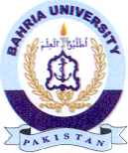
Bahria University Library Islamabad
Source: Express, Thursday, April 29, 2021

